iG Chem ALL EQ 17w to 16m Improving experiments and safety in the lab questions 57marks

Things to know:
These kinds of questions are in every single Paper 6 exam and on average there will b 4.1 marks per exam from this category of question.
Although they look very confusing, they are in fact extremely repetative in the answers they want
Anything involving temperature changes the answers usually require some mention of using more insulation or using a lid to prevent heat moving between the expereiment and the suroundings.
Measuring cylinders allow you to add a liquid really fast, but they are less accurate than buretts, which are less accurate than volumetric pipetes.

Topic Chem 6 Q# 1/ iGCSE Chemistry/Paper 6/2017/w/ Time Zone 3/
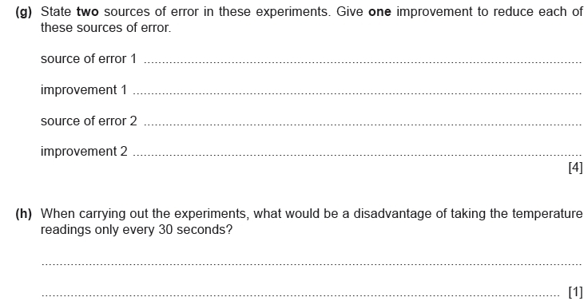

Topic Chem 6 Q# 2/ iGCSE Chemistry/Paper 6/2017/w/ Time Zone 2/
Topic Chem 6 Q# 3/ iGCSE Chemistry/Paper 6/2016/w/ Time Zone 3/
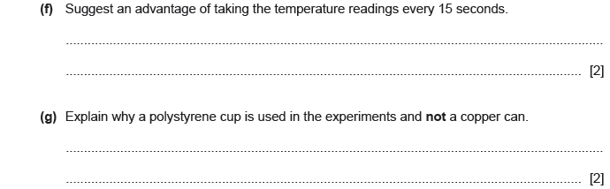
Topic Chem 6 Q# 4/ iGCSE Chemistry/Paper 6/2016/s/ Time Zone 3/
Topic Chem 6 Q# 5/ iGCSE Chemistry/Paper 6/2016/s/ Time Zone 1/
Topic Chem 7 Q# 6/ iGCSE Chemistry/Paper 6/2017/w/ Time Zone 1/

Topic Chem 7 Q# 7/ iGCSE Chemistry/Paper 6/2017/s/ Time Zone 3/
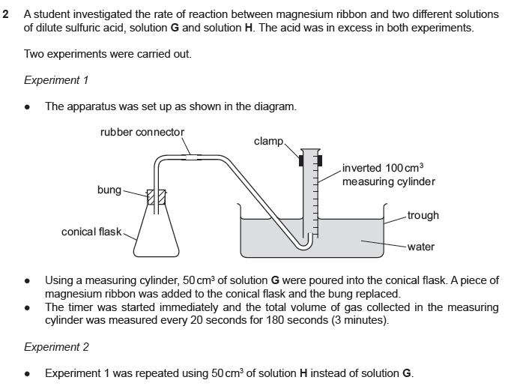
Topic Chem 7 Q# 8/ iGCSE Chemistry/Paper 6/2017/s/ Time Zone 2/
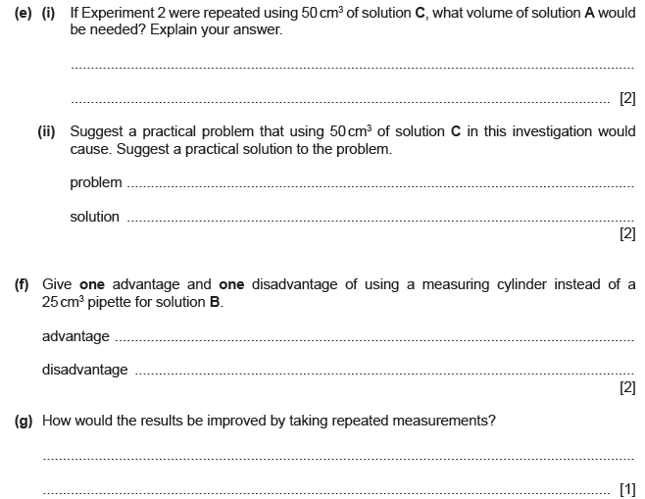
Topic Chem 7 Q# 9/ iGCSE Chemistry/Paper 6/2017/s/ Time Zone 1/
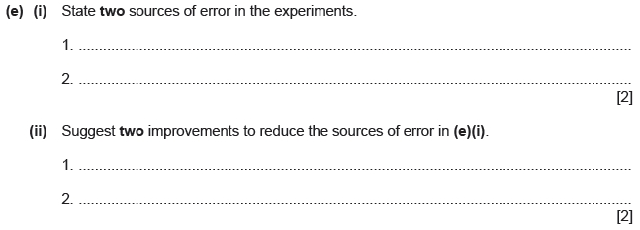
Topic Chem 7 Q# 10/ iGCSE Chemistry/Paper 6/2016/w/ Time Zone 2/
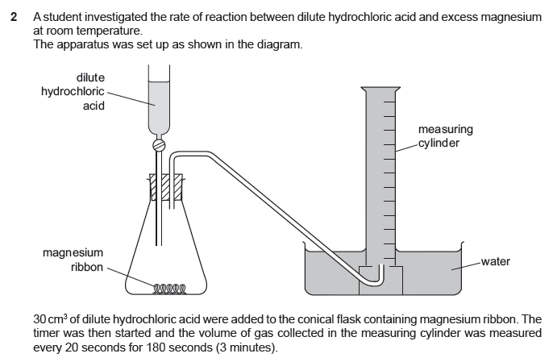
Topic Chem 7 Q# 11/ iGCSE Chemistry/Paper 6/2016/s/ Time Zone 2/
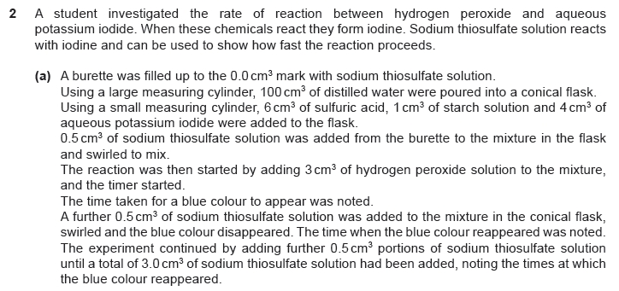
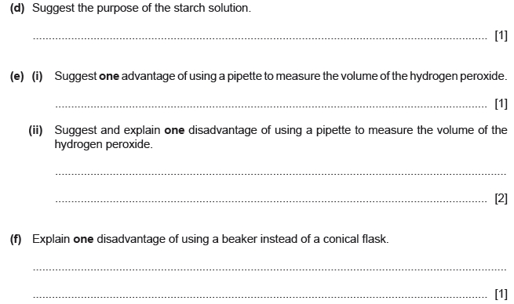
Topic Chem 7 Q# 12/ iGCSE Chemistry/Paper 6/2016/m/ Time Zone 2/
Topic Chem 8 Q# 13/ iGCSE Chemistry/Paper 6/2017/s/ Time Zone 1/

Topic Chem 8 Q# 14/ iGCSE Chemistry/Paper 6/2017/m/ Time Zone 2/
Topic Chem 8 Q# 15/ iGCSE Chemistry/Paper 6/2016/w/ Time Zone 1/
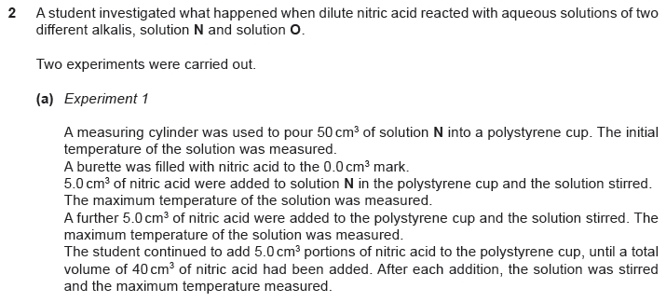
Topic Chem 8 Q# 16/ iGCSE Chemistry/Paper 6/2016/s/ Time Zone 1/Q3

Mark Scheme
Q# 1/ iGCSE Chemistry/Paper 6/2017/w/ Time Zone 3/
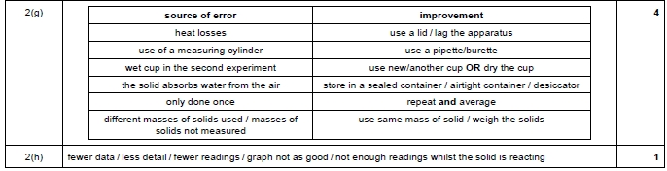
Q# 2/ iGCSE Chemistry/Paper 6/2017/w/ Time Zone 2/
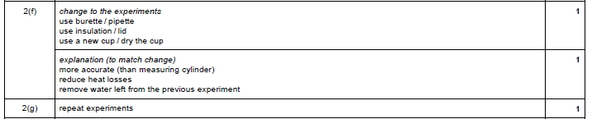
Q# 3/ iGCSE Chemistry/Paper 6/2016/w/ Time Zone 3/
Q# 4/ iGCSE Chemistry/Paper 6/2016/s/ Time Zone 3/
Q# 5/ iGCSE Chemistry/Paper 6/2016/s/ Time Zone 1/

Q# 6/ iGCSE Chemistry/Paper 6/2017/w/ Time Zone 1/
Q# 7/ iGCSE Chemistry/Paper 6/2017/s/ Time Zone 3/
Q# 8/ iGCSE Chemistry/Paper 6/2017/s/ Time Zone 2/
Q# 9/ iGCSE Chemistry/Paper 6/2017/s/ Time Zone 1/
Q# 10/ iGCSE Chemistry/Paper 6/2016/w/ Time Zone 2/
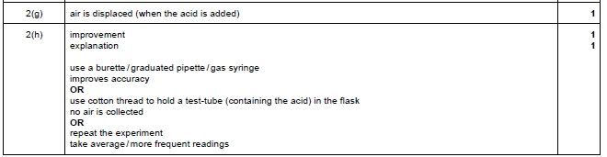
Q# 11/ iGCSE Chemistry/Paper 6/2016/s/ Time Zone 2/
Q# 12/ iGCSE Chemistry/Paper 6/2016/m/ Time Zone 2/
Q# 13/ iGCSE Chemistry/Paper 6/2017/s/ Time Zone 1/
Q# 14/ iGCSE Chemistry/Paper 6/2017/m/ Time Zone 2/
Q# 15/ iGCSE Chemistry/Paper 6/2016/w/ Time Zone 1/
Q# 16/ iGCSE Chemistry/Paper 6/2016/s/ Time Zone 1/

