iG Chem ALL EQ P6 17w to 16m Graph questions 181marks

Topic Chem 6 Q# 1/ iGCSE Chemistry/Paper 6/2017/w/ Time Zone 3/
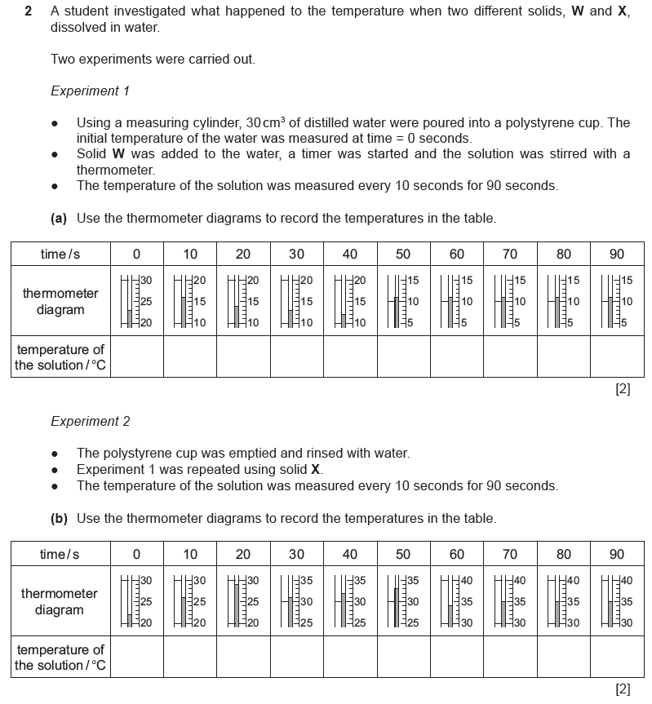

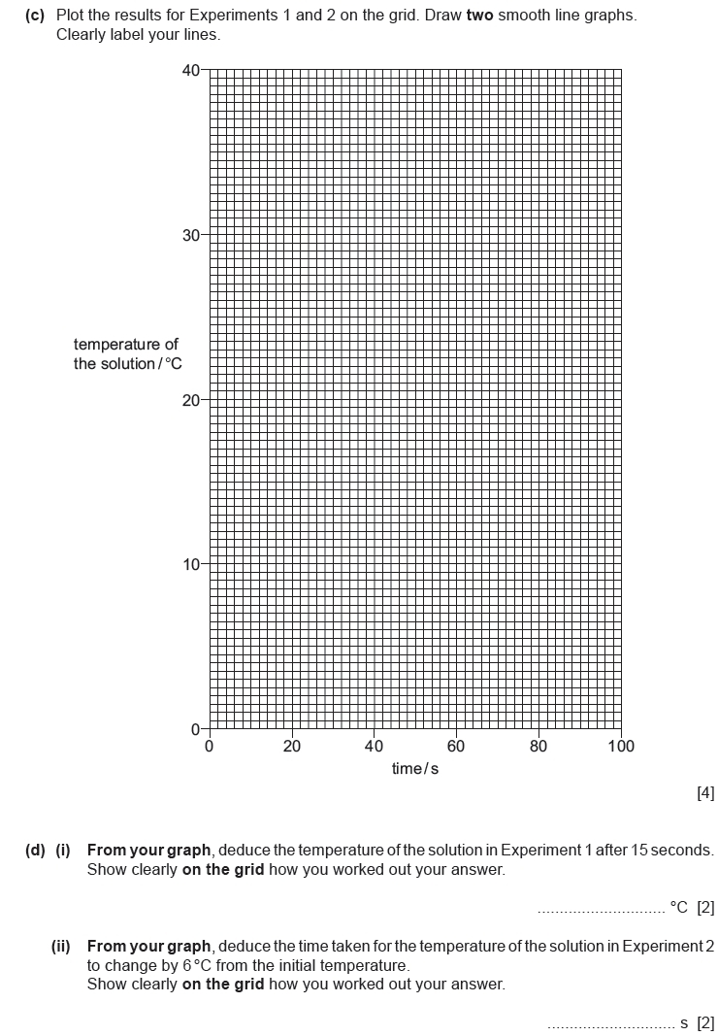
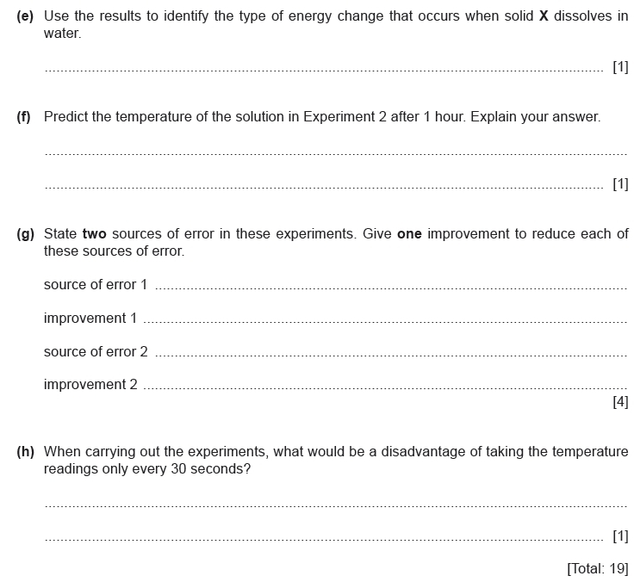
Topic Chem 6 Q# 2/ iGCSE Chemistry/Paper 6/2017/w/ Time Zone 2/
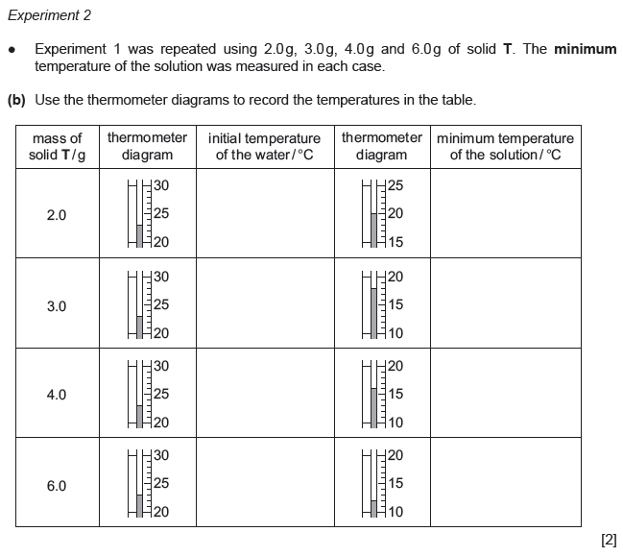
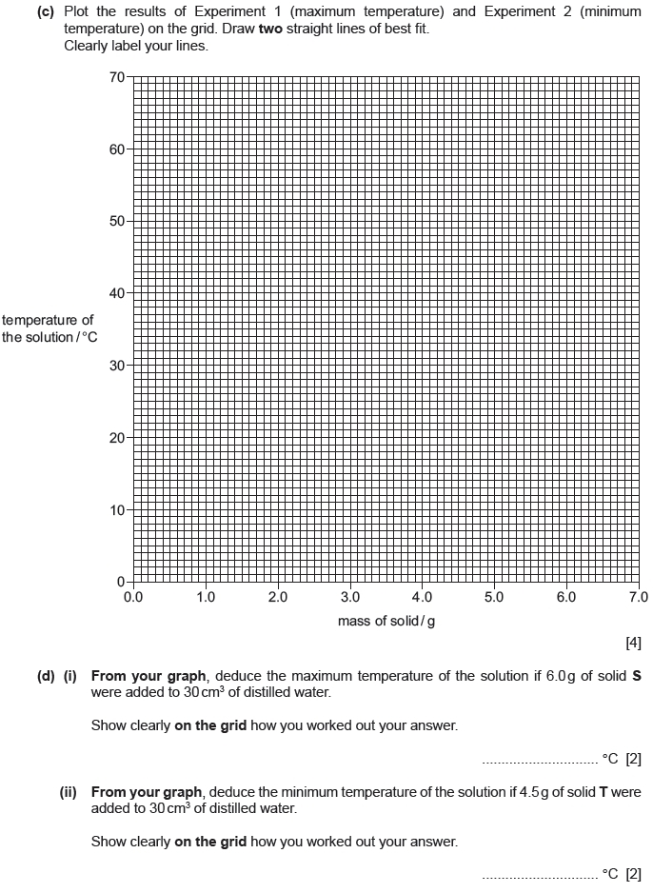
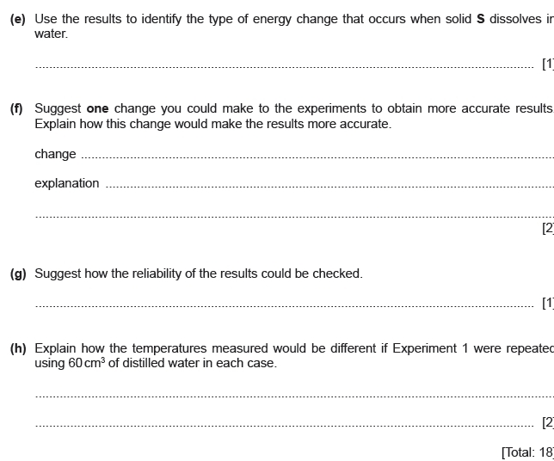
Topic Chem 6 Q# 3/ iGCSE Chemistry/Paper 6/2016/s/ Time Zone 3/
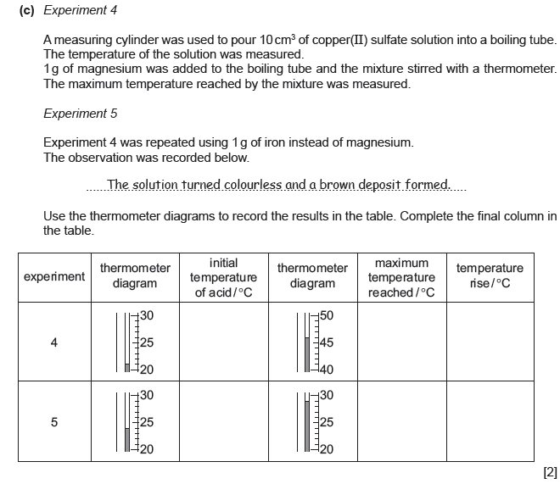
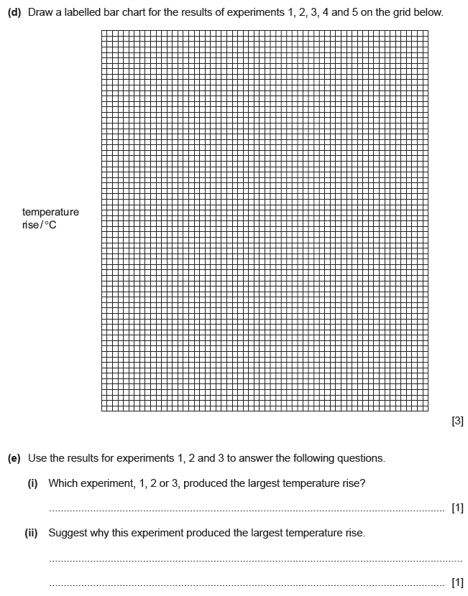
Topic Chem 8 Q# 4/ iGCSE Chemistry/Paper 6/2016/w/ Time Zone 1/
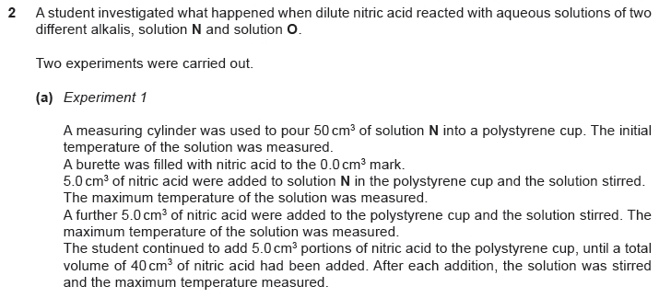
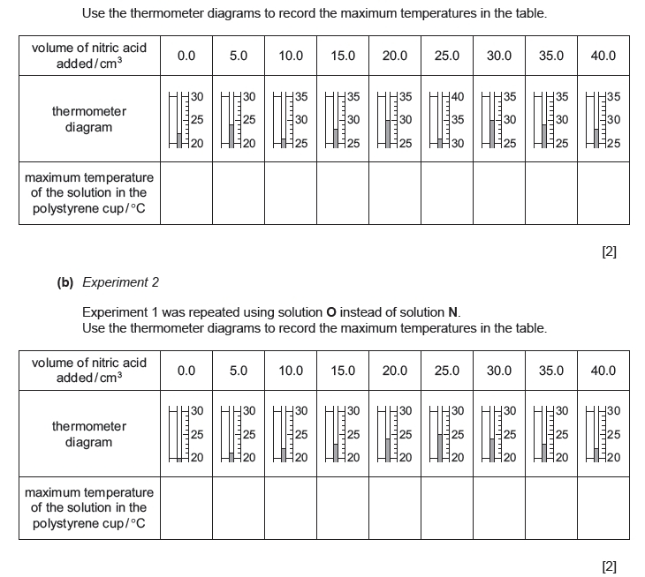
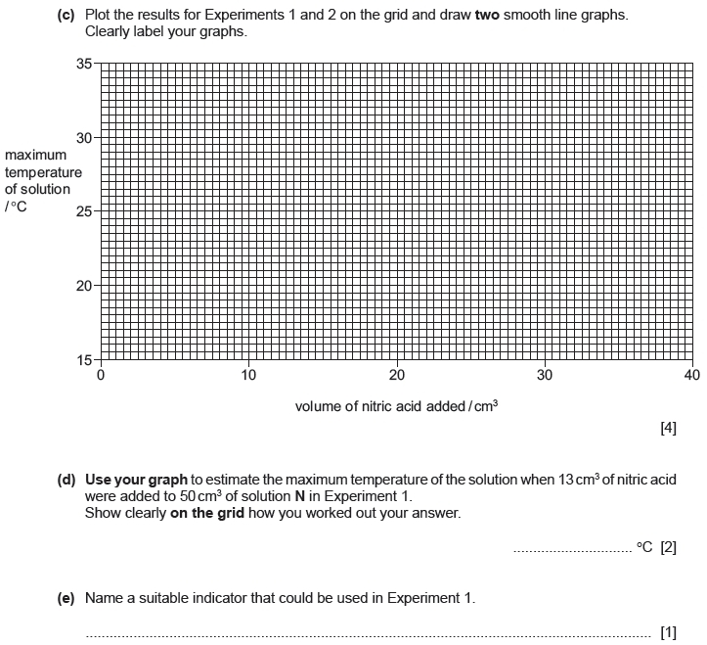
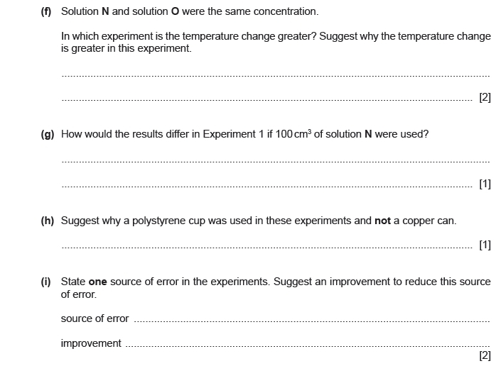
Topic Chem 6 Q# 5/ iGCSE Chemistry/Paper 6/2016/w/ Time Zone 3/
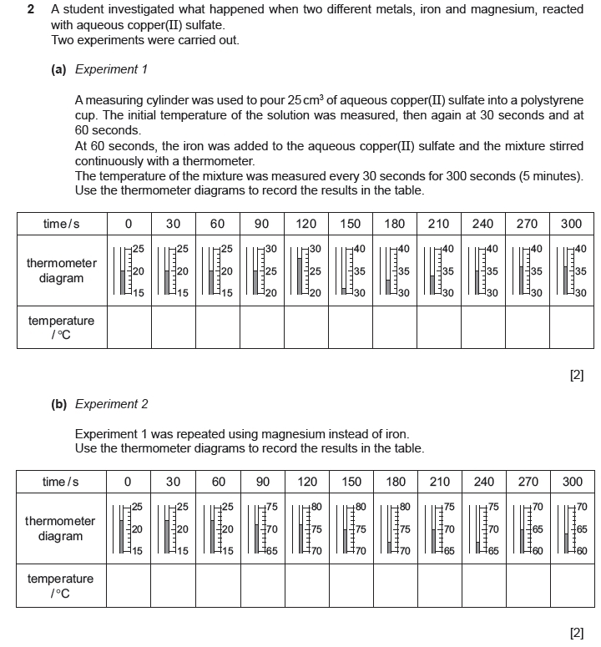
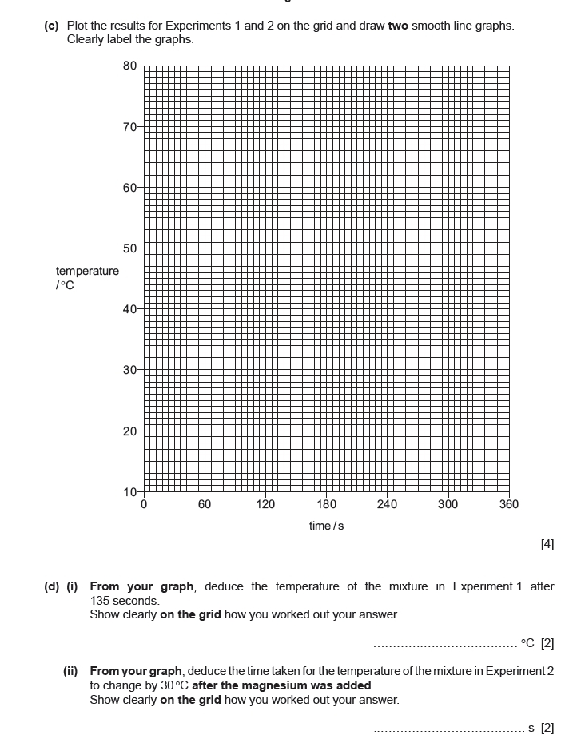
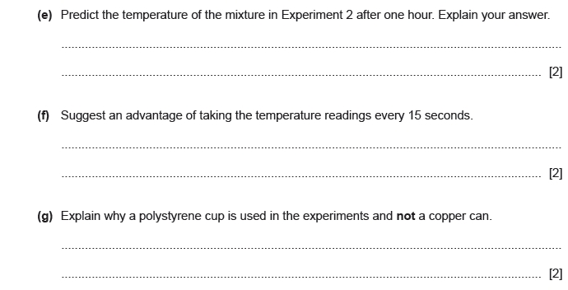
Topic Chem 7 Q# 6/ iGCSE Chemistry/Paper 6/2017/w/ Time Zone 1/
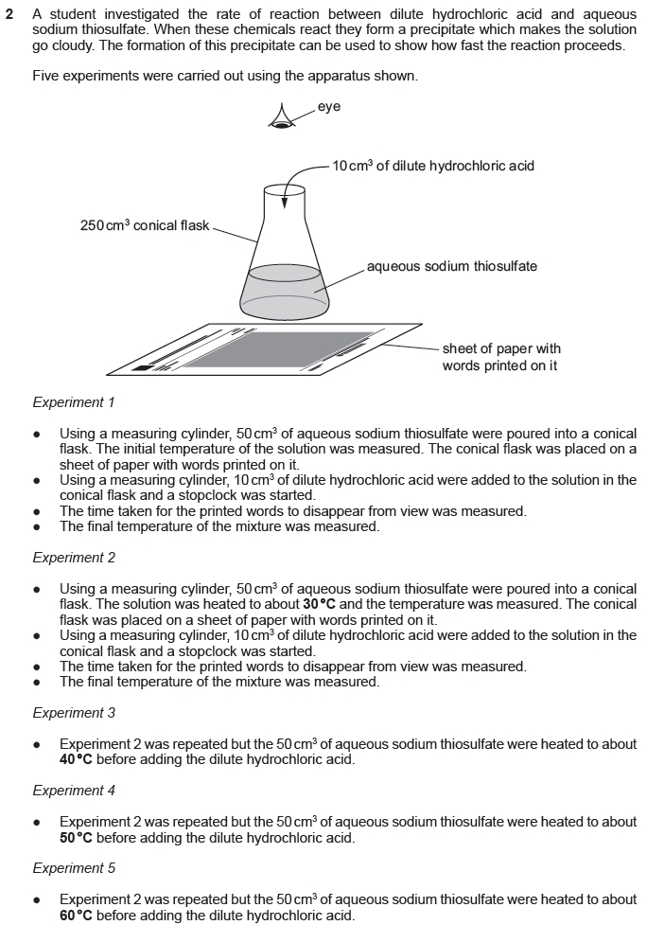
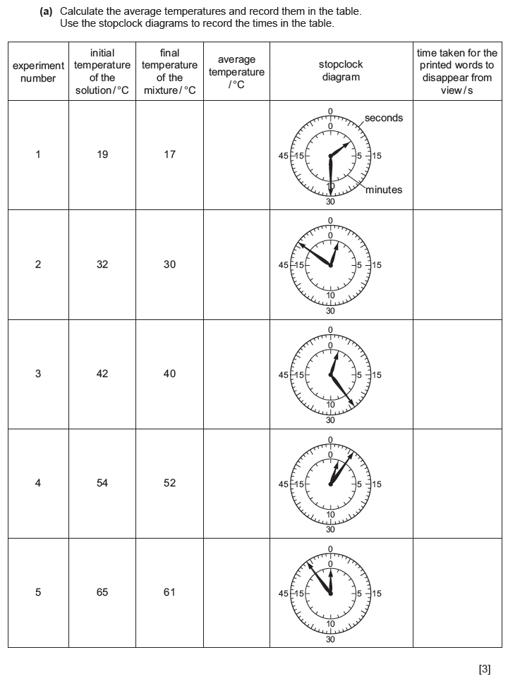
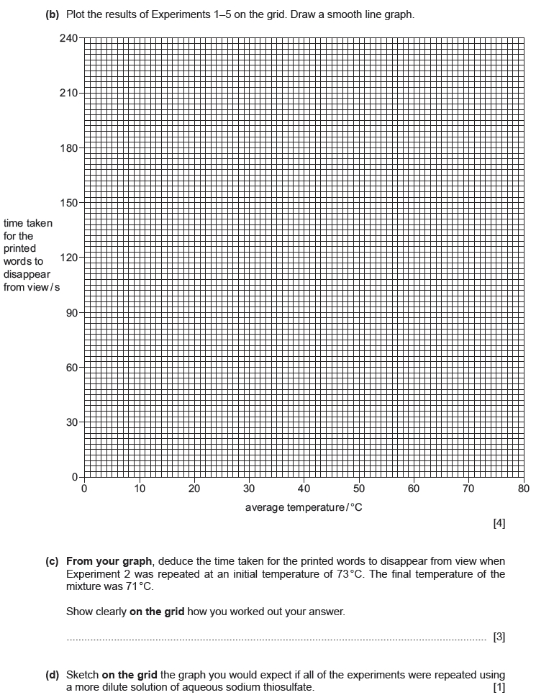
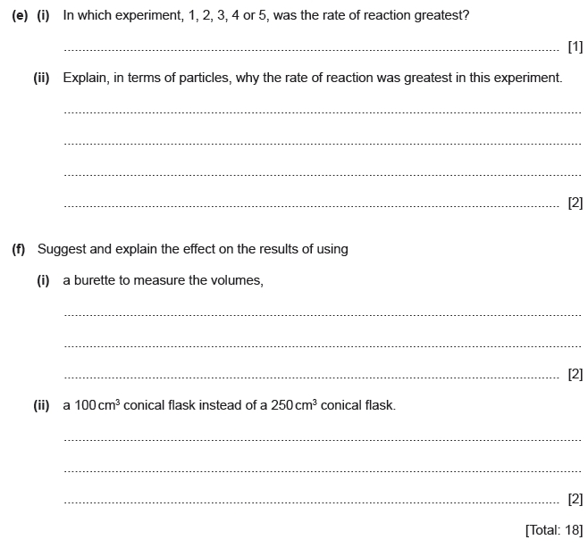
Topic Chem 7 Q# 7/ iGCSE Chemistry/Paper 6/2017/s/ Time Zone 3/
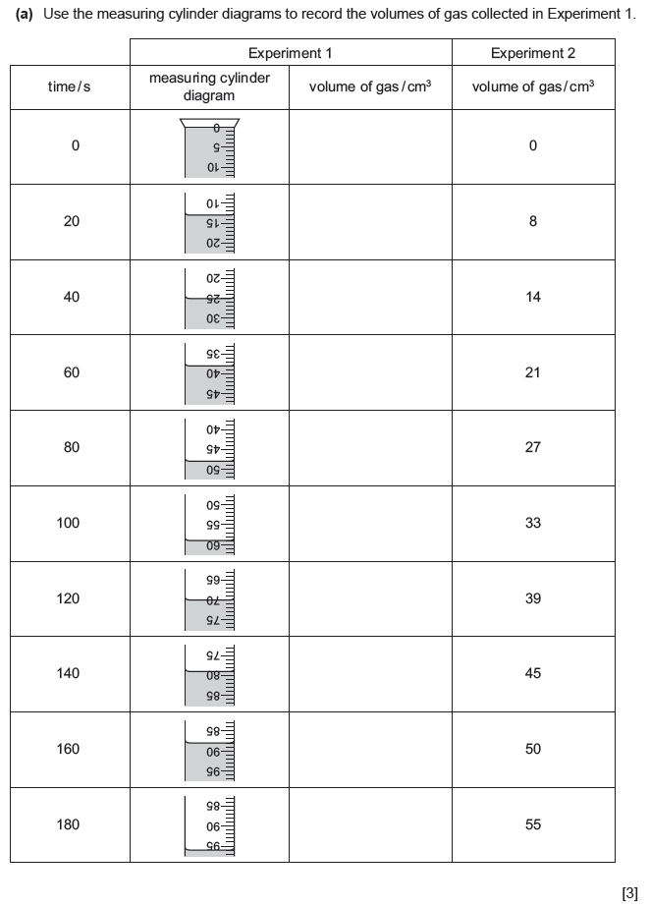
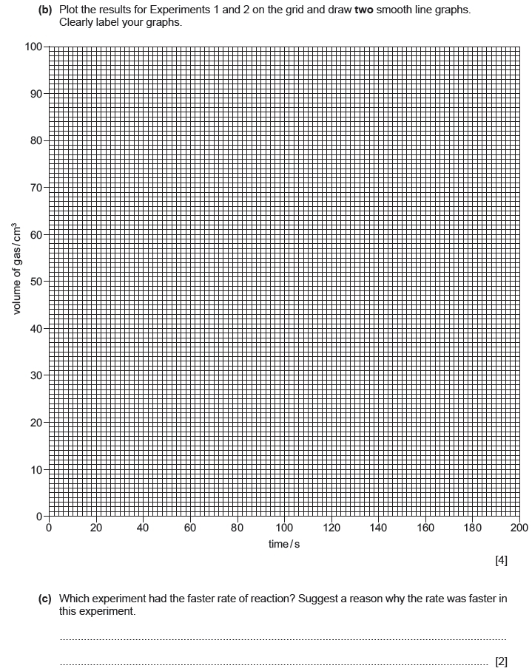
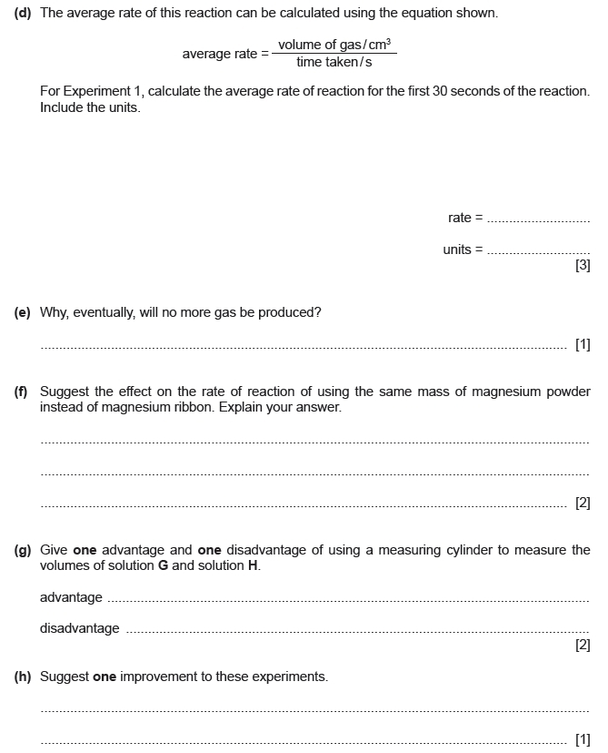

Topic Chem 7 Q# 8/ iGCSE Chemistry/Paper 6/2017/s/ Time Zone 2/

Topic Chem 7 Q# 9/ iGCSE Chemistry/Paper 6/2016/w/ Time Zone 2/
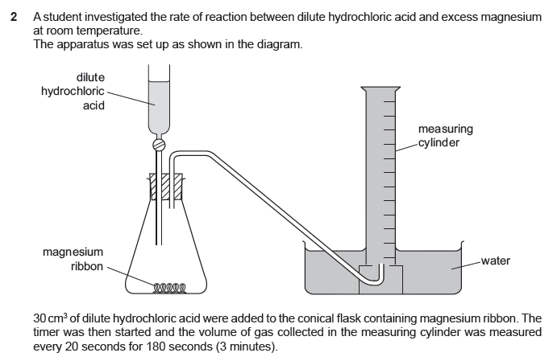
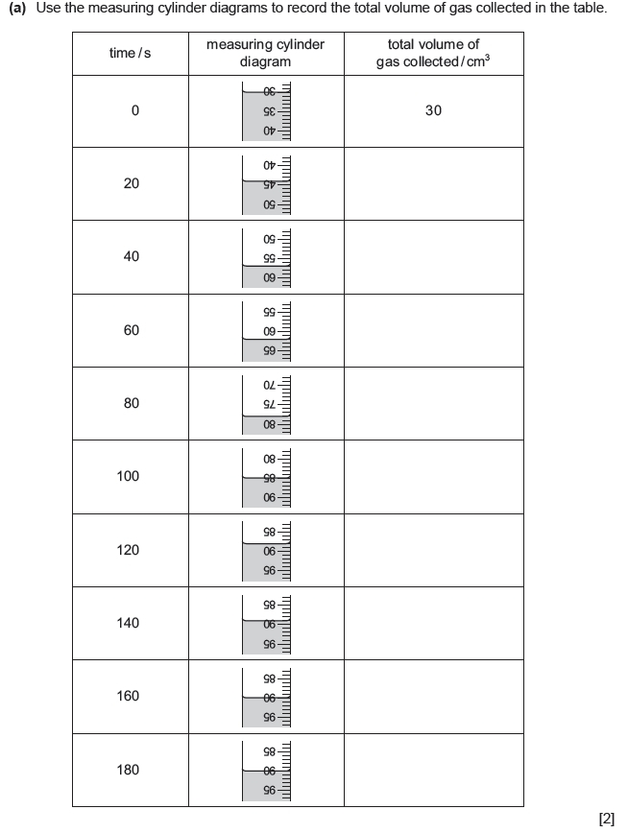
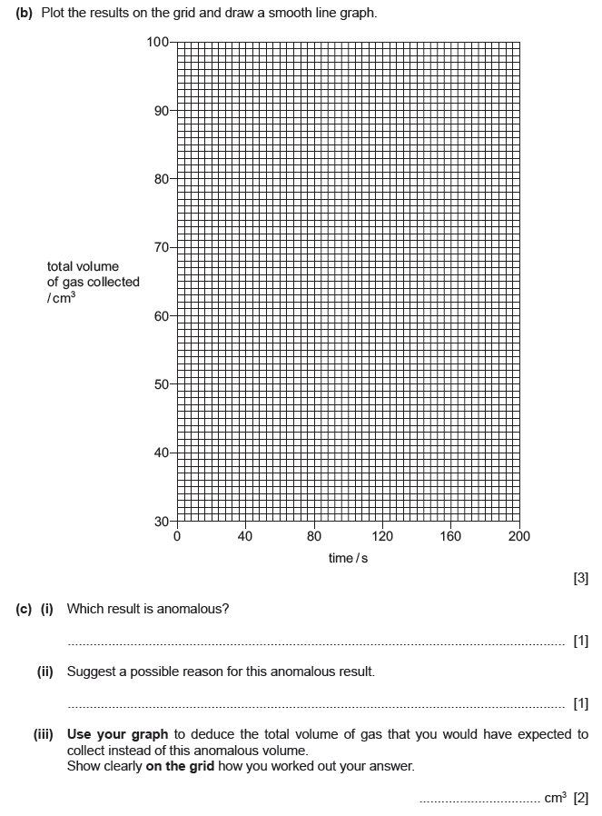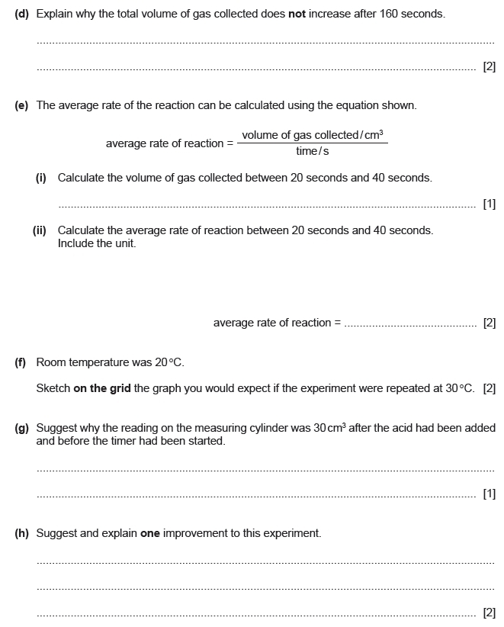
Topic Chem 7 Q# 10/ iGCSE Chemistry/Paper 6/2016/s/ Time Zone 2/
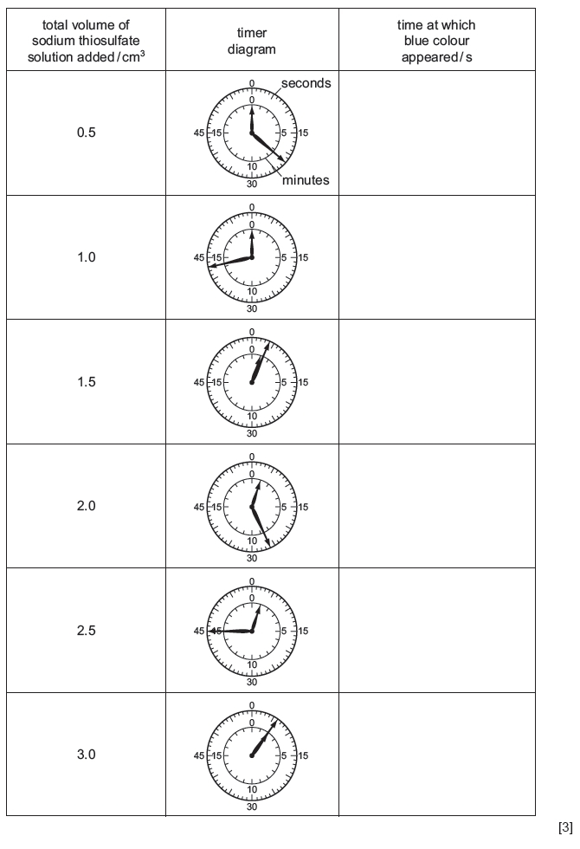
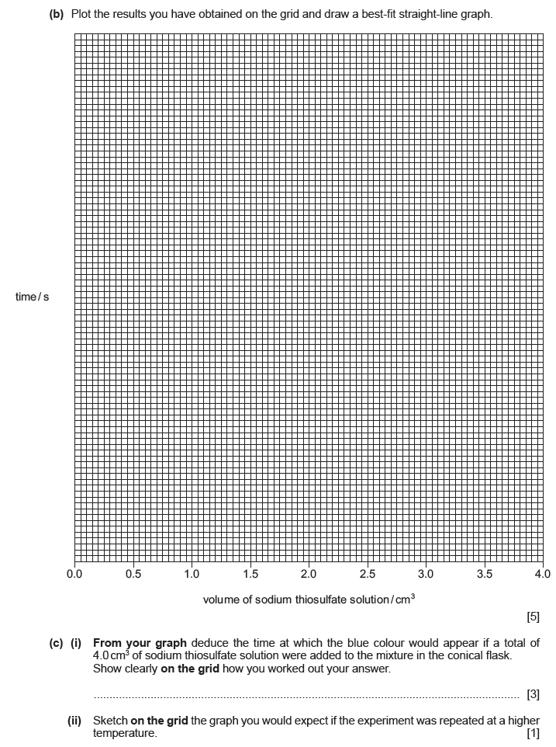
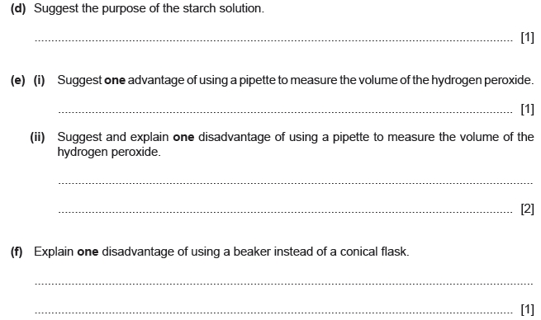
Topic Chem 7 Q# 11/ iGCSE Chemistry/Paper 6/2016/m/ Time Zone 2/
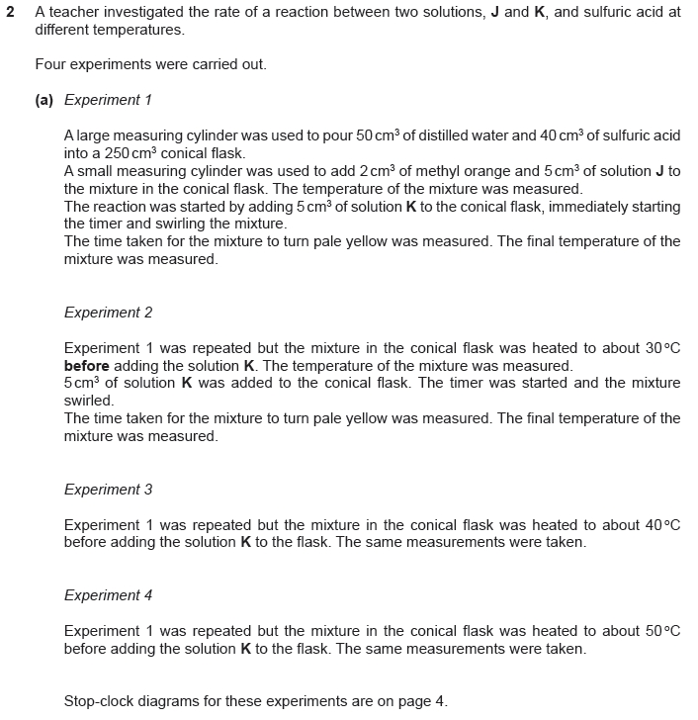
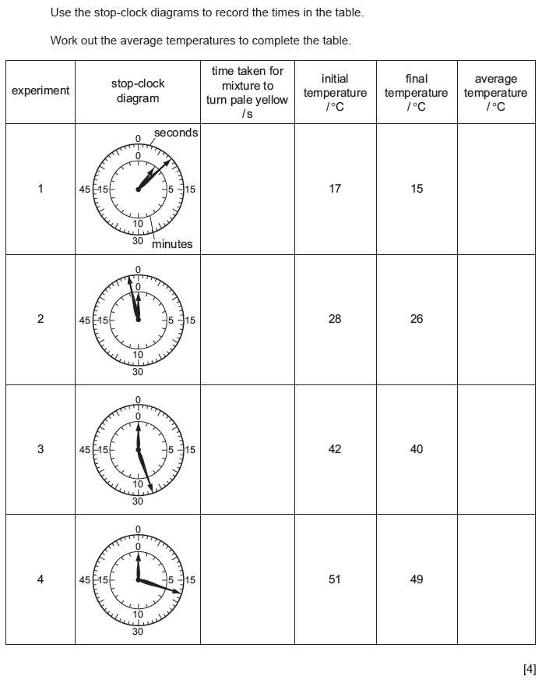
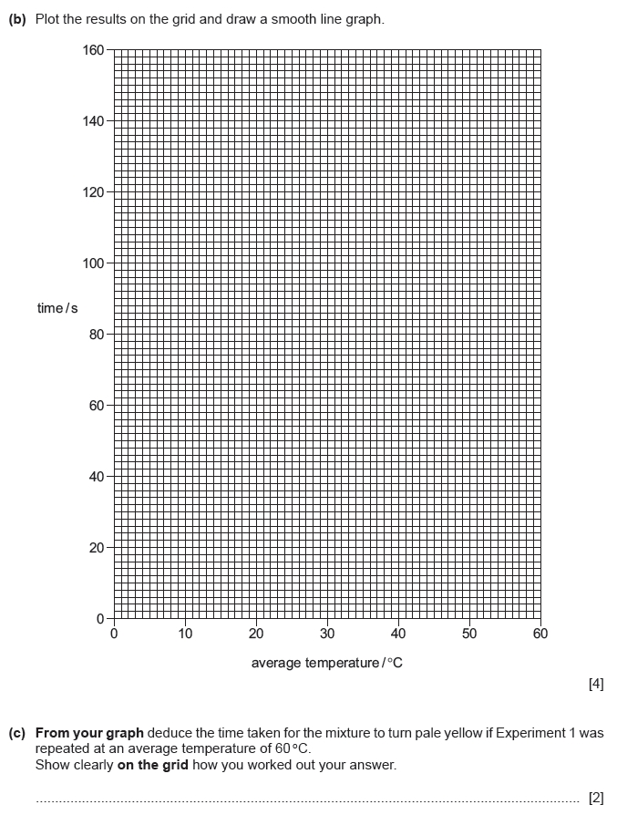

Mark Scheme iG Chem ALL EQ P6 17w to 16m Graph questions
Q# 1/ iGCSE Chemistry/Paper 6/2017/w/ Time Zone 3/
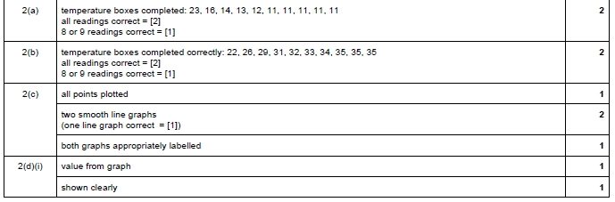
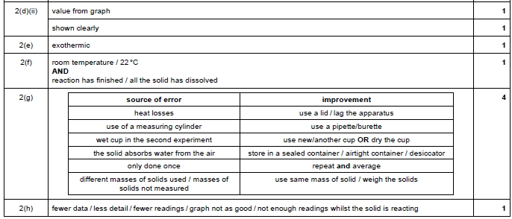

Q# 2/ iGCSE Chemistry/Paper 6/2017/w/ Time Zone 2/
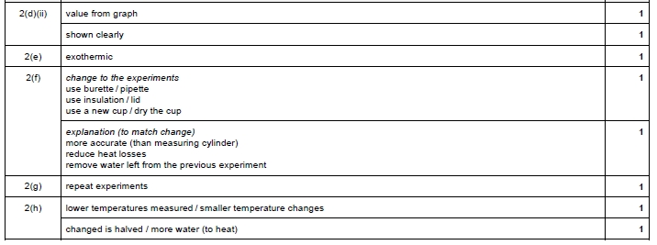
Q# 3/ iGCSE Chemistry/Paper 6/2016/s/ Time Zone 3/
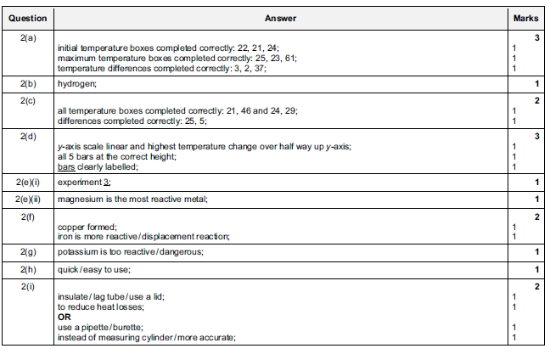
Q# 4/ iGCSE Chemistry/Paper 6/2016/w/ Time Zone 1/
Q# 5/ iGCSE Chemistry/Paper 6/2016/w/ Time Zone 3/
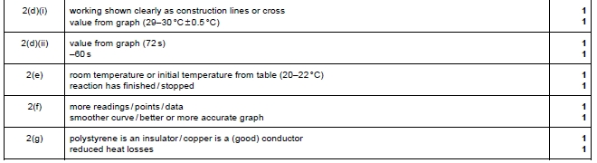
Q# 6/ iGCSE Chemistry/Paper 6/2017/w/ Time Zone 1/
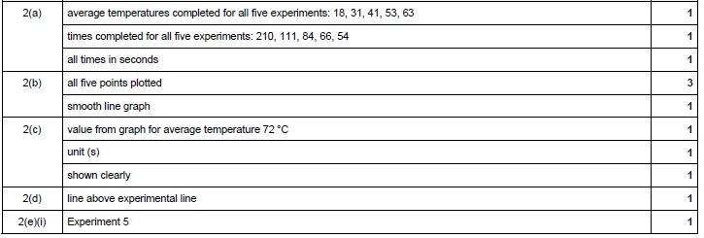
Q# 7/ iGCSE Chemistry/Paper 6/2017/s/ Time Zone 3/

Q# 8/ iGCSE Chemistry/Paper 6/2017/s/ Time Zone 2/
Q# 9/ iGCSE Chemistry/Paper 6/2016/w/ Time Zone 2/
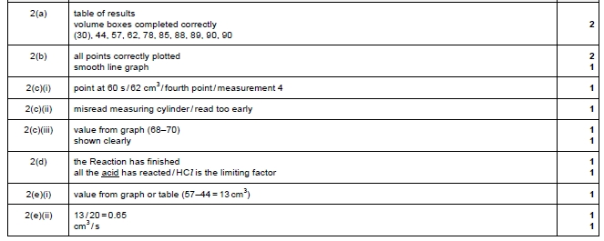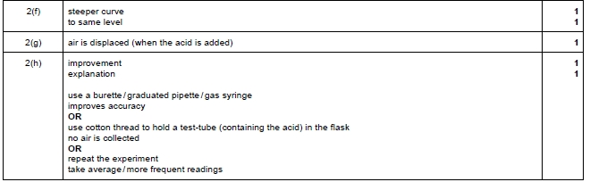

Q# 10/ iGCSE Chemistry/Paper 6/2016/s/ Time Zone 2/
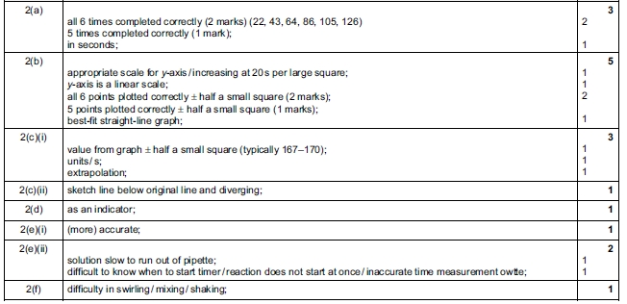
Q# 11/ iGCSE Chemistry/Paper 6/2016/m/ Time Zone 2/
