iG Chem All EQ P6 17w to 16m Titration questions 60marks
Topic Chem 6 15 Q# 1/ iGCSE Chemistry/Paper 6/2016/s/ Time Zone 1/
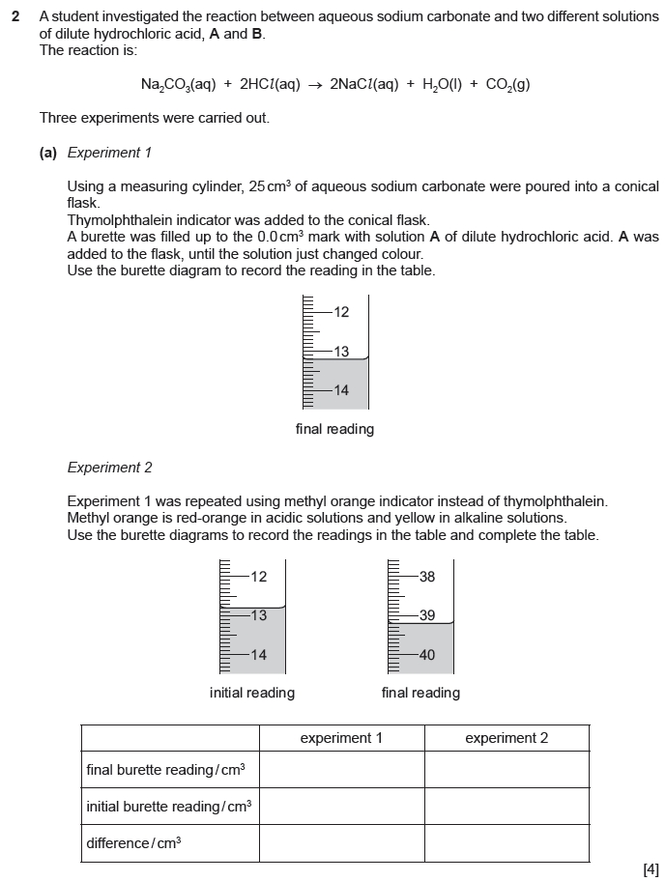
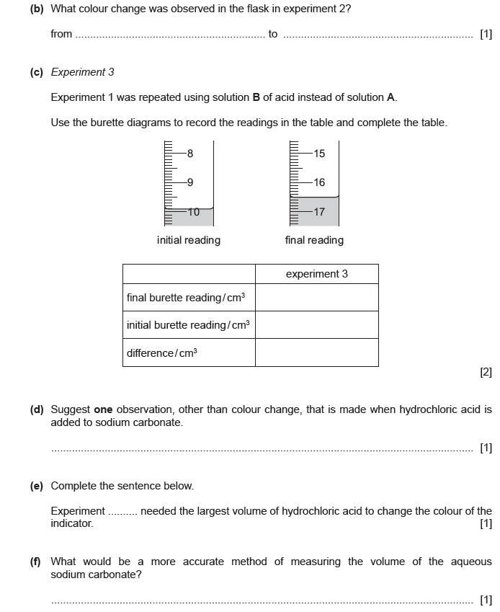

Topic Chem 7 13 Q# 2/ iGCSE Chemistry/Paper 6/2017/s/ Time Zone 1/
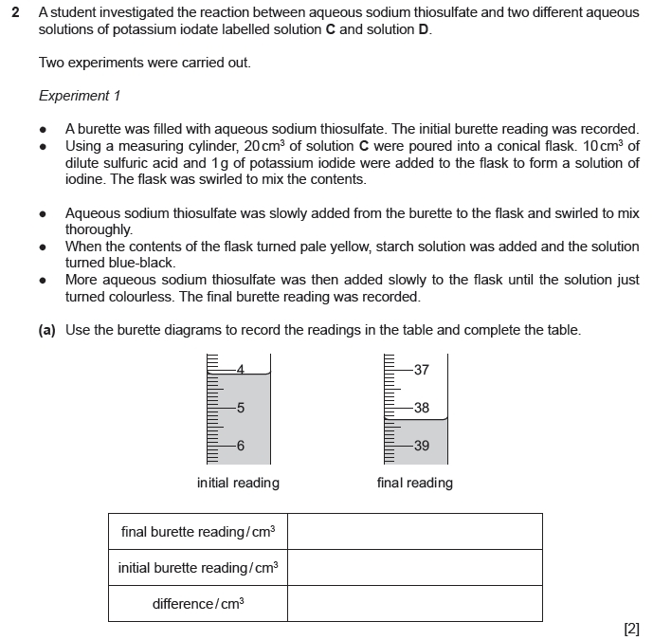
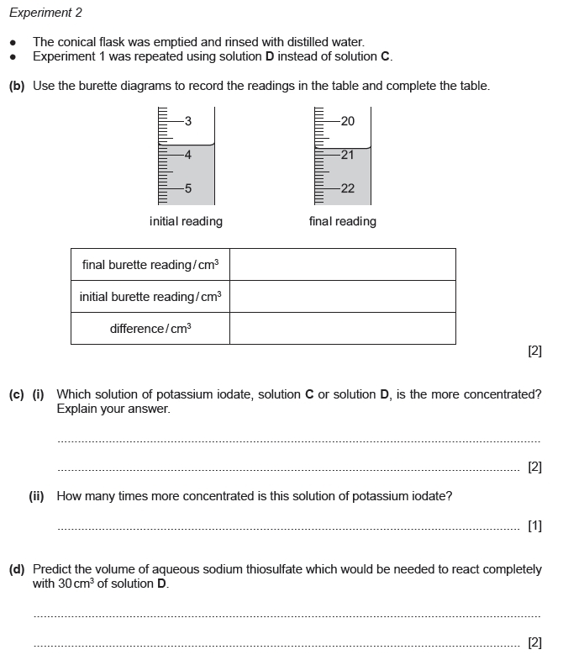
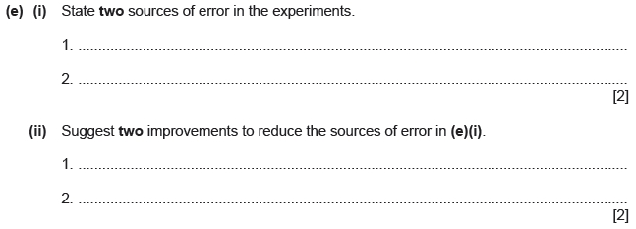
Topic Chem 7 15 Q# 3/ iGCSE Chemistry/Paper 6/2017/s/ Time Zone 2/
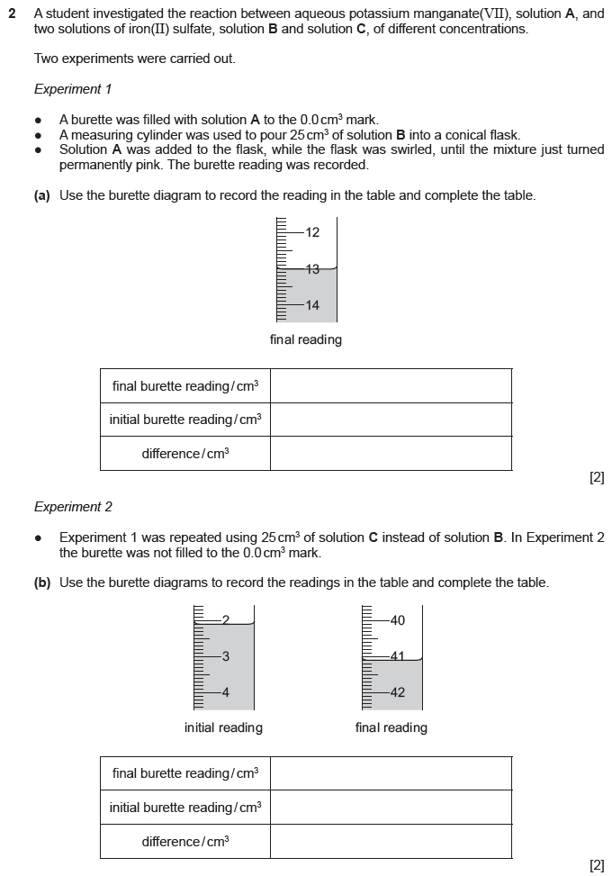
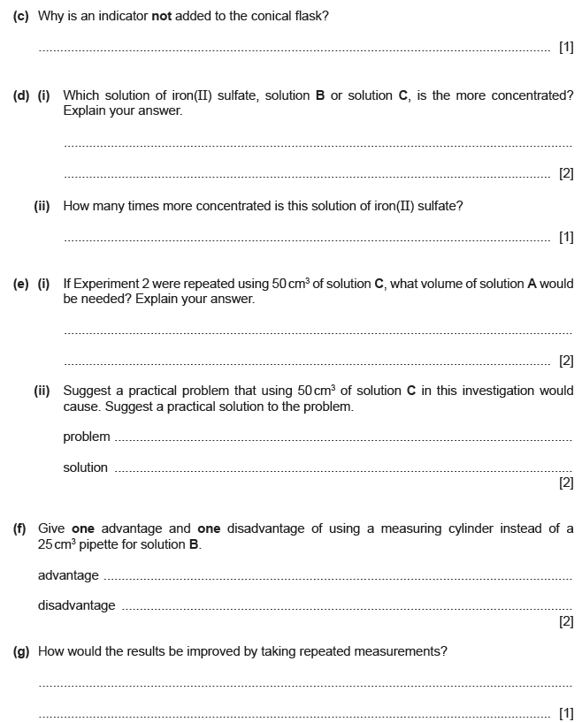

Topic Chem 8 17 Q# 4/ iGCSE Chemistry/Paper 6/2017/m/ Time Zone 2/
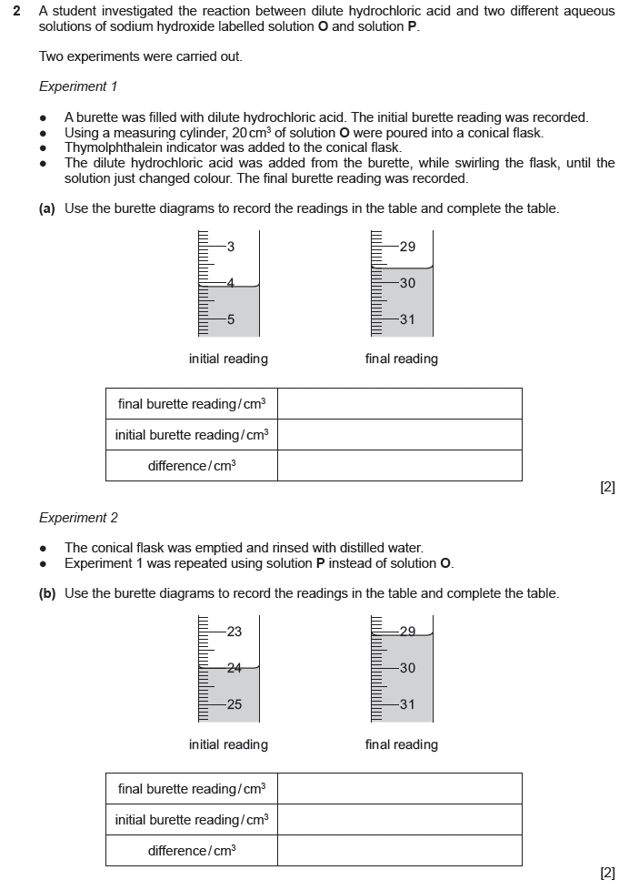
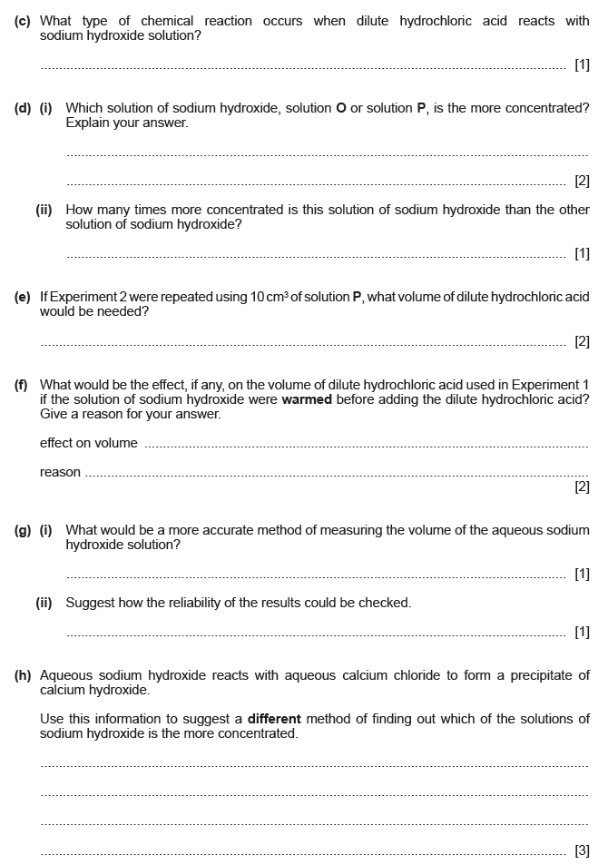

Mark Scheme
Q# 1/ iGCSE Chemistry/Paper 6/2016/s/ Time Zone 1/
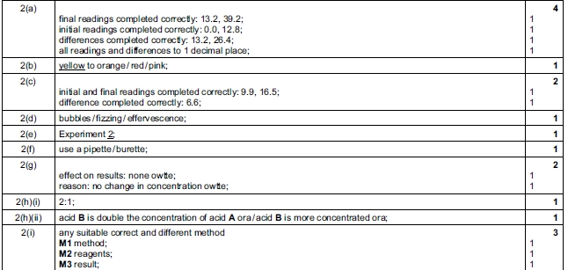
Q# 2/ iGCSE Chemistry/Paper 6/2017/s/ Time Zone 1/
Q# 3/ iGCSE Chemistry/Paper 6/2017/s/ Time Zone 2/

Q# 4/ iGCSE Chemistry/Paper 6/2017/m/ Time Zone 2/
