KS3 Chem 7G Practice Questions about Solids, liquids and gases unit
64 marks
Q2. This question is about three different fuels, A, B and C.
Fuel A is stored in tanks. It is not stored under pressure. It flows along a pipe to where it is needed.
Fuel B is stored under pressure in small cylinders. It is used by campers.
Fuel C can be stored in sacks or bags.
(a) (i) Tick the correct box.
Fuel A is a:
solid
liquid
gas
1 mark
Name a fuel which A could be .............................................................
1 mark
(ii) Tick the correct box.
When fuel B comes out of the cylinder this is a:
solid
liquid
gas
1 mark
Name a fuel which B could be .............................................................
1 mark
(iii) Tick the correct box.
Fuel C is a:
solid
liquid
gas
1 mark
Name a fuel which C could be .............................................................
1 mark
Q3. A test tube of crushed ice is taken out of a freezer and left in a warm room. The graph shows how the temperature in the test tube changes.
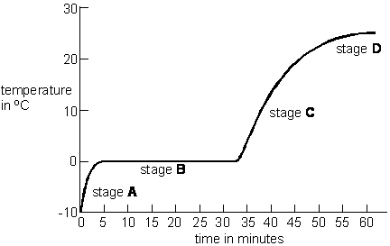
(a) What is happening to the ice at stage B?
......................................................................................................................
1 mark

(b) Why does the temperature of the water stop rising at 23°C (stage D)?
......................................................................................................................
......................................................................................................................
1 mark
(c) Four descriptions of the ways molecules could move are given below.
They vibrate around fixed points.
They move past each other and are close together.
They move in straight lines, colliding occasionally.
They all move in the same direction at the same speed.
(i) How do the molecules move at stage A?
Write A in the correct box above.
1 mark
(ii) How do the molecules move at stage C?
Write C in the correct box above.
1 mark
(d) Ice from a freezer is put in a glass of water at room temperature. The ice floats in the water.
(i) What does this show about the density of the ice compared to that of water?
Tick the correct box.
Ice is more dense than water.
Ice and water have the same density.
Ice is less dense than water.
Ice has a density of zero.
1 mark
(ii) The fact that ice floats in water tells us something about the distances between the molecules.
Tick the box by the correct statement.
The molecules are further apart in ice than in water.
The molecules are the same distance apart in ice and in water.
The molecules are closer together in ice than in water.
1 mark
Maximum 6 marks

Q4. Air is a gas at room temperature. The chemical formulae below show some of the substances in the air.
Ar CO₂ H₂O N₂ Ne O₂
(c) The coldest possible temperature is ‘absolute zero’, which is –273°C. As air is cooled towards absolute zero it liquefies. Table C gives the boiling points of the substances in air.
table C
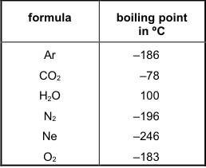
A sample of air at a temperature close to absolute zero is allowed to warm up.
Which substance boils first?
........................................
1 mark
(d) Each particle of neon can be represented by a circle.
Carefully complete the diagrams below to show the arrangement of particles in neon gas and liquid neon.
Use circles about in size.
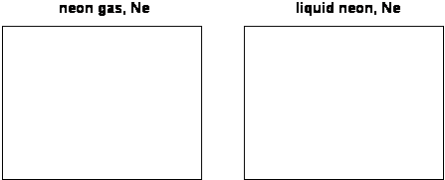
4 marks
Maximum 7 marks
Q5. This question is about four chemical elements.
(a) The melting points and boiling points of the four elements are shown in the table. Complete the table to give the physical state, solid, liquid or gas, of each element at room temperature, 21°C.

element | melting point  in °C | boiling point  in °C | physical state at room  temperature, 21°C
bromine | –7 | 59
chlorine | –101 | –34
fluorine | –220 | –188
iodine | 114 | 184

4 marks
(c) Is bromine a solid, a liquid or a gas when the arrangement of particles is:
(i) far apart and random? .......................................................................
1 mark
(ii) close together but random? ...............................................................
1 mark
(iii) close together in a regular pattern? ...................................................
1 mark
Q6. Sarah wanted to find out how the length of a copper rod changes when it is heated.
She fixed one end of the rod and allowed the other end to roll on a pin which had been put on a glass plate.
A drinking straw, attached to the pin , showed the movement of the end of the rod.
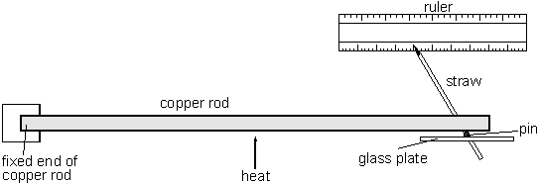
(a) (i) What happens to the motion of the copper atoms in the rod as it is heated?
.............................................................................................................
.............................................................................................................
1 mark
(ii) What happens to the average distance between the atoms of copper when the rod is heated?
.............................................................................................................
.............................................................................................................
1 mark
(b) The graph shows the length of a copper rod at different temperatures.
The rod was 300.0 mm long at room temperature.
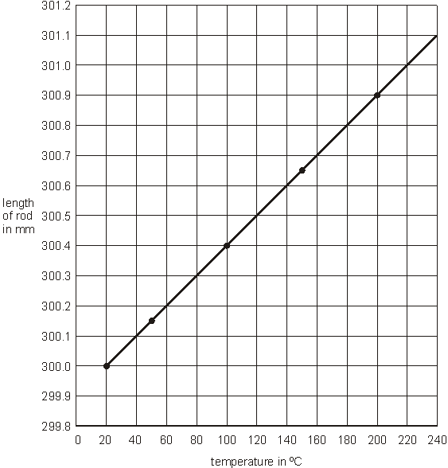
(i) At what temperature has the rod increased its length by 1.0 mm?
…………………… °C
1 mark
(ii) The rod was 300.0 mm long at room temperature. What will its length become if it is placed in melting ice at 0°C?
…………………… mm
1 mark
Q7
The table shows the melting points and boiling points of four substances present in the air.

substance | melting point, in °C | boiling point, in °C
carbon dioxide | –78 | –78
nitrogen | –210 | –196
oxygen | –219 | –183
water vapour | 0 | 100

(a) What happens to a piece of solid carbon dioxide if it is heated from –100°C to –78°C?
.....................................................................................................................
.....................................................................................................................
1 mark
(b) ‘Liquid air’ can be formed from air in a heat exchanger. As the air passes through, thermal energy is transferred from the air to the surroundings. This is shown in the flow diagram below.
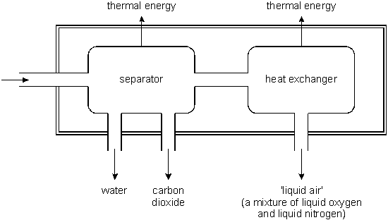
(i) Suggest a likely temperature for the ‘liquid air’ that leaves the heat exchanger.
................°C
1 mark
(c) The ‘liquid air’ is a mixture of liquid nitrogen and liquid oxygen.
Use the information in the table to suggest how liquid oxygen could be obtained from the mixture.
.....................................................................................................................
.....................................................................................................................
1 mark
(iii) How does the distance between the particles in atmospheric air compare to the size of the particles themselves?
.............................................................................................................
.............................................................................................................
1 mark
Q8. The list below shows properties that different elements can have.
• magnetic
• can be compressed
• very high melting point
• very low melting point
• good conductor of heat
• poor conductor of heat
• good conductor of electricity
• poor conductor of electricity
(a) Which two properties from the list above make aluminium suitable for saucepans?
1. .................................................................................................................
2. .................................................................................................................
2 marks
(b) Which property in the list above explains why:
(i) copper is used in the cable of a television?
.............................................................................................................
1 mark
(ii) a lot of oxygen gas can be pumped into a very small container?
.............................................................................................................
1 mark
Q10. (a) The table below shows the melting points of four metals.

metal | melting point,  in °C
gold | 1064
mercury | –37
sodium | 98
iron | 1540

(i) Which metal in the table has the highest melting point?
............................................................
1 mark
(ii) Which metal in the table has the lowest melting point?
............................................................
1 mark
(b) Gold can be a gas or a liquid or a solid.
Choose from these words to fill the gaps below.
When gold is heated from room temperature to 1070°C, the gold
changes from a ................................. to a ................................... .
1 mark
(c) 5 g of gold is melted and all of it is poured into a mould to make a pendant as shown below.
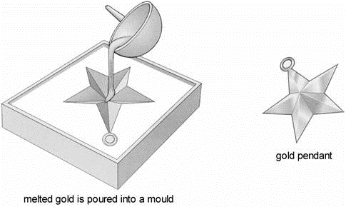
What is the mass of the gold pendant?
........................... g
1 mark
Q11. (a) Methane can be a gas, a liquid or a solid. In the diagram below, arrows P, Q, R and S represent changes of state.
The boxes on the right show the arrangement of particles of methane in the three different physical states.
Each circle represents a particle of methane.
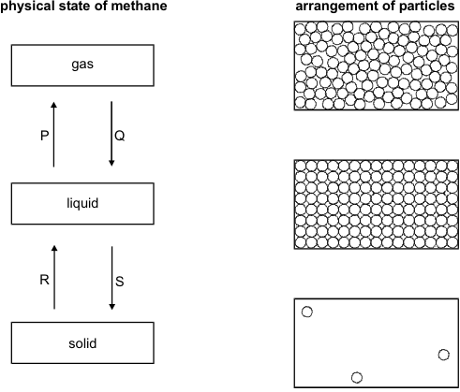
(i) Draw a line from each physical state of methane to the arrangement of particles in that physical state.
Draw only three lines.
1 mark
(ii) Arrows P, Q, R and S represent changes of state.
Which arrow represents:
evaporation? ............................................................
melting? ...................................................................
2 marks
(b) Methane is the main compound in natural gas. The scale below shows the
melting point and the boiling point of methane.
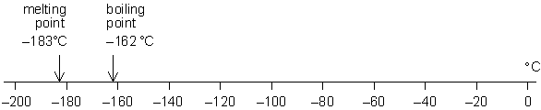
Methane has three physical states: solid, liquid and gas.
(i) What is the physical state of methane at –170°C?
.............................................................
1 mark
Q12. (a) Jenny put a bottle of fizzy drink on a balance.
She removed the bottle-top, and the drink began to fizz.
She left the open bottle of drink and the bottle-top on the balance for five days in a warm room.
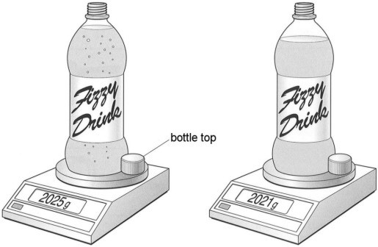
at the start five days later
Five days later the drink was no longer fizzy. It’s mass had decreased and the level of the liquid had gone down.
(i) Look at the drawings of the balance.
Work out the decrease in mass after five days.
............... g
1 mark
(ii) The fizzy drink contained sugar, colouring, a gas and water. The mass decreased because two of these substances were lost into the air.
Which two substances were lost into the air?
1. ..................................................................
1 mark
2. ..................................................................
1 mark
Q13. (a) (i) Air contains nitrogen.
In the box below draw five circles, , to show the arrangement of particles
in nitrogen gas.
1 mark
(ii) Zeena carries a personal emergency alarm.
It uses nitrogen gas to produce a very loud sound.
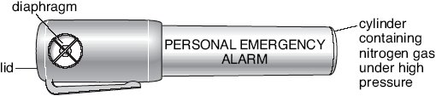
The nitrogen gas in the container is under much higher pressure than the
nitrogen gas in the air.
How does the arrangement of nitrogen particles change when the gas is
under higher pressure?
.............................................................................................................
.............................................................................................................
1 mark
(b) Use words from the boxes below to complete the sentence.
The rate at which the nitrogen particles hit the inside of the container is
.................................... the rate at which nitrogen particles hit the outside of the
container.
1 mark
Q14. Sam made a model cat.
He mixed modelling powder with water.
He poured all of the mixture into a mould.
He covered the mould with plastic film so that water could not evaporate.
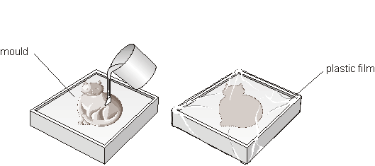
(a) (i) After 10 minutes, Sam removed the model cat from the mould.
Sam had mixed 40 g of modelling powder with 12 g of water.
What was the mass of the model cat?
................. g
(ii) Complete the sentence below using words from the list.
gas liquid solid vapour
After 10 minutes, the mixture in the mould changed from a
.......................................... into a .............................................
2 marks
Q15. Diagram A represents a gas in a container.
The gas can be compressed by moving the piston to the right.
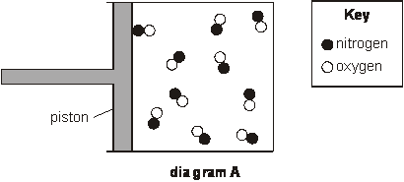
(a) (i) How can you tell that the substance in the container is a gas?
...............................................................................................................
...............................................................................................................
1 mark
Q17. (a) The table below shows the melting points and boiling points of four elements.

element | melting point (°C) | boiling point (°C)
aluminium | 660 | 2520
iron | 1540 | 2760
magnesium | 650 | 1100
mercury | −39 | 357

When answering the questions below, you may give the name of an element
more than once.
Which element in the table is:
(i) a liquid at 0°C?
...............................................................................................................
1 mark
(ii) a solid at 1500°C?
...............................................................................................................
1 mark
(iii) a gas at 500°C?
...............................................................................................................
1 mark
(iv) a liquid over the biggest temperature range?
...............................................................................................................
1 mark
(b) The melting point and boiling point of nitrogen are marked on the scale below.
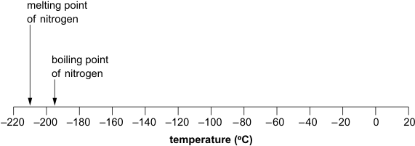
(i) Draw an arrow on the scale above to show the temperature at which water
freezes.
1 mark
(ii) When water is a liquid, what is the physical state of nitrogen?
Tick the correct box.
solid liquid gas
1 mark
(iii) What is the physical state of nitrogen at −200°C?
Tick the correct box.
solid liquid gas
1 mark
maximum 7 marks
Q18. Anna has a can of deodorant that she uses once each day.
Before she uses the deodorant she measures the mass of the can.
(a) Her results are shown in the graph below.
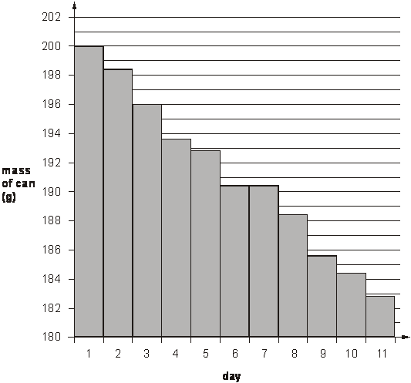
(i) What was the mass of the can of deodorant on day 1?
.............. g
1 mark
(ii) How did the mass change as Anna used the deodorant?
...............................................................................................................
1 mark
(iii) Anna did not use the deodorant on day 6.
How can you tell this from the graph?
...............................................................................................................
...............................................................................................................
1 mark
(c) A deodorant contains a solution of perfume and alcohol.
What happens to the perfume when it is mixed with the alcohol?
Tick the correct box.
It boils. It dissolves.
It freezes. It melts.
1 mark

Mark Scheme

M2. (a) (i) liquid
if more than one box is ticked award no mark
accept ‘A’ in the liquid box instead of a tick
1
petrol or oil or diesel
accept a brand name
or paraffin or kerosene
1
(ii) gas
if more than one box is ticked award no mark
accept ‘B’ in the gas box instead of a tick
1
gas or natural gas or calor
accept a brand name
gas or butane or propane
do not accept ‘hydrogen’ or methane or camping gaz
1
solid
if more than one box is ticked award no mark
accept ‘C’ in the solid box instead of a tick
1
coal or coke or wood or charcoal
accept a brand name or ‘peat’
1
M3. (a) It melts or is melting
accept ‘it starts to melt’ or ‘thaws’ or ‘turns to liquid’
or ‘changes state’
do not accept ‘it is between solid and liquid’
1 (L5)
(b) it is room temperature
accept no more energy being put in’
1 (L5)
(c) (i) They vibrate around fixed points A
if more than one box is labelled A, award no mark
1 (L6)
(ii) They move past each other and are close together C
if more than one box is labelled C, award no mark
disregard any ticks
1 (L6)
(d) (i) Ice is less dense than water.
if more than one box is ticked, award no mark
1 (L6)
(ii) The molecules are further apart in ice than in water.
if more than one box is ticked, award no mark
1 (L6)
[6]
M4
(a)
element | compound
Ar  N₂  Ne  O₂ | CO₂  H₂O

all six formulae are required for the mark
1 (L7)
(b)
atom | molecule
Ar  Ne | N₂  O₂  CO₂  H₂O

all six formulae are required for the mark
1 (L7)
(c) Ne or neon
1 (L7)
(d) up to ten randomly arranged particles spaced throughout the box
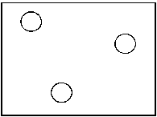
accept just one particle
do not accept an empty box
1 (L7)
most of the particles are not in contact with each other
1 (L7)
the box almost full of particles of neon, more than 50% of which
are touching each other
1 (L7)
the particles are randomly arranged
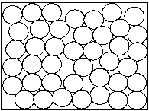
if the level of liquid is drawn then accept the circles
drawn correctly below the liquid level
1 (L7)
[7]
M5. (a)
bromine | liquid
chlorine | gas
fluoride | gas
iodine | solid

4 (L6)
(b) gas
1 (L6)
(c) (i) gas
1 (L6)
(ii) liquid
1 (L6)
(iii) solid
1 (L6)
[8]
M6. (a) (i) any one from
• they vibrate further
accept ‘they vibrate more or faster’
• they move faster
accept ‘they go faster’
do not accept ‘they move about more’
or ‘they collide more’
1 (L6)
(ii) it increases
accept ‘it gets bigger’ or ‘they move further apart’
1 (L6)
(b) (i) 220
1 (L5)
(ii) 299.9
1 (L5)
[4]
M7. (a) changes from a solid to a gas
accept ‘it sublimes’
accept ‘it remains solid’
1
(b) (i) any temperature from –196°C to –210°C
1
(ii) they would become solid or freeze
1
they would block the pipes
accept ‘the pipes could burst’
1
(c) any one from
• boil away the nitrogen
accept ‘by fractional distillation’
• warm it to between –196°C and –183°C
accept ‘warm it to above – 196°C’
accept ‘cool it to below –210°C’ or ‘freeze the nitrogen’
1
(iii) any one from
• distance is much larger than the size of the particles
accept ‘it is larger’
• in the gas the volume includes the space between particles,
but in the liquid it is the volume of the particles only
1
[9]
M8. (a) very high melting point
answers may be in either order
1 (L3)
good conductor of heat
do not accept ‘good conductor’
1 (L3)
(b) (i) good conductor of electricity
do not accept ‘good conductor’
1 (L3)
(ii) can be compressed
1 (L4)
[4]
M10. (a) (i) iron
do not accept ‘1540°C’
1 (L3)
(ii) mercury
do not accept ‘–37°C’
1 (L3)
(b) solid to a liquid
answers must be in the correct order
both answers are required for the mark
1 (L3)
(c) 5
1 (L3)
(d) (i) sodium
1 (L3)
(ii) gold
1 (L3)
[6]
M11. (a) (i)
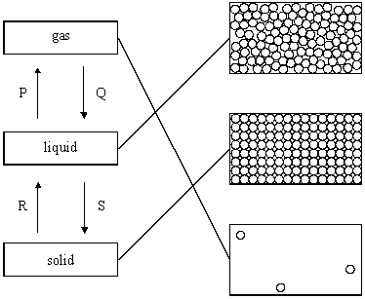
all three lines must be correct for the mark
1 (L6)
(ii) evaporation: P
1 (L5)
melting: R
1 (L5)
(b) (i) liquid
1 (L6)
(ii) carbon
1 (L6)
hydrogen
1 (L6)
(iii) carbon dioxide
accept ‘CO₂’
accept ‘carbon monoxide’ or ‘CO’
accept ‘carbon’ or ‘soot’
answers must be in the correct order
1 (L6)
[7]
M12. (a) (i) 4
1 (L4)
(ii) water
accept H₂O
1 (L3)
gas
accept ‘carbon dioxide’ or ‘CO₂’
answers may be in either order
1 (L3)
(b) solvent
if more than one box is ticked, award no mark
1 (L4)
[4]
M13. (a) (i) five circles not touching and randomly arranged
accept at least three circles
accept pairs of similar atoms
1 (L6)
(ii) they are closer
do not accept ‘they move faster’; ‘they are close’
1 (L6)
(b) greater than
accept ‘greater’
1 (L6)
M14. (a) (i) • 52
accept ‘40+12’
1 (L3)
(ii) • liquid into a solid
both states are required for the mark
1 (L3)
M15. (a) (i) • (molecules) are far apart or not touching each other
accept ‘only gases can be compressed’
‘the gas can be compressed’ is insufficient
as it is given in the question
accept ‘they are randomly arranged’
1 (L7)
(ii) • there is only one type of molecule
or compound or substance
accept ‘there is one type of particle’
do not accept ‘there is only one type of atom or element’
1 (L7)
(b) any one from
• the space or distance between the molecules or particles is smaller
accept ‘the volume is less’
accept ‘atoms’ for ‘particles’
• the particles or they are closer together
• more particles are touching the sides
accept ‘particles hit the sides more often’
‘the particles are hitting the sides’ is insufficient
‘if the gas is compressed the pressure rises’ is insufficient
1 (L7)
(c) (i) any one from
• new or different compounds have formed
accept ‘they are now joined in threes’
accept ‘new combinations of particles or atoms’
• there is more than one compound
accept ‘the compounds are different’
accept ‘there is no longer a pure substance’
1 (L7)
(ii) any one from
• the same number of atoms are present
accept ‘mass is conserved’
‘the mass stays the same’ is insufficient
• nothing has been added to or lost
‘the same atoms are present’ is insufficient
‘nothing changed’ is insufficient
‘the amount of gas stays the same’ is insufficient
1 (L7)
M17. (a) (i) • mercury
accept ‘Hg’
1 (L5)
(ii) • iron
accept ‘Fe’
1 (L5)
(iii) • mercury
accept ‘Hg’
1 (L6)
(iv) • aluminium
accept ‘Al’
1 (L6)
(b) (i) • an arrow drawn at 0°C
accept any unambiguous indication
1 (L5)
(ii) • gas
if more than one box is ticked, award no mark
1 (L6)
(iii) • liquid
if more than one box is ticked, award no mark
1 (L6)
[7]
M18. (a) (i) 200 g
1 (L3)
(ii) it decreased
accept ‘it went down’
1 (L3)
(iii) any one from
• the mass stayed the same or constant
‘the graph or line is flat’ is insufficient
• it does not go down on day 7
accept ‘it is the same on day 7’
‘it stays the same’ is insufficient
1 (L4)
(b) any one from
• it is flammable
accept ‘it is inflammable’
‘it explodes’ is insufficient
• it catches fire (easily)
accept ‘it will burn’
‘do not put it near the fire’ is insufficient
accept ‘it is a fire hazard’
1 (L4)
(c) it dissolves
if more than one box is ticked, award no mark
1 (L4)
(d) it evaporated
if more than one box is ticked, award no mark
1 (L4)
[6]

