Sec1 Sci C7c EQ 2010 to 1995 Acids and Alkalis 70marks TestB 7E
Q1. pH paper is used to show whether a solution is acidic, neutral or alkaline.
One type of pH paper shows the following range of colours.

colour of pH paper | red | orange | yellow | green | blue | purple
pH value | 0 - 4 | 5 | 6 | 7 | 8 - 10 | 11 - 14

Some solutions were tested with pH Paper. The results are shown below.
(a) Complete the following table by placing a tick in the correct column for each substance.
substance | colour of pH paper | acidic | neutral | alkaline
orange juice | red
egg white | blue
oven cleaner | purple
milk | yellow
4 marks
(b) Which substance was the most alkaline?
.....................................................................................................................
1 mark
(c) Equal amounts of egg white and milk are mixed. What is the most likely pH of the mixture?
Tick the correct box.
pH2 pH6 pH7 pH14
1 mark
Q2. (a) Vinegar is sometimes put on chips. It has a sharp, sour taste.
What does the taste tell you about vinegar?
Tick the correct box.
It contains salt.
It contains sugar.
It is an acid.
It has turned bad.
1 mark
(b) Washing soda crystals react with acid to give off carbon dioxide.
If you added some washing soda crystals to vinegar,what would you see happening?
.....................................................................................................................
1 mark

(c) Red cabbage can be used to test for acids and alkalis. It is bright red in acids and purple in alkalis.
(i) What colour is it in lemon juice?
.............................................................................................................
1 mark
(ii) Complete the sentence below.
Substances which change colour when you add acid or alkali are
called ..............................
1 mark
(d) The labels have fallen off two bottles. The labels say ‘Distilled Water’ and ‘Sulphuric Acid’.
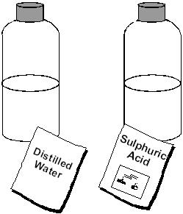
(i) Why should you not taste the liquids to see which is which?
.............................................................................................................
.............................................................................................................
1 mark
(ii) You can use some washing soda crystals to find out what is in each bottle. Describe what you would do and what you would see in each case.
.............................................................................................................
.............................................................................................................
.............................................................................................................
.............................................................................................................
2 marks
Maximum 7 marks
Q3. (a) Neutral litmus paper is:
purple in neutral solutions;
red in acids;
blue in alkalis.
Use this information to answer the questions.
(i) A piece of neutral litmus paper turned red in some grapefruit juice. What does this show about the grapefruit juice?
.............................................................................................................
1 mark
(ii) Gwen added drops of sodium hydroxide solution to the grapefruit juice. The litmus paper soon turned blue. What does the blue colour show about the sodium hydroxide solution?
.............................................................................................................
1 mark
(iii) Gwen then tested some water with a new piece of neutral litmus paper. The pH of the water was 7. What colour was the litmus paper in the water.
.............................................................................................................
1 mark
(b) What name is given to the reaction between an acid and an alkali?
Tick the correct box.
distillation
neutralisation
precipitation
separation
1 mark
Maximum 4 marks
Q4. Dilute acids react with many things.
Tick the four boxes by the correct descriptions.
Tick no more than four boxes.
Acids always dissolve glass.
Acids can be burned as fuels.
Acids damage teeth.
Acids react with metals such as magnesium.
Acids turn universal indicator solution blue.
Acids may harm your skin.
Acids react with limestone.
Acids are always poisonous.
4 marks
Q5. The chart is taken from a bottle of Johnson’s pH5.5 Facial Wash.
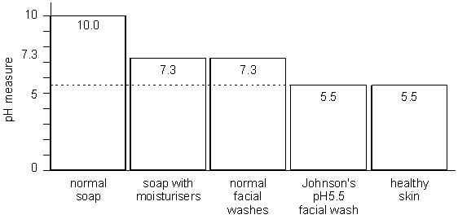
(a) From the information in the chart give:
(i) a substance which is almost neutral.
.............................................................................................................
1 mark
(ii) the substance which is most alkaline.
.............................................................................................................
1 mark
(b) Tick one box to describe Johnson’s facial wash.

It is very alkaline.
It is slightly alkaline.
It is neutral.
It is slightly acidic.
1 mark
(c) A bee sting is acidic. Which one of the substances given in the chart would be best to neutralise the sting?
....................................................................................................................
1 mark
Q6. The table below gives information about four gases. It shows the volume of each gas that will dissolve in 1000 cm³ of water at two different temperatures.
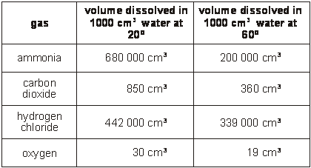
Use the information in the table to answer the following questions.
(a) (i) Which one of the four gases is the most soluble at 60°C?
.............................................................................................................
1 mark
(ii) Which one of the four gases is the least soluble at 20°C?
.............................................................................................................
1 mark
(b) How does a rise in temperature affect the amount of gas which will dissolve?
......................................................................................................................
......................................................................................................................
1 mark

(c) The table below shows the pH of a solution of each of the four gases.
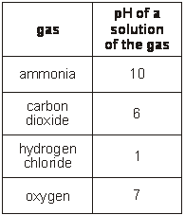
Which gas dissolves in water to form:
(i) an acid? ..............................................................................................
1 mark
(ii) an alkali? ............................................................................................
1 mark
(iii) a neutral solution? ..............................................................................
1 mark
Q7. Owen used litmus paper to find out if six different liquids were acidic, alkaline or neutral. He dipped pieces of litmus paper into each liquid.
He wrote some of his results in the table below. Complete the table of results.
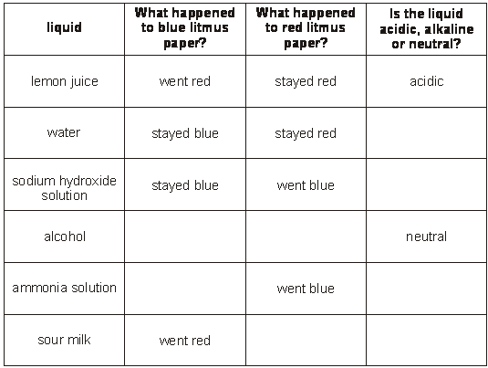
5 marks

Q8. The table shows the pH of five soil samples.
soil sample | pH of soil
A | 6.0
B | 7.5
C | 7.0
D | 4.5
E | 8.0

Use letters from the table to answer questions (a), (b) and (c).
(a) Which soil sample is neutral? ............................
1 mark
(b) (i) Most types of heather grow better in acidic soil.
In which of the soil samples should heather grow well? .........................
1 mark
(ii) Cabbage grows better in alkaline soil. In which
of the soil samples should cabbage grow well? ......................................
1 mark
(c) Lime is an alkaline substance which is sometimes put onto acidic soils.
What type of reaction takes place between the lime and the acid?
.............................................................
1 mark
Maximum 4 marks
Q9. (a) Sunil picked yellow, red and purple primula flowers from his garden.
He dipped the different flower petals into water and into two different solutions.
The pH of one solution was 1 and the pH of the other was 10.
The table shows the results.
colour of  flower petals | in solutions of  pH 1 | in water  pH 7 | in solution of  pH 10
yellow | stayed yellow | stayed yellow | stayed yellow
red | stayed red | stayed red | turned green
purple | turned pink | stayed purple | turned blue

Which colour of flower petal would be most useful to make an indicator for both acids and alkalis? Explain your answer.
......................................................................................................................
......................................................................................................................
......................................................................................................................
2 marks

Sunil crushed petals from each flower separately in some liquid and poured off the coloured solutions. Then he put drops of each coloured solution into the middle of different pieces of filter paper.
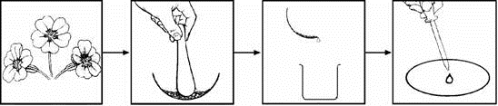
The solutions spread out on the filter paper. The diagrams show his results.
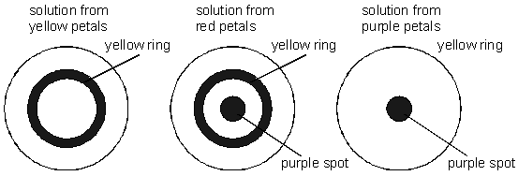
(b) What is the name of this method of investigating coloured substances?
..................................................................
1 mark
(c) Sunil made notes on his experiment. Some words are missing.
Complete the sentences.
When I crushed a flower in a liquid it produced a coloured solution.
This is because a coloured substance had ......................……….. in the
liquid. This shows that the liquid is a .............................................. for these
coloured substances.
My experiment shows that one of the flowers probably contained two
coloured substances. This was the ......................……….. flower.

3 marks

Q10. (a) Many chemicals are dangerous if not used carefully.
Read the two hazard descriptions. Look at the hazard labels.
Draw a line from each description to the correct label.
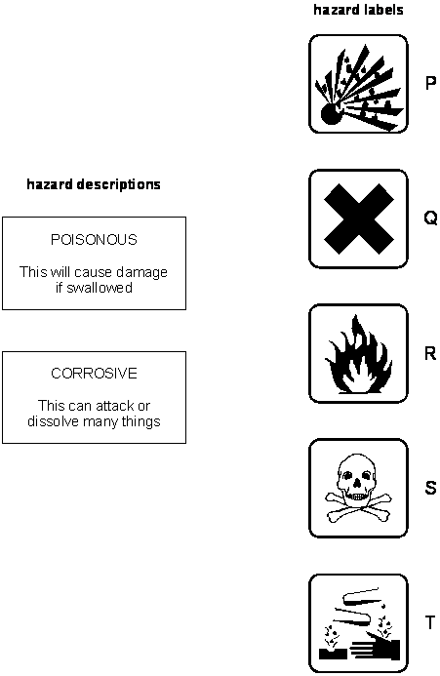
2 marks
(b) The label on a bottle of kitchen cleaner says:
It leaves kitchen and bathroom surfaces bright and shiny.
Another part of the label says:
Contains sulphamic acid
Irritating to eyes and skin
Keep out of reach of children
(i) The chart shows the colour of universal indicator in different solutions.
type of solution | strongly acidic | weakly acidic | neutral | weakly alkaline | strongly alkaline
colour of universal indicator | red | orange | green | blue | purple

What colour will the kitchen cleaner turn universal indicator?
..................................................................……….
1 mark
(ii) Which hazard label do you expect to see on the bottle?
Write the correct letter from the list above.
............................................…
1 mark
Q13. Water from red cabbage can be used to find out if a liquid is acidic, alkaline or neutral.

Type of liquid added to  the cabbage water | colour of  the cabbage water
acidic | red
alkaline | blue
neutral | purple

John added three different liquids to the cabbage water.
(a) Use the information above to complete the table below.

Liquid added to the  cabbage water | colour of  the cabbage water | Is the liquid  acidic, alkaline or  neutral?
water | purple
lemon juice |  | acidic
washing up liquid | blue

3 marks
(b) What word describes chemicals which change colour in acids or alkalis?
Tick the correct box.
filters indicators
liquids solids
1 mark
Q14. The diagrams show two different types of apparatus for measuring volumes of liquid.
Each piece of apparatus contains some dilute hydrochloric acid.
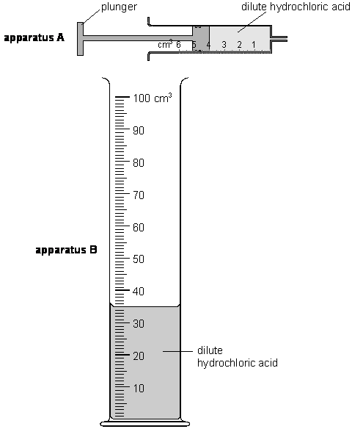
not to scale
(a) What is the name of apparatus B?
……………………………………………………………………………………….
1 mark
(b) What is the volume of dilute hydrochloric acid in:
(i) apparatus A? …………..….. cm³
1 mark
(ii) apparatus B? ..…………….. cm³
1 mark
(c) (i) Wayne wants to add exactly 3 cm³ of dilute hydrochloric acid to some chalk in a beaker.
How can he remove exactly 3 cm³ of the acid from apparatus A?
…………………………………………………………………………………
…………………………………………………………………………………
2 marks
(ii) Wayne adds the acid to the chalk. He sees bubbles.
Which two things does this show? Tick two boxes.
A gas is produced. |  | Chalk is a gas.
Chalk is an acid. |  | The acid reacts with the chalk.
The acid is boiling.
2 marks
Q15. Bees and wasps are both insects which use a sting as part of their defence.
The pH values of their stings are shown on the diagrams.
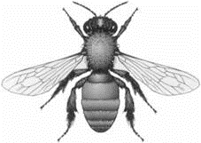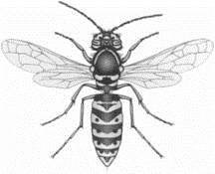
bee wasp
bee sting, pH 2 wasp sting, pH 10
(a) Complete the table below to show whether the stings are acidic or alkaline and what colour they would turn universal indicator paper.
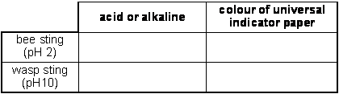
2 marks

(b) The table below shows five household substances and the pH of each substance
name of substance | pH of substance
bicarbonate toothpaste | 8
lemon juice | 3
vinegar | 4
washing soda | 11
water | 7

Give the name of one substance in the table which would neutralise each sting.
(i) bee sting .............................................................................................
1 mark
(ii) wasp sting ...........................................................................................
1 mark
Q17. Ben put a beaker weighing 50 g on a balance. He added 50 g of dilute hydrochloric acid and
2.5 g of calcium carbonate to the beaker.
The total mass of the beaker and its contents was 102.5 g.
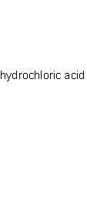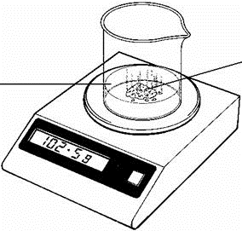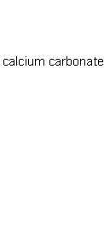
(a) The hydrochloric acid reacted with the calcium carbonate. How could Ben tell that a chemical reaction was taking place in the beaker?
.....................................................................................................................
1 mark
(b) The word equation for the reaction which took place is:
hydrochloric  acid | + | calcium  carbonate |  | calcium  chloride | + | carbon  dioxide | + | water

When the reaction stopped, the total mass had decreased from 102.5 g to 101.4 g.
Some water had evaporated from the beaker.What else caused the drop in mass?
Use the word equation to help you answer the question.
.....................................................................................................................
1 mark
(c) When the reaction stopped, Ben tested the contents of the beaker with universal indicator paper. The calcium carbonate had neutralised the acid. What is the colour of universal indicator paper in a neutral solution?
..........................................
1 mark
(d) Which two materials in the list below are mainly calcium carbonate?
Tick the two correct boxes.
coal
glass
limestone
marble
sandstone
2 marks
(e) Metals react with acids.
What gas is produced when a metal reacts with an acid?
.....................................................
1 mark
Maximum 6 marks

Q18. The pH scale shown below is used to measure how acidic or alkaline a solution is.
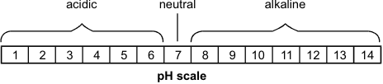
The graph below shows how the pH of the liquid in Barry's mouth changed as he ate a meal.
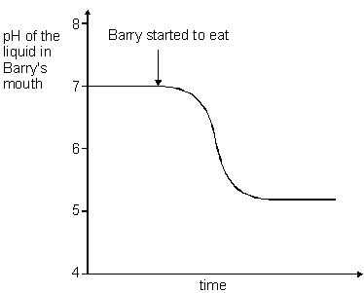
(a) (i) Use the graph to give the pH of the liquid in Barry's mouth before he started to eat.
pH ..................
1 mark
(ii) What does this pH tell you about the liquid in Barry's mouth before he started to eat?
Use the pH scale above to help you.
Tick the correct box.
It was acidic. It was alkaline. It was colourless. It was neutral.
1 mark
(b) Look at the graph above.
What happened to the pH of the liquid in Barry's mouth as he ate the meal?
.....................................................................................................................
1 mark
(c) Barry chews special chewing gum after each meal. The chewing gum neutralises the liquid in his mouth.
What type of substance neutralises an acid?
Tick the correct box.
an acid an alkali
an indicator a solid
1 mark
Maximum 4 marks
Q19. A pupil used a sensor to record the change in pH of 10 cm³ of an acid solution when an alkali solution was added a little at a time. The concentrations of the alkali and acid solutions were fixed.
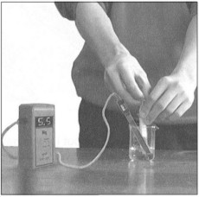

His results are shown in the table below.
volume of alkali added (cm³) | pH of resulting mixture
0.0 | 5.0
2.0 | 5.0
4.0 | 5.0
6.0 | 5.5
8.0 | 6.0
10.0 | 7.0
12.0 | 8.0
14.0 | 8.5
16.0 | 9.0
18.0 | 9.0
20.0 | 9.0
(a) Use his results to draw a graph on the grid below.
• Label the axes.
• Plot the points.
• Draw a smooth curve.
4 marks
(b) Look at the graph.
What would be the likely pH of the solution if the pupil added a further 2 cm³ of alkali solution?
...............
1 mark
Q20. Hydrochloric acid is a strong acid.
(a) Winston used universal indicator solution to find the pH of some hydrochloric acid.
(i) Suggest the colour of the mixture of universal indicator solution and the hydrochloric acid.
...........................................................
1 mark
(ii) Suggest the pH of the hydrochloric acid.
...............
1 mark
(b) Indigestion can be caused when too much hydrochloric acid is produced in the stomach.
Magnesium carbonate can be used to treat indigestion.
Winston crushed some indigestion tablets containing magnesium carbonate. He added them to hydrochloric acid in a test-tube. The mixture fizzed.
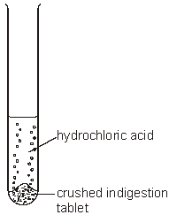
The word equation for the reaction is shown below.
magnesium + hydrochloric → magnesium + carbon + water
carbonate acid chloride dioxide
(i) Use the word equation to explain why the mixture fizzed when the reaction took place.
.............................................................................................................
.............................................................................................................
1 mark
(ii) Winston continued to add crushed tablets to the acid until the mixture stopped fizzing.
Why did the fizzing stop?
.............................................................................................................
.............................................................................................................
1 mark
(c) When magnesium carbonate reacts with hydrochloric acid, magnesium chloride is formed.
Which two words describe magnesium chloride?
Tick the two correct boxes.
a compound a mixture
an element a salt
a metal a solvent
2 marks

(d) It is important that the hydrochloric acid in the stomach is not completely neutralised by indigestion tablets.
Why is hydrochloric acid needed in the stomach?
.....................................................................................................................
.....................................................................................................................
1 mark
Q21. A scientist compared the acidity of four gases to see which gas might cause acid rain.
She used four balloons to collect the gases.
She then bubbled the gases, in turn, through a fresh sample of green, neutral,
universal indicator solution.
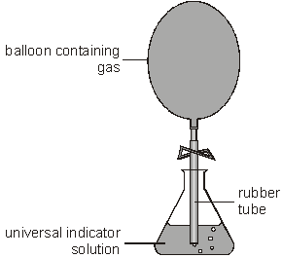
(a) Three of the gases caused the indicator to change colour.
The scientist added drops of alkali to the indicator until the indicator changed back to green.
Her results are shown in the table below.
gases  collected | change in colour  of indicator | number of drops of alkali needed to change the indicator back to green
exhaust gases  from a car | green to red | 31
carbon dioxide | green to red | 160
air | no change | 0
human breath | green to yellow | 10

Use information in the table to answer part (i) and part (ii) below.
(i) Which gas dissolved to form the most acidic solution?
...........................................................
Explain your choice.
.............................................................................................................
1 mark
(ii) Which gas formed a neutral solution?
...........................................................
Explain your choice.
.............................................................................................................
1 mark
(iii) What effect does an alkali have on an acid?
.............................................................................................................
1 mark
(b) Some metals react with acids in the air.
Complete the word equation for the reaction between zinc and hydrochloric acid.
zinc + hydrochloric → ........................................ + ........................................
acid
2 marks
Q22. Molly used a pH sensor to test different liquids. She dipped the probe of the sensor
into each liquid and recorded the pH value in a table.
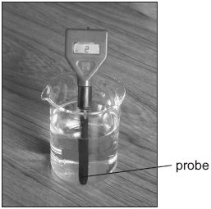
(a) In the table below, tick one box for each liquid to show whether it is acidic,
neutral or alkaline. One has been done for you.

liquid | pH value | acidic | neutral | alkaline
alcohol | 7
dilute hydrochloric acid | 2
distilled water | 7
vinegar | 3
sodium hydroxide solution | 11

2 marks
(b) Between each test Molly dipped the probe into distilled water.
(i) Why did she do this?
.............................................................................................................
1 mark
(ii) Which other liquid in the table could Molly use between tests to have the
same effect as distilled water?
.............................................................................................................
1 mark
(c) Molly put a piece of magnesium into a test-tube containing 20 cm³ of vinegar.
She put another piece of magnesium into a test-tube containing 20 cm³ of dilute
hydrochloric acid.
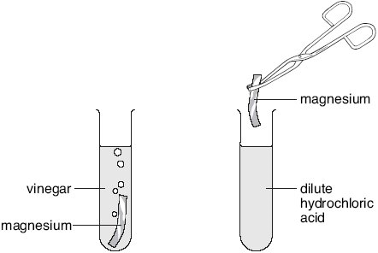
(i) Molly thought that magnesium would react more vigorously with
hydrochloric acid than with vinegar.
What information in the table made Molly think this?
.............................................................................................................
.............................................................................................................
1 mark
(ii) How would Molly be able to tell if a more vigorous reaction took place with
hydrochloric acid than with vinegar?
.............................................................................................................
.............................................................................................................
1 mark
(d) (i) Complete the word equation for the reaction between magnesium and
hydrochloric acid.
magnesium + hydrochloric → .................................. + ........................
acid
2 marks
(ii) After some time this reaction stopped. Why did the reaction stop?
.............................................................................................................
.............................................................................................................
1 mark
maximum 9 marks

Q23. Table 1 below shows the colour of universal indicator in acidic, neutral and alkaline
solutions.

 | acidic |  |  | neutral | alkaline
colour of indicator | red | orange | yellow | green | blue | dark  blue | purple
table 1
Ramy tested different liquids with the indicator solution.
His results are shown in table 2 below.

liquid | colour of indicator solution
Milk | green
lemonade | orange
water | green
fruit juice | red
washing-up liquid | blue

table 2
(a) Use Ramy’s results to answer the following questions.
(i) Give the name of one acidic liquid in table 2.
.............................................................................................................
1 mark
(ii) Give the name of one neutral liquid in table 2.
.............................................................................................................
1 mark
(b) Ramy dissolved some bicarbonate of soda in distilled water.
This produced an alkaline solution.
(i) Ramy added the indicator to the alkaline solution.
Suggest what colour the indicator became.
Use table 1 to help you.
................................................................
1 mark

(ii) Ramy added lemon juice to the solution of bicarbonate of soda.
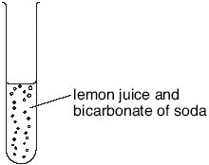
How could he tell that a gas was produced?
.............................................................................................................
1 mark
(c) Ramy mixed an acid with an alkali and tested the mixture with the indicator
solution.
The indicator solution turned green.
What is the name of the reaction between an acid and an alkali?
Tick the correct box.
condensation
crystallisation
evaporation
neutralisation
1 mark
maximum 5 marks
Q25. The word equation for the reaction between magnesium carbonate and hydrochloric
acid is shown below.
magnesium + hydrochloric → magnesium + carbon + water
carbonate acid chloride dioxide
(a) Sadiq added hydrochloric acid to magnesium carbonate in a flask.
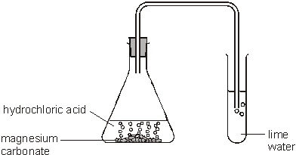
(i) Suggest the pH of hydrochloric acid.
..................

(ii) The carbon dioxide produced was bubbled through lime water.
How would the lime water change?
................................................................................................................
2 marks
(c) Sadiq made a model volcano.
He put magnesium carbonate into the model.
He added vinegar and a drop of washing-up liquid.
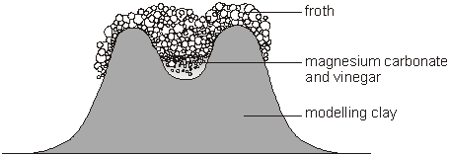
The mixture fizzed, and froth poured out of the model volcano.
(i) The vinegar reacted with the magnesium carbonate.
Suggest the pH of vinegar.
.............
(ii) The froth running down the side of the model represents part of a real
volcano.
Give the name of this part.
..................................................................
2 marks
Q26. Paul had four substances:
He dissolved 1 g of each substance in 20 cm³ of distilled water.
He used universal indicator to find the pH of each solution.
(a) (i) Sugar solution does not change the colour of green universal indicator.
What does this tell you about sugar solution?
Tick the correct box.
It is an acid. It is an alkali.
It is neutral. It is sweet.
1 mark
(ii) Suggest the pH of citric acid.
............
1 mark

(iii) Indigestion tablets neutralise acid in the stomach.
What does this tell you about indigestion tablets?
...............................................................................................................
1 mark
(b) Complete the flow chart below with the names of the substances in the boxes.
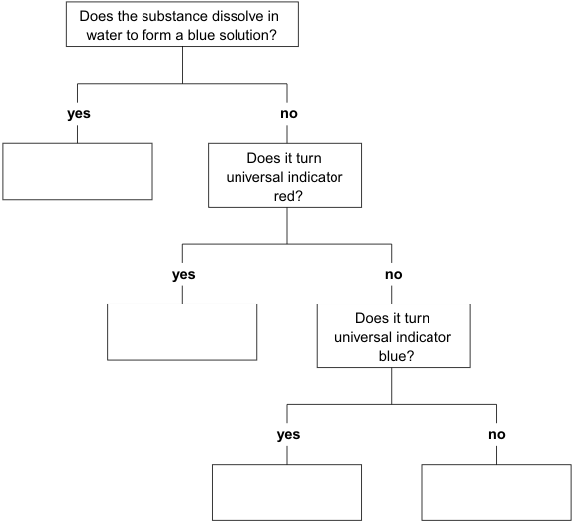
3 marks
Q27. (a) The chemical formula for hydrochloric acid is HCl.
The chemical formula for sodium hydroxide is NaOH.
When they react together, two products are formed.
The chemical formula for one product is NaCl.
(i) Complete the word equation below with the names of both products.
1 mark
(ii) On the dotted line, give the chemical formula of the other product.
sodium + hydrochloric _______________ + _______________
hydroxide acid
NaOH HCl NaCl ...............
2 marks

(b) In experiment 1, Molly put two beakers on a balance.
One contained 20 cm³ of hydrochloric acid.
The other contained 20 cm³ of sodium hydroxide solution.
The total mass was 163.5 g.
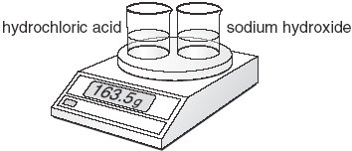
She poured the acid onto the sodium hydroxide. They reacted.
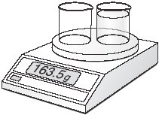
Why did the reading on the balance not change?
........................................................................................................................
........................................................................................................................
1 mark
(c) In experiment 2, Molly put two beakers on a balance.
One contained 20 cm³ of hydrochloric acid.
The other contained 5 g of sodium carbonate.
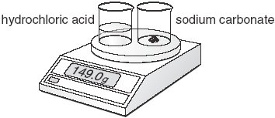
She poured the acid onto the sodium carbonate. They reacted. Two of the products are the same as in experiment 1.
(i) Complete the word equation with the names of the three products.
sodium + hydrochloric → .......................... + .......................... + ..........................
carbonate acid
1 mark
(ii) The total mass at the start was 149.0 g.
When the reaction stopped, the reading on the balance was 147.0 g.
Why was there a loss of mass in this reaction?
...............................................................................................................
1 mark

Q28. (a) The table below shows the pH of four acidic liquids.

acidic liquid | pH
grapefruit juice | 3.1
ethanoic acid | 3.0
lemonade | 4.4
dilute hydrochloric acid | 1.0

Which of these liquids is the least acidic?
1 mark
(b) Emilio cooked an egg until it was hard-boiled.
He put the egg in a beaker of dilute hydrochloric acid as shown.
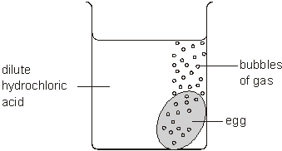
(i) The egg shell reacted completely with the acid.
After two days the pH of the liquid in the beaker was 2.5.
How did the acidity of the liquid in the beaker change?
Use the table above to help you.
..................................................
1 mark
(ii) Emilio put another hard-boiled egg in some ethanoic acid.
It took longer for the shell to react completely.
Use the table opposite to suggest a reason for this.
...............................................................................................................
...............................................................................................................
1 mark
(c) The chemical formulae for four acids are shown in the table below.
sulphuric acid | hydrochloric acid | nitric acid | ethanoic acid
H₂SO₄ | HCl | HNO₃ | CH₃COOH

(i) Give the name of the element that is present in all four acids.
..................................................
1 mark

(ii) Give the names of the two other elements present in sulphuric acid.
1. ................................................
1 mark
2. ................................................
1 mark
(iii) How many atoms are there in the formula HNO₃ (nitric acid)?
...................
1 mark
Q29. Michelle added some universal indicator solution to four liquids.
Michelle uses the pH chart to fill in her table of results.
pH chart
pH | 1 | 2 | 3 | 4 | 5 | 6 | 7 | 8 | 9 | 10 | 11 | 12 | 13 | 14
colour | red |  |  | orange |  |  | green | blue |  |  | purple

(a) The table below shows some of Michelle’s results.
Complete Michelle’s table of results below.
Use the pH chart to help you.
liquid | colour of universal indicator solution | pH
milk | green
rain water |  | 5
hydrochloric acid | red
bleach |  | 11
2 marks
(b) Explain why using acids can be dangerous.
........................................................................................................................
........................................................................................................................
1 mark

(c) Michelle measured the pH of some milk stored at room temperature for five days.
The graph of Michelle’s results is shown below.
One of the axes has been labelled.
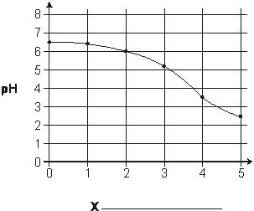
1 mark
(i) Write the axis label for the graph at X.
(ii) Use the graph. How does the pH of the milk change over the five days?
...............................................................................................................
1 mark
maximum 5 marks

M1. (a)
substance | acidic | neutral | alkaline
orange juice | *
egg white |  |  | *
oven cleaner |  |  | *
milk | *

if more than one box is ticked in any row
award no mark for that row
do not accept a tick in ‘neutral’
4
(b) oven cleaner
1
(c) pH7
1
[6]
M2. (a) It is an acid
if more than one box is ticked, award no mark
1 (L3)
(b) bubbling
accept ‘fizzing’ or ‘froth’ or ‘effervescence’
or ‘gas given off’ or ‘carbon dioxide given off’
do not accept ‘a reaction’
1 (L3)
(c) (i) red or bright red
1 (L3)
(ii) indicators
1 (L3)
(d) (i) acid can be poisonous or burn or is dangerous or harmful
accept ‘it makes you ill’ or ‘it is corrosive’
or ‘because it might be acid’
do not accept ‘it will kill you’
1 (L4)
(ii) the answer should refer to the use of washing soda crystals
with both liquids
any one from
• pour some of the liquid from each bottle onto the washing soda
• add washing soda to a sample from each bottle
do not accept ‘ add washing soda to each bottle’
1 (L4)
any one from
• one bubbles and one does not
accept ‘one of them bubbles’
• one gives off carbon dioxide and one does not
accept ‘one of them gives off carbon dioxide’
• the acid bubbles or gives off carbon dioxide
do not accept ‘it bubbles’ or ‘it gives off carbon dioxide’
• the water does not bubble or give off carbon dioxide
1 (L4)
[7]
M3. (a) (i) acid or acidic
accept ‘has acid in it’
do not accept ‘more acid than alkali’
1 (L3)
(ii) alkali or alkaline
accept ‘it neutralises acid’
do not accept ‘turns the acid into an alkali’
1 (L3)
(iii) purple
1 (L3)
(b) neutralisation
if more than one box is ticked, award no mark
1 (L4)
[4]
M4. Acids damage teeth
1 (L4)
Acids react with metals such as magnesium
1 (L4)
Acids may harm your skin.
1 (L4)
Acids react with limestone.
1 (L4)
i.e. ticks in the third, forth, sixth and seventh boxes
if more than four boxes are ticked, deduct one mark
for each incorrectly ticked box
minimum mark zero
[4]
-
M5. (a) (i) any one from
• soap with moisturisers
do not accept ‘soap’ or ‘pH 7.3’
• normal facial wash
1 (L5)
(ii) normal soap
do not accept ‘soap’ or ‘pH 10.0’
1 (L5)
(b) It is slightly acidic.
if more than one box is ticked award no mark
1 (L5)
(c) normal soap
do not accept ‘soap’ or pH 10.0’
1 (L5)
[4]
M6. (a) (i) hydrogen chloride
1 (L3)
(ii) oxygen
1 (L3)
(b) less gas will dissolve
accept ‘it gets less’ or ‘lowers it’
do not accept ‘it dissolves less quickly’
1 (L4)
(c) (i) any one from
• carbon dioxide
accept ‘CO₂’
• hydrogen chloride
accept ‘HCl’
1 (L4)
(ii) ammonia
accept ‘NH₃’
1 (L4)
(iii) oxygen
accept ‘O₂’
do not accept ‘O’’
1 (L4)
[6]
M7.
liquid | what happened to blue litmus paper? | what happened to red litmus paper? | is the liquid acidic, alkaline or neutral?
lemon juice | went red | stayed red | acidic
water | stayed blue | stayed red | neutral |  | 1
sodium  hydroxide  solution | stayed blue | went blue | alkaline |  | 1
alchohl | stayed blue | stayed red | neutral | both answers are  required for the mark | 1
ammonia  solution | stayed blue | went blue | alkaline | both answers are required for the mark | 1
sour milk | went red | stayed red | acidic | both answers are required for the mark | 1

(L4)
accept ‘blue’ or ‘did not change’ for stayed blue
accept ‘red’ or ‘did not change’ for stayed red
accept ‘alkali’ for alkaline
accept ‘acid’ for acidic
do not accept ‘went blue’ for stayed blue
do not accept ‘went red’ for stayed red
[5]
M8. (a) C
1 (L5)
(b) (i) A or D
1 (L5)
(ii) B or E
1 (L5)
(c) neutralisation
1 (L5)
[4]
M9. (a) purple
1
any one from
• it changes colour in both acids and alkalis
do not accept ‘it changes colour in acids’
or ‘it changes colour in alkalis’
• it goes pink in acid or pH1 and blue in alkaline or pH10
1
(b) chromatography
1
(c) dissolved
answers must be in the correct order
do not accept ‘made a solution’
1
solvent
1
red
accept ‘second’
1
[6]
M10. (a)
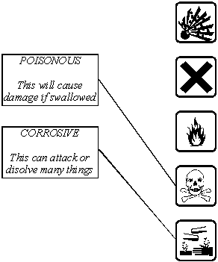
award one mark for each correct line if more than one
line has been drawn from a hazard description box,
award no mark for any of the lines from that box.
2
(b) (i) red or orange
accept ‘yellow’
1
(ii) Q
accept a drawing of the correct hazard label
accept ‘X’
accept ‘T’
1
[4]
M11. (a) any one from
• amylase is denatured or destroyed
• enzymes work best at the right pH
accept ‘enzymes only work at the right pH’
do not accept ‘enzymes do not work at this pH’
do not accept ‘amylase does not work at this pH’
do not accept ‘amylase is killed at that pH’
1
(b) (i) an alkali
accept ‘strongly or weakly alkaline’
1
(ii) neutralisation
do not accept ‘digestion’
1
(c) (i) any one from
• blood sugar level does not rise as high after eating pasta
accept ‘blood sugar is lower’
do not accept ‘there is not as much starch in pasta’
• amount of insulin produced is related to the blood sugar level
1
(ii) 0.9 mg/cm³
accept answers from 0.8 mg/cm³ to 1.0 mg/cm³
the unit is required for the mark
1
[5]
M12. (a) in tube B: no oxygen
1 (L5)
in tube C: no water or water vapour
accept ‘no air’
accept ‘no moisture’
accept ‘it was dry’ or ‘it was not wet’
1 (L5)
(b) (i) acidic
1 (L5)
(ii) hydrogen
1 (L6)
(c) (i) it increased or it was more
accept ‘it was heavier’
1 (L6)
(ii) any one from
• oxygen or water was added
• the oxygen has mass
• rust contains iron and oxygen or water
accept ‘rust is iron oxide’
• the iron reacted with oxygen or water
1 (L6)
(d) Answers must refer to either test-tube D or to sea water.
any one from
• the nail was more rusty in D than in A
accept ‘D was the only one which was rusty’
accept ‘D was very rusty’
• it was more rusty in sea water
• sea water contains salt
1 (L6)
[7]
M13. (a)
Liquid added to the cabbage water | Colour of the cabbage water | Is the liquid acidic, alkaline or neutral?
water | purple | neutral
lemon juice | red | acidic
washing up liquid | blue | alkaline

3 (L4)
(b) indicators
if more than one box is ticked, award no mark
1 (L3)
[4]
M14. (a) measuring cylinder
1 (L3)
(b) (i) 4
1 (L3)
(ii) 35
1 (L3)
(c) (i) push the plunger in
accept ‘squeeze the syringe’
do not accept a reference to pouring
1 (L3)
until it reads 1.0 cm³
accept ‘to 1’
award two marks for ‘remove 1 cm³
and push the rest into a beaker’
1 (L4)
(ii) A gas is produced.
1 (L3)
The acid reacts with the chalk.
if more than two boxes are ticked,
deduct one mark for each incorrect tick
1 (L3)
[7]
M15. (a)
 | acidic or alkaline | colour of universal indicator paper
bee sting  (pH2) | acidic | red
wasp sting  (pH10) | alkaline | blue  accept ‘purple’

award one mark for each correct row
2 (L5)
(b) (i) any one from
• bicarbonate toothpaste
accept ‘bicarbonate’ or ‘toothpaste’
or ‘hydrogencarbonate’
• washing soda
1 (L5)
(ii) any one from
• vinegar
• lemon juice
1 (L5)
[4]
M16. (a) cast iron
do not accept ‘4.5’
1 (L3)
(b) (i) 0.8
1 (L4)
(ii) high carbon steel
1 (L4)
(c) (i) any one from
• for buildings
accept any other reasonable answer, for
• for bridges
example ‘street lights’ or ‘fence posts’
1 (L4)
(ii) any one from
• oxygen
accept ‘air’
• water
accept ‘moisture’
1 (L4)
[5]
M17. (a) any one from
• it would be fizzing
• there would be effervescence
• bubbles would be given off
accept ‘gas or carbon dioxide would be given off’
accept ‘there was a rise in temperature’
accept ‘there was a loss of mass’
1 (L5)
(b) any one from
• carbon dioxide was lost
accept ‘carbon dioxide was produced’
accept ‘gas was given off’
• the carbon dioxide had mass
accept ‘the gas also weighed something’
1 (L6)
(c) green
1 (L5)
(d) limestone
1 (L6)
marble
if more than two boxes are ticked,
deduct one mark for each incorrect tick
minimum mark zero
1 (L6)
(e) hydrogen
1 (L6)
[6]
M18. (a) (i) 7
do not accept ‘neutral’
1 (L3)
(ii) it was neutral
if more than one box is ticked, award no mark
consequential marking applies
accept ‘it was acidic’ if the answer to part (i) was less than 7
accept ‘it was alkaline’ if the answer to part (i) was greater
than 7 and up to 14
1 (L4)
(b) any one from
• it decreased or went down
accept ‘it dropped to 5’
• it became acidic or more acidic
1 (L3)
(c) an alkali
if more than one box is ticked, award no mark
1 (L4)
[4]
M19. (a) • volume or alkali in cm³ on the x axis and pH of mixture on the y axis
pupils can gain credit for correct responses to other
parts if the axes are wrongly labelled
1 (L7)
• appropriate scales for volume of alkali and pH of mixture
this mark cannot be awarded for a non- linear scale
1 (L7)
• 11 points correctly plotted
1 (L7)
smooth curve of best fit
do not accept a line drawn from point to point
1 (L7)
(b) 9.0
accept ‘9’
1 (L6)
[5]
M20. (a) (i) red or pink
accept ‘orange’ or ‘yellow’
1 (L5)
(ii) any number greater than 0 and smaller than 7
accept ‘0’
1 (L6)
(b) (i) carbon dioxide is gas
accept ‘carbon dioxide or a gas is produced’
1 (L5)
(ii) any one from
• no more carbon dioxide or gas was produced
• the reaction stopped
• all the hydrochloric acid was used up
accept ‘the acid had been neutralised’
do not accept ‘all the magnesium carbonate was used up’
• there was an excess of magnesium carbonate or carbonate
1 (L6)
(c) a compound
1 (L6)
a salt
if more than two boxes are ticked, deduct one mark for
each incorrect tick
minimum mark zero
1 (L6)
(d) any one from
• without it digestion would stop or slow down
accept ‘to break down food’
• acid is needed for digestion
• the enzymes only work in acid conditions or at a low pH
• it is needed to kill bacteria or microbes
do not accept ‘germs’
1 (L6)
[7]
M21. (a) (i) carbon dioxide
accept ‘CO₂’
any one from
it took more or most alkali to neutralise it
or to change the colour of the indicator back to green
accept ‘it took most drops’ or ‘it took 160’
both the answer and the reason are required for the mark
1 (L5)
(ii) air
it did not change the colour of the indicator or the pH of the solution
accept ‘no drops or alkali were needed’
accept ‘there was no change’
both the answer and the reason are required for the mark
1 (L5)
(iii) any one from
• neutralises it
• it raises the pH
accept ‘it makes it less acidic’
accept ‘it makes it pH 7’
accept ‘it forms a salt’
do not accept ‘makes it more alkaline’
1 (L6)
(b) zinc chloride +
1 (L6)
hydrogen
answers may be in either order
1 (L6)
[5]
M22. (a)
liquid | acidic | neutral | alkaline
alcohol
dilute hydrochloric acid
distilled water
vinegar
sodium hydroxide solution

award one mark for a correct tick for
both alcohol and distilled water
award one mark for a correct tick for
both vinegar and sodium hydroxide solution
if more than one column is ticked for any liquid
award no mark for the corresponding pair of liquids
2 (L5)
(b) (i) any one from
• to clean the probe or it
• to prevent contamination
• to get an accurate reading
• so the liquids do not get mixed up
• it is neutral
accept ‘to neutralise the probe’ or ‘so that it does not
affect the other liquids’ or ’to make it pH 7’
‘to make it a fair test’ is insufficient
1 (L5)
(ii) alcohol
accept ‘the first or top one’
1 (L5)
(c) (i) hydrochloric acid has a lower pH or is more acidic
accept the converse
accept ‘vinegar is a weak acid’
‘vinegar is a weaker acid’ is insufficient
1 (L5)
(ii) any one from
• more bubbles would be given off
accept ‘more bubbles’ or ‘more fizzing’
• bubbles would be given off more rapidly
• there would be a bigger rise in temperature
accept ‘there would be a rise in temperature’
or ‘the test-tube would get hot’
• the magnesium would be used up more quickly
1 (L5)
(d) (i) • magnesium chloride +
1 (L6)
• hydrogen
answers may be in either order
1 (L6)
(ii) any one from
• the acid was used up
accept ‘there were no reactants left’
• the magnesium was used up
accept ‘one of the reactants has been used up’
accept ‘the reaction was complete’
do not accept ‘the magnesium had dissolved’
1 (L6)
[9]
M23. (a) (i) any one from
• lemonade
• fruit juice
accept ‘fruit or juice’
1 (L3)
(ii) any one from
• milk
• water
1 (L3)
(b) (i) any one from
• blue
• dark blue
• purple
1 (L3)
(ii) any one from
• it bubbled
accept ‘it fizzed’
• bubbles were formed
accept ‘bubbles’
accept ‘effervescence’
1 (L3)
(c) neutralisation
if more than one box is ticked, award no mark
1 (L4)
[5]
M24. (a) (i) filtration
if more than one box is ticked, award no mark
1 (L3)
(ii) chromatography
if more than one box is ticked, award no mark
1 (L3)
(b) (i) it is alkaline
accept ‘alkali’
1 (L3)
(ii) red
1 (L3)
(c) indicator
if more than one box is ticked, award no mark
1 (L4)
[5]
M25. (a) (i) • a number less than 7
1 (L5)
(ii) • it would turn milky or cloudy
accept ‘white or chalky’
1 (L6)
(b) • magnesium sulphate
1 (L6)
(c) (i) • a number less than 7
1 (L5)
(ii) • lava
do not accept ‘magma’
1 (L5)
[5]
M26. (a) (i) • It is neutral
if more than one box is ticked, award no mark
1 (L5)
(ii) • any number less than 7
1 (L6)
(iii) any one from
• they are alkaline or an alkali
accept ‘a soluble base’
accept ‘it has a pH above 7’
specific pH values such as ‘its pH is 8.5’ are insufficient
• they react with the acid
1 (L5)
(b) •
accept ‘copper sulfate’
accept ‘the sulphate’ for ‘copper sulphate’
•
accept ‘acid’ for ‘citric acid’
• •
accept ‘tablet’ for ‘indigestion tablet’
if all four answers are correct, award three marks
if two or three answers are correct, award two marks
if one answer is correct, award one mark
3 (L5)
[6]
-
M27. (a) (i) • sodium chloride + • water
accept ‘hydrogen oxide’ for water
answers must be in the correct order
2 (L7)
(ii) • H₂O
1 (L7)
(b) any one from
• the same atoms are present in the reactants and the products
accept ‘mass is conserved’
‘the mass did not change’ is insufficient
‘the particles are the same’ is insufficient
do not accept ‘the molecules are the same’
• no gas was given off
accept ‘nothing was added or lost’
1 (L7)
(c) (i) • sodium chloride
carbon dioxide
water
answers may be in any order
all three answers are required for the mark
1 (L7)
(ii) any one from
• carbon dioxide or gas escapes
‘mass is lost’ is insufficient as it is given in the question
• carbon dioxide is a gas
• one of the products is a gas or escapes
1 (L7)
[6]
M28. (a) lemonade
accept ‘4.4’
1 (L5)
(b) (i) any one from
• it is less acidic
accept ‘it is weaker’
do not accept ‘it has become more alkaline’
accept ‘it decreases’
• its pH has increased
accept ‘it has gone from 1.0 to 2.5’
do not accept ‘it increased’
do not accept ‘the acidity changed by pH 1.5’
1 (L5)
(ii) any one from
• ethanoic acid is less acidic than the hydrochloric acid
accept the converse
‘ethanoic acid is pH 3’ is insufficient
accept ‘it is less acidic’
‘ethanoic acid is weak’ is insufficient
• ethanoic acid has a higher pH
accept ‘partially neutralised’
‘it is weaker’ is insufficient
• it has a pH of 3 compared with 1
• it is a weaker acid
1 (L6)
(c) (i) hydrogen
‘H₂’ or ‘H’ are insufficient
1 (L6)
(ii) • sulphur
1 (L6)
• oxygen
1 (L6)
‘S’ or ‘O’ or ‘O₂’ are insufficient
answers can be in either order
(iii) 5
1 (L6)
[7]
M29. (a) • 7
• orange
• an answer in the range 1–3 accept ‘1–3’
• purple
for all four rows correct, award two marks
for any two or three rows correct, award one mark
answers must be in the correct column and row in the table
2 (L3)
(b) any one from
• they are corrosive
• they burn or irritate
accept ‘they can damage your skin or eyes’
‘‘in case it touches your skin’ is insufficient
it is harmful or poisonous’ is insufficient
‘it can kill you’ is insufficient
‘wear gloves’ is insufficient
do not accept ‘it is flammable’
1 (L4)
(c) (i) • time, in days
accept ‘time’
accept ‘days’
do not accept ‘hours’ or ‘minutes’
1 (L4)
(ii) it goes down or decreases
accept ‘it becomes acidic’
‘it goes red’ is insufficient
accept ‘it goes from 6.5 to 2.5’
accept ‘the acid gets stronger’
‘it goes sour’ is insufficient
if the label for X is incorrect in part (ci),
do not penalise again in part (cii)
1 (L4)
[5]

