Sec1 Sci C7p 2010 to 1995 60marks
Q# 1/ Q2. Magnesium burns in air giving a very bright light.
(a) Complete the word equation below to show this reaction.
magnesium + ............................................. → ...........................................
1 mark
The diagram shows four gas-jars. Each contains a different gas. Burning magnesium is put into each jar.
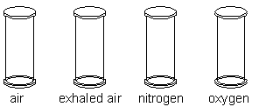
(b) In one of the gas-jars, the magnesium goes out immediately.
Name the gas in this jar.
............................................................
1 mark
Explain your answer.
......................................................................................................................
1 mark
Q# 2/ Q3. Krypton is an element which is a non-metal. Tungsten is an element which is a metal.
(a) The lines show one property of krypton and one property of tungsten. Draw two more lines from each element to its other properties.
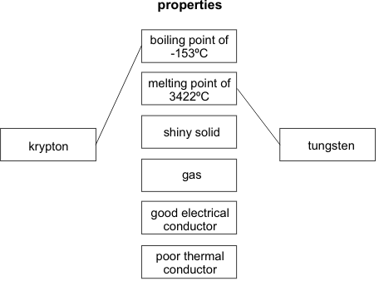
4 marks
(b) The diagram shows a light bulb.
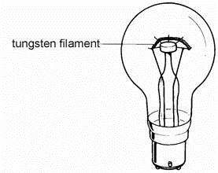
Give two properties which make tungsten a good material for light bulb filaments. Choose from the list of properties above.
1. ..................................................................................................................
2. ..................................................................................................................
2 marks
Q# 3/ Q4. Air is a gas at room temperature. The chemical formulae below show some of the substances in the air.
Ar CO₂ H₂O N₂ Ne O₂
(a) Put these formulae in the correct columns in table A to show which substances are elements and which are compounds.
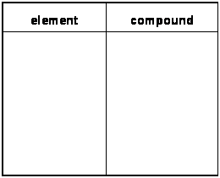
table A

1 mark
(b) Put the formulae in the correct columns in table B to show whether the formula of each substance represents an atom or a molecule.
table B
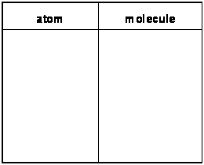
1 mark
(c) The coldest possible temperature is ‘absolute zero’, which is –273°C. As air is cooled towards absolute zero it liquefies. Table C gives the boiling points of the substances in air.
table C
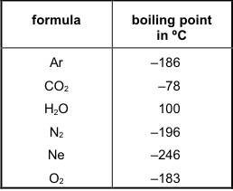
A sample of air at a temperature close to absolute zero is allowed to warm up.
Which substance boils first?
........................................
1 mark
(d) Each particle of neon can be represented by a circle.
Carefully complete the diagrams below to show the arrangement of particles in neon gas and liquid neon.
Use circles about in size.
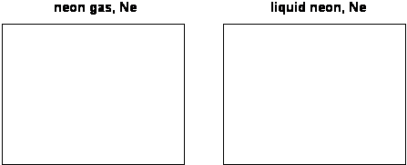
4 marks
Q# 4/ Q5. The table shows the chemical formulae of six minerals which occur naturally.
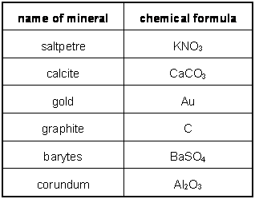
From the table give the name of one mineral which is:
(i) a non-metallic element. ...........................................
1 mark
(ii) a carbonate. ...........................................
1 mark
(iii) a compound containing potassium. ...........................................
1 mark
(iv) an electrical conductor at
room temperature. ............................................
1 mark
Maximum 4 marks
Q# 5/ Q6. The flow chart shows how zinc sulphate can be obtained.
(a) In the reaction zinc oxide → zinc an element is removed from zinc oxide to leave zinc. Give the name of the element.
........................................................
1 mark
Q# 6/ Q7. This question is about four chemical elements.
(a) The melting points and boiling points of the four elements are shown in the table. Complete the table to give the physical state, solid, liquid or gas, of each element at room temperature, 21°C.
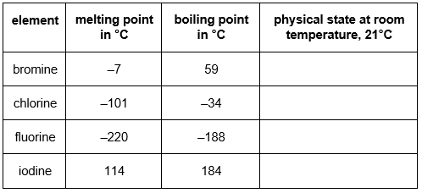
4 marks
(c) Is bromine a solid, a liquid or a gas when the arrangement of particles is:
(i) far apart and random? .......................................................................
1 mark
(ii) close together but random? ...............................................................
1 mark
(iii) close together in a regular pattern? ...................................................
1 mark
Maximum 8 marks
Q# 7/ Q8. The diagrams represent the way 'atoms' are arranged in six chemical substances.
Each 'atom' is represented by a circle. The 'atoms' are labelled with their chemical symbols.
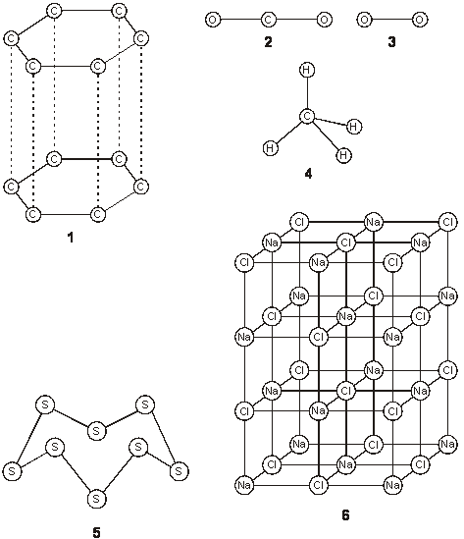
(a) (i) Which diagrams represent the structures of chemical elements?
Write the numbers.
.............................................................................................................
1 mark
(ii) Explain how you made your decision.
.............................................................................................................
1 mark
(b) Give the formulae of two of the compounds represented in the diagrams.
1. .................................................................................................................
2. .................................................................................................................
2 marks
(c) Give the name of substance 6.
......................................................................................................................
1 mark
(d) Give the names of the chemical elements whose atoms can be represented by the following symbols.
C ….………..……….……..…………………………………………………..…
Cl ….………..……….……..…………………………………………………..…
Cu ..………..……….……..…………………………………………………..…..3 marks
Q# 8/ Q9. A section of the periodic table of elements is shown below.
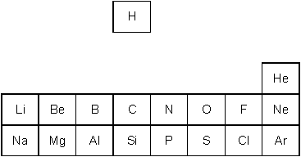
(a) Where in this section of the periodic table are the metals found?
......................................................................................................................
1 mark
(b) Sodium chloride is formed when sodium and chlorine combine together in a chemical reaction.
Write the symbols for sodium and chlorine.
sodium …………………………………..
chlorine …………………………………..
2 marks
(c) The formula for a substance is MgS. What is the name of this substance?
......................................................................................................................
1 mark
(d) Give the name of one element in the table above which is a gas at room temperature and in which the atoms are joined together in molecules.
......................................................................................................................
1 mark
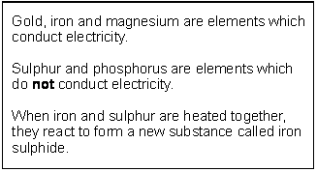
Q# 9/ Q10.
(a) From the substances named above, give:

(i) the name of a metal;
..................................................................
1 mark
(ii) the name of an element which is a non-metal;
.............................................................................................................
1 mark
(iii) the name of an element which will rust;
.............................................................................................................
1 mark
(iv) the name of a compound.
.............................................................................................................
1 mark
(b) When magnesium and sulphur are heated together, they react.
Write the name of the compound which is formed when magnesium reacts with sulphur.
......................................................................................................................
1 mark
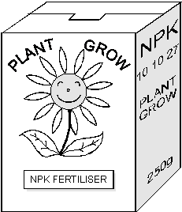
Q# 10/ Q11. The drawing shows the label on a box of fertiliser for houseplants.

(b) Part of the Periodic Table is shown below. The three elements N, P and K shown on the fertiliser label are also shown in the table.
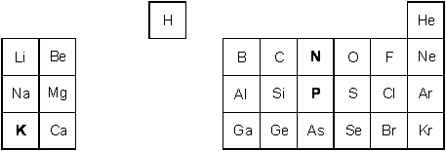
(i) The element N is nitrogen. What are the names of the other two elements?
P ..................................................................……
K ..................................................................……
2 marks
(ii) Give the symbol for the most reactive metal shown in this part of the Periodic Table.
......................……
1 mark
Q# 11/ Q12. The diagrams represent the arrangement of atoms or molecules in four different substances, A, B, C and D.
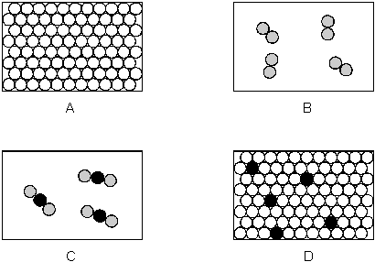
Each of the circles, , and represents an atom of a different element.
(a) (i) Which substance is a compound?
…………
1 mark
(ii) Which substance is a mixture?
…………
1 mark
(iii) Which two substances are elements?
………… and …………
1 mark
(iv) Which two substances could be good thermal conductors?
………… and …………
1 mark
(v) Which substance could be carbon dioxide?
…………
1 mark
(b) The following experiment was set up. Test-tubes containing substances B and C were placed together as shown. The substances did not react.
They were left for five minutes.
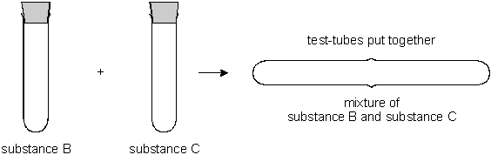
(i) How many molecules are there in the mixture compared to the total number in substances B and C?
……………………………………….……………………………………….
1 mark
(ii) Complete the diagram which is a model of this experiment.
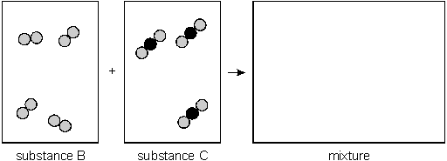
1 mark
Q# 12/ Q13. A Japanese volcano erupted in 1936. Molten sulphur poured out of the volcano.
When it cooled it formed rock sulphur.
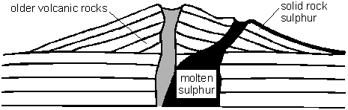
(b) Sulphur is a non-metallic element. It is yellow and melts at 115°C.
Complete the sentences about sulphur.
(i) Sulphur is a poor conductor of
………………………………………
1 mark
(ii) At 115°C sulphur changes from
a …………………………………… into a …………………..……………
2 marks
(c) Sulphur burns in air to form an oxide.
What gas in the air reacts with sulphur when it burns?
………………………………………
1 mark

Mark Scheme Sec1 Sci C7p 2010 to 1995 60marks

Q# 1/ M2. (a) oxygen → magnesium oxide
both parts of the equation are needed
do not accept ‘air’ for oxygen
1
(b) nitrogen
1
the following explanations are only applicable to nitrogen: if any other
answer is given above a mark cannot be awarded for the second part
any one from
• contains no oxygen
accept ‘the other jars all contain oxygen’
• nitrogen is unreactive
accept ‘nitrogen does not support burning’
1
Q# 2/ M3. (a)
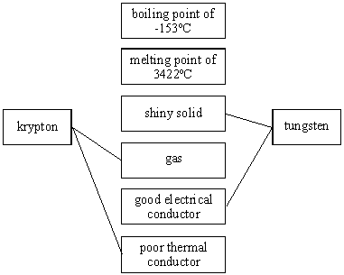
If more than four lines are drawn, deduct one mark
for each incorrect line
minimum mark zero
4 (L4)
(b) answers may only be taken from the list in part (a)
good electrical conductor
1 (L4)
melting point of 3422°C
1 (L4)
answers may be in either order
accept ‘conducts electricity’ or ‘conductor’
accept ‘ high melting point’ or ‘solid at high temperatures’
do not accept ‘good thermal conductor’
[6]
Q# 3/ M4 (a)
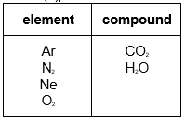
all six formulae are required for the mark
1 (L7)
(b)
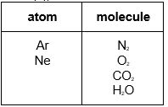
all six formulae are required for the mark
1 (L7)
(c) Ne or neon
1 (L7)
(d) up to ten randomly arranged particles spaced throughout the box
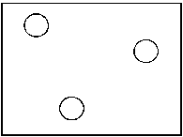
accept just one particle
do not accept an empty box
1 (L7)
most of the particles are not in contact with each other
1 (L7)
the box almost full of particles of neon, more than 50% of which
are touching each other
1 (L7)
the particles are randomly arranged
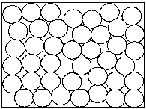
if the level of liquid is drawn then accept the circles
drawn correctly below the liquid level
1 (L7)
Q# 4/ M5. (i) graphite
do not accept ‘C’
1 (L7)
(ii) calcite
do not accept ‘CaCO₃’
1 (L7)
(iii) saltpetre
do not accept ‘KNO₃’
1 (L7)
(iv) gold or graphite
do not accept ‘Au’ or ‘C’
1 (L7)
Q# 5/ M6. (a) oxygen
1 (L6)
Q# 6/ M7. (a)
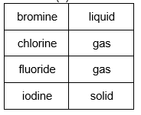
4 (L6)
(c) (i) gas
1 (L6)
(ii) liquid
1 (L6)
(iii) solid
1 (L6)
[8]

Q# 7/ M8. (a) (i) 1
accept ‘C’
3
accept ‘O’
5
accept ‘S’
answers may be in any order
all three answers are required for the mark
1 (L7)
(ii) they contain only one type of atom or symbol or letter
1 (L7)
(b) any two from
• CO₂
accept ‘O₂ C’
• CH₄
accept ‘H₄C’
• NaCl
accept ‘Cl Na’ or ‘Na₁₈Cl₁₈’
do not accept names of compounds
2 (L7)
(c) sodium chloride or salt
do not accept ‘NaCl’
1 (L7)
(d) carbon
1 (L7)
chlorine
do not accept ‘chloride’
1 (L7)
copper
answers must be in the correct order
1 (L7)
[8]

Q# 8/ M9. (a) the three columns on the left hand side
accept ‘the first three columns’ or ‘ on the left’
1 (L7)
(b) Na
1 (L7)
Cl
1 (L7)

(c) magnesium sulphide
do not accept ‘magnesium sulphite’
or ‘magnesium sulphate’
1 (L7)
(d) any one from
• hydrogen
• nitrogen
• oxygen
• fluorine
• chlorine
do not accept symbols
1 (L7)
[5]
Q# 9/ M10. (a) (i) any one from
• gold
• iron
• magnesium
1 (L3)
(ii) any one from
• sulphur
• phosphorus
1 (L4)
(iii) iron
1 (L3)
(iv) iron sulphide
1 (L5)
(b) magnesium sulphide
do not accept ‘magnesium sulphite’
or ‘magnesium sulphate’
1 (L5)
[5]
Q# 10/ M11 (b) (i) P: phosphorus
1
K: potassium
1
(ii) K
do not accept ‘potassium’
1
[4]
Q# 11/ M12. (a) (i) C
1 (L7)
(ii) D
1 (L7)
(iii) A and B
answers may be in either order
both answers are required for the mark
1 (L7)
(iv) A and D
answers may be in either order
both answers are required for the mark
1 (L7)
(v) C
1 (L7)
(b) (i) the same
accept ‘seven’
1 (L7)
(ii) a random, mixed arrangement of both types of molecule should be
drawn with the molecules not touching each other
1 (L7)
[7]

Q# 12/ M13. (b) (i) any one from
• thermal energy
accept ‘heat’ or ‘energy’
• electricity
1 (L3)
(ii) answers may be in either order
• solid
1 (L3)
• liquid
accept ‘fluid’
1 (L3)
(c) oxygen
1 (L4)
[6]

