Sec1 Sci C7p WS Where are some of the elements named after?
The names of the oldest elements were created before modern science, but new elements are still being discovered and the scientists involved have decided on rules for what you can call a new element:
- a mythological concept or character (including an astronomical object),
- a mineral or similar substance,
- a place, or geographical region,
- a property of the element, or
- a scientist.
Today we are going to look at elements named after places and using the information on this page mark on the map using the chemical symbol where each element is named after. Moscovium, Mc, has already been done for you. You will need to use a periodic table to find out many of the elements’ symbols.
Element | Symbol | Continent | Named after this place or geographical region
americium |  | North America | USA
berkelium |  | North America | Berkeley, California, western USA
californium |  | North America | California, western USA
copper |  | Europe | Cyprus (= Cuprum in Latin), an island between Greece and Turkey
erbium |  | Europe | Ytterby, Southern Sweden
francium |  | Europe | France
germanium |  | Europe | Germany
hafnium |  | Europe | Copenhagen, Denmark (Hafnia = Latin name for Copenhagen)
holmium |  | Europe | Stockholm, central Sweden
magnesium |  | Europe | Magnesia, Greece
moscovium, Mc | Mc | Europe | Moscow, Russia
nihonium, Nh | Nh | Asia | Japan
polonium |  | Europe | Discovered in Paris, but named after Poland, homeland of Marie Curie, who discovered it.
ruthenium |  | Europe | Russia (Ruthenia = Latin name for Russia)
strontium |  | Europe | Strontian, Scotland (in the north of the UK)
tennessine, Ts | Ts | North America | Tennessee, central USA
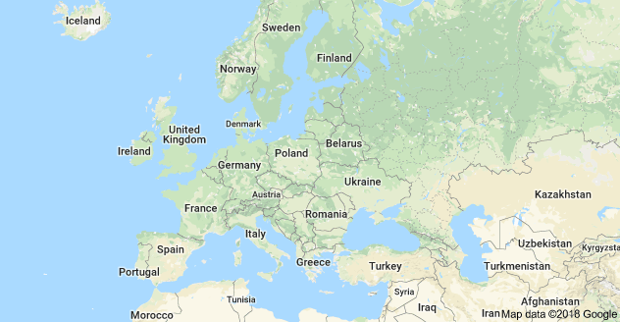

Map of Europe
For elements not named after places in Europe, use a globe to find out where they are exactly.

Label the places on this map that have elements named after them using the correct symbol. Does this map look odd to you?
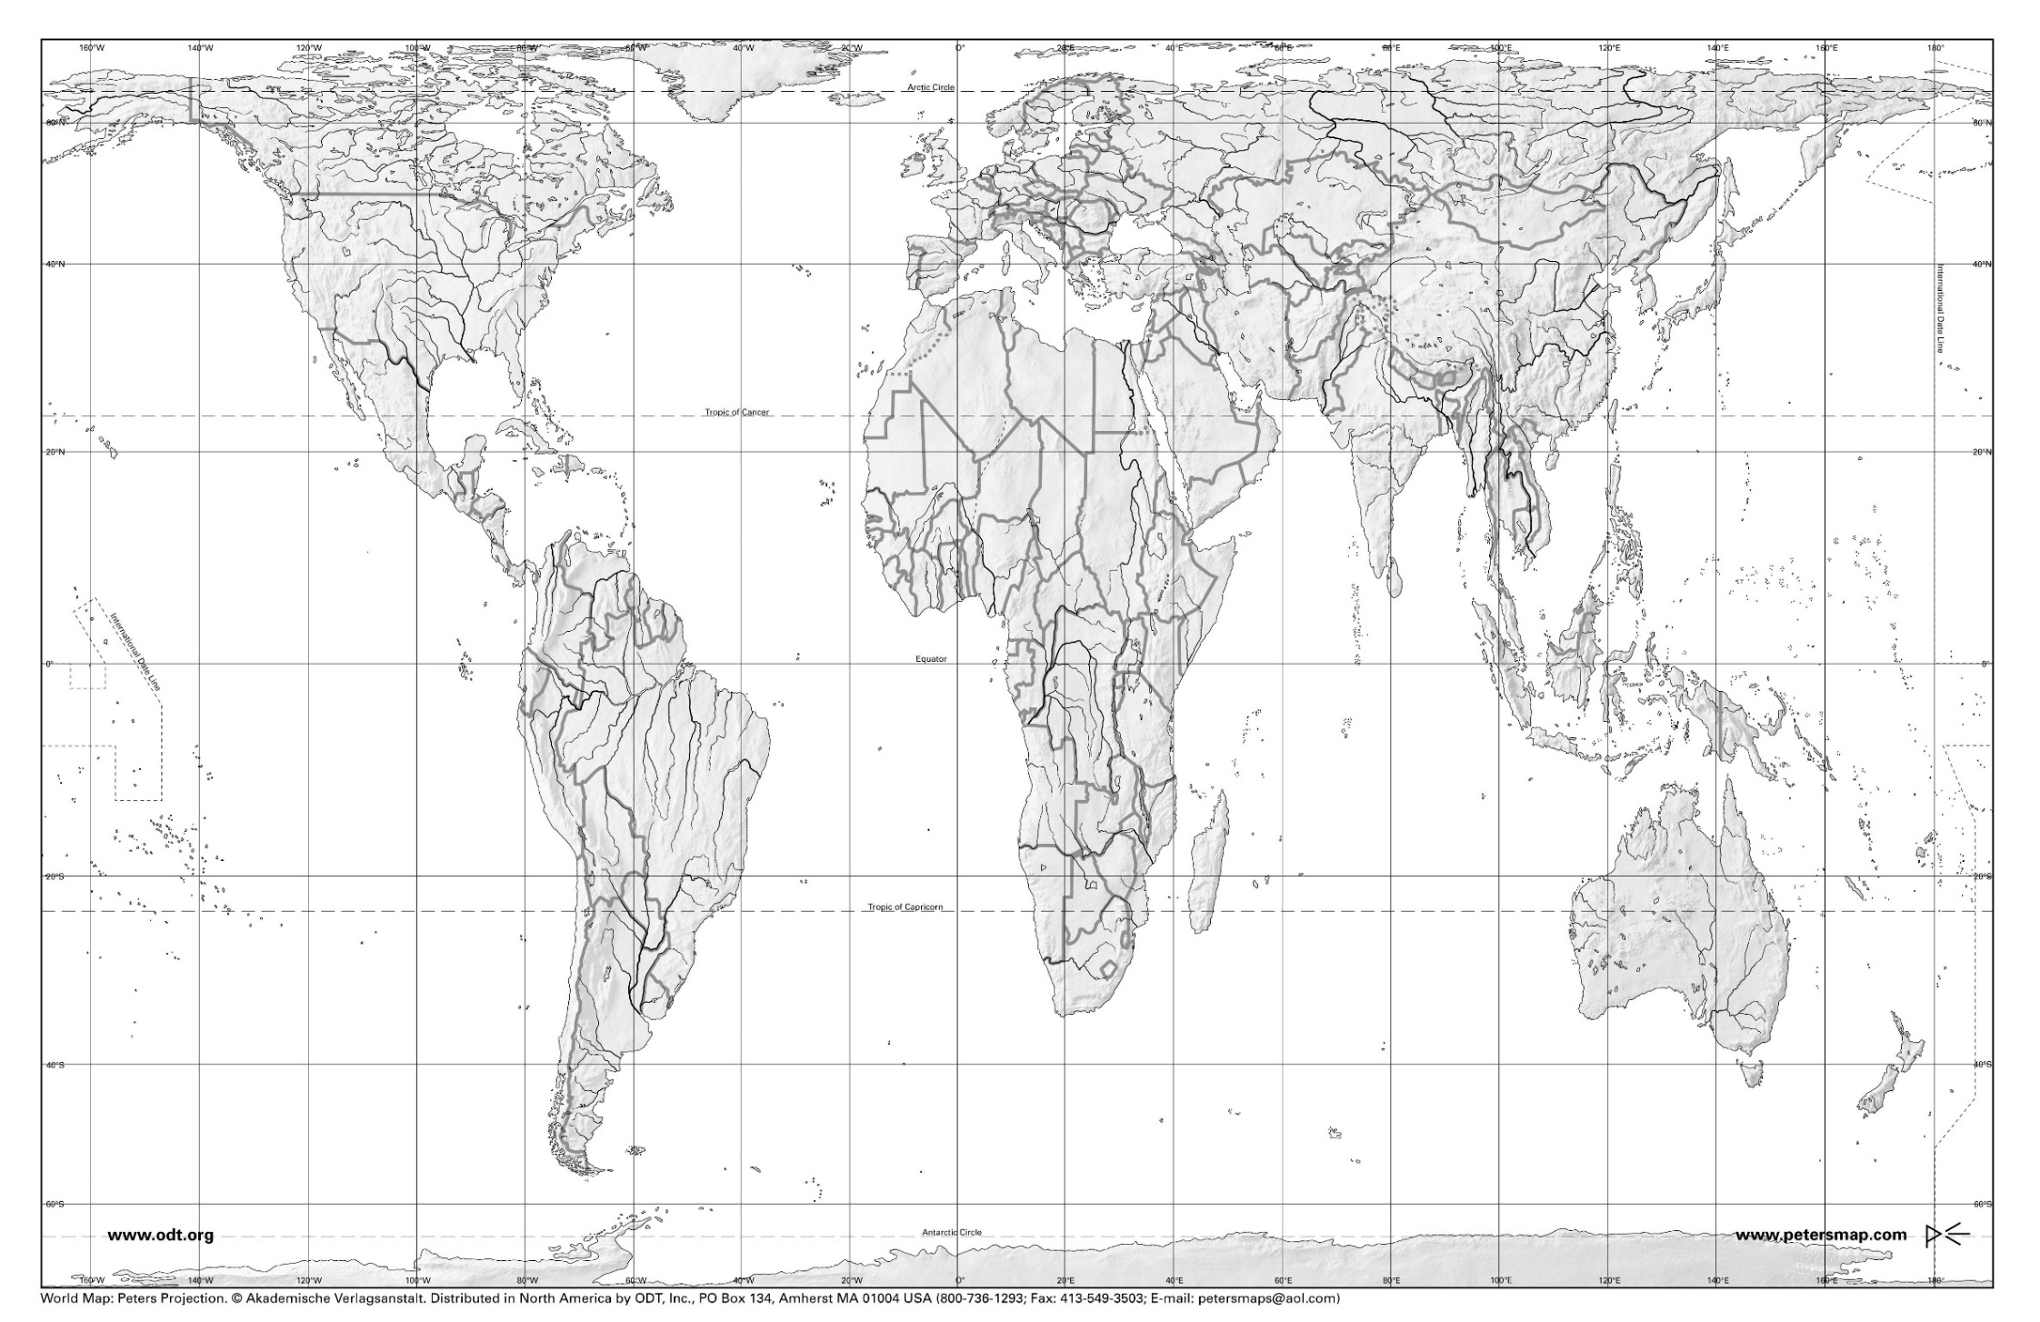
Mc

Check out this website for more information: https://iupac.org/who-we-are/our-history/
Check out this website for more information: https://en.wikipedia.org/wiki/Gall%E2%80%93Peters_projection

