KS3 Sci P7B EQ 1st 39marks
Q# 1/ Q12
(d) The table below gives information about five planets.
planet | distance from the Sun (million km) | time for planet to orbit  the Sun (Earth-years)
Venus | 110 | 0.6
Earth | 150 | 1.0
Mars | 230
Jupiter | 780 | 12.0
Saturn | 1400 | 30.0
(i) Look at the information in the table.
How does the time for a planet to orbit the Sun change with its distance
from the Sun?
...............................................................................................................
1 mark
(ii) Use information in the table to estimate the time for Mars to orbit the Sun.
............. Earth-years
1 mark
Q# 2/ Q13
(b) The table below gives information about three of the planets in our
solar system.
planet | average distance  from Sun  (millions of km) | time for one  orbit  (Earth years) | Average surface  temperature of planet  (ºC)
Saturn | 1427 | 30 | –180
Uranus | 2870 | 84 | –210
Pluto | 5900 | 248 | –230
(i) The time for one orbit of the planet Neptune is 165 Earth years.
Estimate the average distance of Neptune from the Sun.
Use information in the table to help you.
......................... millions of km
1 mark
(ii) How does the surface temperature of these planets vary with
distance from the Sun?
Use information in the table to help you.
.............................................................................................................
1 mark
(iii) Explain why the temperature varies with distance from the Sun in
this way.
.............................................................................................................
1 mark
Q# 3/ Q14. (a) Alfie made a model of part of the solar system.
He used metal balls for the Sun, the Moon and the planets.
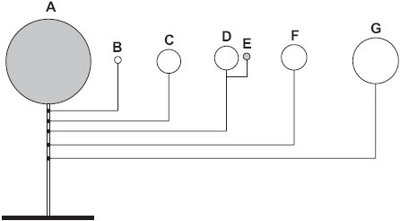
• E goes around D.
• B, C, D, F and G go around A.
Give the letter that is used to label:
(i) the model Sun;
..............
1 mark
(ii) the model Earth;
..............
1 mark
(iii) the model Moon;
..............
1 mark
(iv) the model planet with the largest orbit.
..............
1 mark
(b) The bar chart shows the force of gravity on eight of the planets.
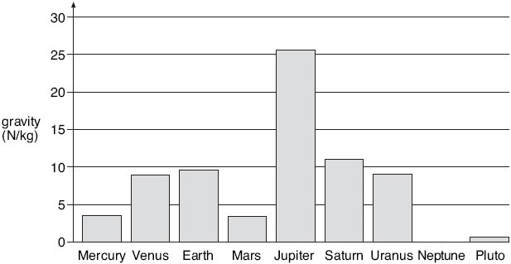
(i) The gravity on Neptune is 12 N/kg.
On the chart above, draw a bar for the planet Neptune.
Use a ruler.
1 mark
(ii) Give the name of a planet where you would weigh more than you weigh on
Earth.
................................................................
1 mark
(iii) On which planet would a spaceship need the largest force to take off?
................................................................
1 mark

Q# 4/ Q3. (a) The diagram below shows the positions of the Sun, Moon and Earth during a solar eclipse.
Write numbers (1–4) on the diagram below to label the features during an eclipse.
1. the Earth
2. the Moon
3. the Sun
4. a region where the total eclipse of the Sun is taking place
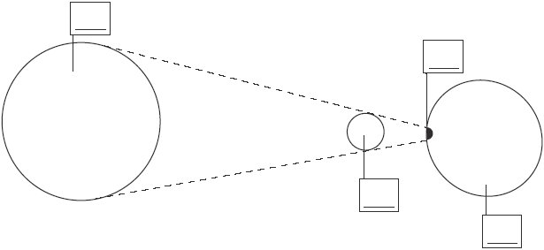
not to scale
2 marks
128
Q# 5/ Q30 On 11th August 1999 there will be an eclipse. The shadow of the Moon will pass over part of the Earth.
(a) The diagram below shows the Moon, the Moon’s shadow and the Earth.
not to scale
On the diagram, draw an arrow pointing towards where the Sun must be.
1 mark
(c) The map shows the shape of the Moon’s shadow and the path it will take across Cornwall.
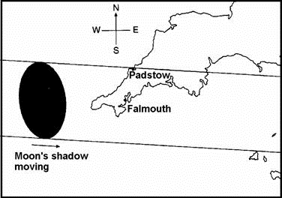
The Moon’s shadow will take about 2 minutes to move across a house in Falmouth. It will take less than 2 minutes to move across a house in Padstow.
Explain why it will take less time for the Moon’s shadow to move across a house in Padstow than to move across one in Falmouth.
......................................................................................................................
1 mark
(d) Why does the Moon’s shadow move over the surface of the Earth?
......................................................................................................................
1 mark
Q# 6/ Q4. The table below shows information about four planets.
planet | time taken to orbit the Sun (Earth years) | distance from the Sun (million km)
Mercury | 0.25 | 60
Venus | 0.5 | 108
Earth | 1.0 | 150
Mars | 2.0 | 228
The diagram below shows the orbits of the Earth, Mercury, Venus and Mars, and their position at one particular time.
The arrows show the direction in which the planets move.
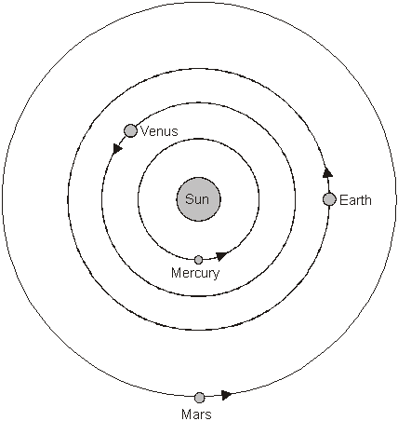
not to scale
(a) Show the position of each planet six months later by drawing a letter X on the orbit of each planet.
2 marks
(b) Use the information in the table to calculate the largest and smallest distance between the Earth and Venus.
closest ............................................ million km
1 mark
furthest ............................................ million km
1 mark
(c) The speed of light is 300 000 km/second.
Calculate how long light takes to reach the Earth from the Sun.
..................................................................................................................... s
1 mark
130
Q# 7/ Q6. The table shows information about three planets in our solar system.
planet | time taken to orbit the  Sun (Earth-years)
Mars | 2.0
Venus | 0.6
Earth | 1.0
(a) Give one reason why Venus takes less time than Earth to orbit the Sun.
........................................................................................................................
........................................................................................................................
1 mark
(b) The diagram below shows the orbits of Venus and Earth.
The Sun is a source of light. Venus does not produce its own light.
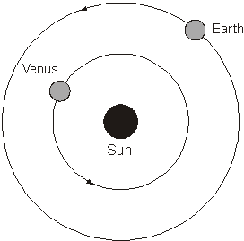
not to scale
On the diagram above, draw rays of light to show how Venus can be seen from
Earth. Use a ruler.
1 mark
Draw an arrow on each ray to show the direction of light.
1 mark

(c) The diagram below shows how the astronomer Ptolemy drew the solar system
2000 years ago.
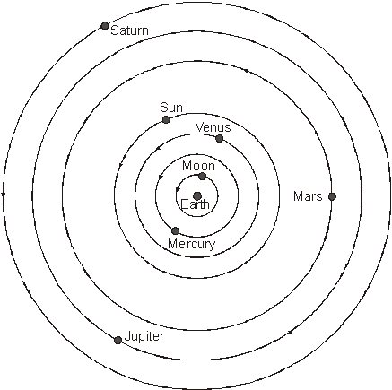
not to scale
(i) The planets Uranus and Neptune are missing from his diagram.
Suggest why Ptolemy did not include these planets in his diagram.
...............................................................................................................
1 mark
(ii) Today we know the correct arrangement of the planets in our solar system.
Give one way the diagram above is incorrect.
Complete the sentence below.
In the correct arrangement ...................................................................
1 mark
Q# 8/ Q7. The diagram below shows the Hubble telescope in orbit around the Earth.
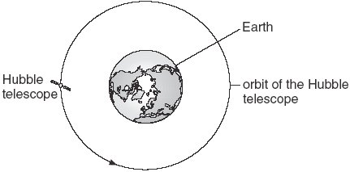
not to scale
(a) Which force keeps the telescope in orbit around the Earth?
Tick the correct box.
air resistance friction
gravity magnetism
1 mark
(b) The Hubble telescope is a satellite used for looking at planets and stars.
Give one other use of satellites.
........................................................................................................................
1 mark
(c) Fill each of the gaps in the following sentences with a different word from the box
below.
absorbs produces reflects
You can see the Sun because it .............................................. light.
You can see a satellite because it ........................................... light.
1 mark
(d) The bar chart shows the size of five planets compared to the size of Earth.
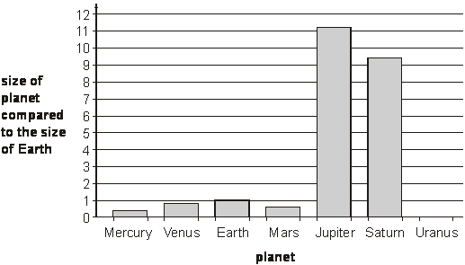
The planet Uranus is four times the size of Earth.
On the chart above, draw a bar for the planet Uranus.
1 mark
(e) (i) Arrange the following in order of size, starting with the smallest.
Sun Hubble telescope Earth
....................................... ...................................... .....................................
smallest largest
1 mark
(ii) Some stars are bigger than the Sun but they look smaller.
Why do they look smaller than the Sun?
Tick the correct box.
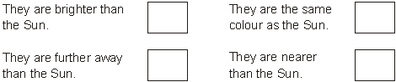
1 mark
maximum 6 marks

Q# 9/ Q8. (a) Sita made a model of three parts of the solar system, the Sun, Earth and Moon.
She used a marble, a torch and a tennis ball.
Draw a line from each part of the solar system to the object she used.
Draw only three lines.
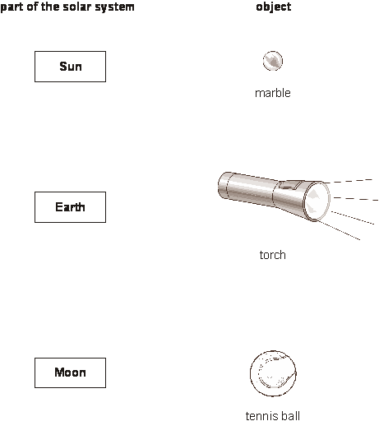
2 marks
(b) The table below shows the order of some of the planets in our solar system.
Complete the table to show the positions of the Earth, Neptune and the Sun.
 | Mercury | Venus |  | Mars | Jupiter | Saturn | Uranus
2 marks
(c) The diagram shows a satellite in orbit around the Earth.
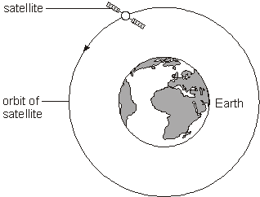
not to scale
(i) Give one use of a satellite.
...................................................................................................................
...................................................................................................................

(ii) Which force keeps the satellite in orbit around the Earth?
Tick the correct box.
gravity friction
air resistance magnetism
2 marks
maximum 6 marks

Mark Scheme

Q# 1/ M12. (d) (i) • the greater the distance
accept ‘it increases’ the greater the time for one orbit
1 (L5)
(ii) • an answer from 1.6 to 6 inclusive
1 (L6)
(e)
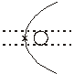
award a mark for X marked on the orbit within the
tolerances shown
1 (L6)
[7]
Q# 2/ M13. (b) (i) a number greater than 2870 and smaller than 5900
1 (L5)
(ii) the further away the lower the temperature
accept the converse
accept ‘the further away the colder it is’
1 (L5)
(iii) any one from
• planets further away receive less energy or heat
accept ‘light’ for energy
do not accept ‘the Sun’s heat cannot reach heat
planets that are far away’
• energy from the Sun spreads out
accept ‘the Sun’s rays are weaker or not as strong’
‘the Sun is weaker’ is insufficient
• less heat reaches the planets that are further away
1 (L6)
[6]
Q# 3/ M14. (a) (i) A
1 (L3)
(ii) D
1 (L3)
(iii) E
1 (L4)
(iv) G
accept ‘Jupiter’
1 (L4)
(b) (i) a bar drawn to 12 N/kg
the top of the bar must be in the middle third between
10 and 15
1 (L4)
(ii) any one from
• Jupiter
• Saturn
• Neptune
1 (L4)
(iii) Jupiter
1 (L4)
[7]
Q# 4/ M3. (a)
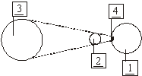
for all four numbers in the correct place, award two marks
for any two or three numbers in the correct place, award one mark
2 (L5)
(b) any one from
• 21st August
• 22nd August
• 23rd August
accept dates written in another format
1 (L5)
• 2017
1 (L5)
[4]
Q# 5/ M30. (a) horizontal arrow pointing to the left
the arrow may be drawn anywhere on the diagram
1 (L5)
(c) any one from
• the part of the shadow which passes over Padstow is narrower
• the part of the shadow which passes over Falmouth is wider or bigger
1 (L5)
(d) any one from
• the Moon moves around the Earth
• the Earth spins on its axis
accept ‘the Earth turns or rotates or goes round’
do not accept ‘the Earth moves around the Sun ‘
or ‘the Earth moves’ or ‘the Sun moves’
1 (L5)
[4]
Q# 6/ M4. (a)
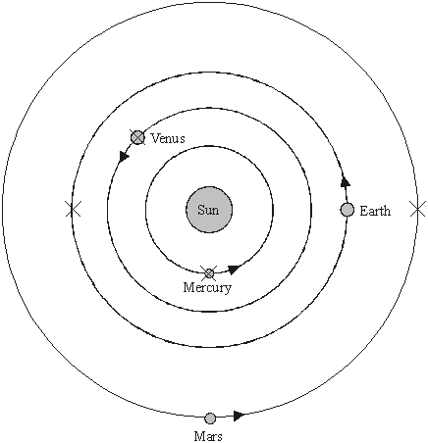
for all four correct, award two marks
for any two or three correct, award one mark
accept a cross drawn that lies within the width
of the Sun for each planet, e.g.
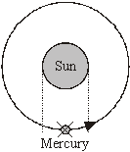
2 (L7)
(b) • 42
accept ‘150-108’
1 (L7)
• 258
accept ‘150+108’
1 (L7)
(c) 500
accept 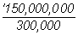 or 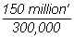
accept ‘8.3 minutes’
accept ‘about 8 minutes’
1 (L7)
Q# 7/ M6. (a) any one from
a comparative statement is needed
• Venus is nearer to the Sun
‘it is closer’ is insufficient
• the Sun’s gravity on Venus is greater
• it travels faster
• it has a smaller orbit
accept ‘it does not have as far to go’
1 (L5)
(b) • a straight line from the Sun to Venus and a straight
line from Venus to Earth
1 (L6)
• arrows drawn on both rays in the correct direction
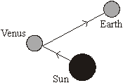
accept two discontinuous straight lines that touch the Sun,
Venus and the Earth
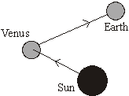
do not accept a line from the Sun which touches the Earth
1 (L6)
(c) (i) any one from
• they had not been discovered
accept ‘he did not know they existed’
• they had not been seen
accept ‘they could not be seen’
do not accept ‘they did not exist’
‘they are too far away’ is insufficient
1 (L5)
(ii) any one from
• the Earth is not at the centre
answers must refer to the arrangement
and not to missing planets
• the planets do not go round the Earth
or the planets orbit the Sun
• the Earth goes round the Sun
• the Sun is in the middle
accept answers which give the correct order
of the planets in the solar system
‘there are more planets’ is insufficient
1 (L6)
[5]
Q# 8/ M7. (a) • gravity
if more than one box is ticked, award no mark
1 (L4)
(b) any one from
• telecommunications
accept ‘communication’
• television or TV
• telephones
accept ‘phone’ or ‘fax’
• radio
• weather
• military or spy observations
• land use observations
• GPS
accept ‘navigation’
• internet
• monitoring or taking pictures of the Earth
‘looking at or taking pictures of planets or stars
or galaxies’ is insufficient as it is given in the question
1 (L4)
(c) • produces
reflects
answers must be in the correct order
both answers are required for the mark
1 (L4)
(d) • a bar drawn to 4
1 (L4)
(e) (i) • Hubble telescope Earth Sun
accept ‘Hubble’ or ‘telescope’ for Hubble telescope
answers must be in the correct order
all three answers are required for the mark
1 (L3)
(ii) • They are further away than the Sun
if more than one box is ticked, award no mark
1 (L3)
[6]
Q# 9/ M8. (a) •
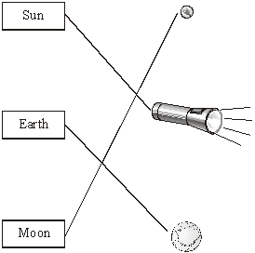
if all three lines are correct, award two marks
if one or two lines are correct, award one mark
if more than one line is drawn from any part of the
solar system, award no credit for that part
2 (L3)
(b) •
Sun Mercury Venus Earth Mars Jupiter Saturn Uranus Neptune
award one mark for the Sun in the correct position
award one mark for both Earth and Neptune in the
correct positions
2 (L3)
(c) (i) any one from
• weather forecasting
accept ‘weather’
• communications
accept ‘phone’ or ‘fax’
• telescopes
• global positioning system
accept ‘GPS’
• TV
• spying
accept ‘taking photographs’
• internet
1 (L4)
(ii) • gravity
if more than one box is ticked, award no mark
1 (L4)
[6]

Chinese Translations (form Google Translate)

Q＃1 / Q12
（d）下表给出了有关五个行星的信息。
行星距离太阳（百万公里）的行星到行星的轨道
太阳（地球年）
金星110 0.6
地球150 1.0
火星230
木星780 12.0
土星1400 30.0
（i）查看表中的资料。
太阳星球的运行时间如何随着距离的变化而变化
从太阳？
................................ ...........
1标记
（ii）使用表格中的信息来估计火星进入太阳轨道的时间。
.....地球年
1标记
Q＃2 / Q13
（b）下表给出了我们三个行星的信息
太阳系。
行星平均距离
来自太阳
（百万公里）时间为一
轨道
（地球年）平均面
行星的温度
（℃）
土星1427 30 -180
天王星2870 84 -210
冥王星5900 248 -230
（i）海王星的一个轨道的时间是165年的地球年。
估算海王星与太阳的平均距离。
使用表格中的信息来帮助您。
数百万公里
1标记
（ii）这些行星的表面温度如何变化
距离太阳？
使用表格中的信息来帮助您。
................................ .........
1标记
（iii）解释为什么温度随着与太阳的距离而变化
这条路。
................................ .........
1标记
Q＃3 / Q14。 （a）Alfie制作了太阳系的一部分模型。
他用金属球为太阳，月球和行星。
•E绕过D.
•B，C，D，F和G绕过A.
给出用于标记的字母：
（i）太阳模型;
..............
1标记
（ii）地球模型;
..............
1标记
（iii）模型月亮;
..............
1标记
（iv）具有最大轨道的模型行星。
..............
1标记
（b）条形图显示了八颗行星的重力。
（i）海王星的重力为12N / kg。
在上面的图表上，为海王星行星绘制一个酒吧。
使用尺子
1标记
（ii）给你一个称重的地球的名字，你的体重比你重
地球。
.................................................. ..............
1标记
（iii）宇宙飞船在哪个星球上需要最大的起飞力？
.................................................. ..............
1标记
Q＃4 / Q3。 （a）下图显示了日食中太阳，月球和地球的位置。
在下图中编写数字（1-4），以便在日食期间标记功能。
地球
月亮
太阳
4.太阳总日食的地区
不规模
2分
128
Q＃5 / Q30 1999年8月11日将有日食。月球的阴影将超过地球的一部分。
（a）下图显示了月球，月球的阴影和地球。
不规模
在图表上，绘制一个指向Sun所在的箭头。
1标记
（c）地图显示了月球阴影的形状及其在康沃尔郡的路径。
月球的影子需要2分钟的时间才能穿过法尔茅斯的一个房子。在Padstow的一个房子内移动不到2分钟。
解释为什么月球的影子需要较少的时间来移动在Padstow的一个房子，而不是在法尔茅斯的一个房子。
................................ ..................
1标记
（d）为什么月球的影子移动到地球表面？
................................ ..................
1标记
Q＃6 / Q4。下表显示有关四个行星的信息。
行星时间被带到太阳（地球年）的距离太阳（百万公里）
汞0.25 60
金星0.5 108
地球1.0 150
火星2.0 228
下图显示了地球，水星，金星和火星的轨道及其在特定时间的位置。
箭头显示行星移动的方向。

不规模
（a）六个月后，通过在每个星球的轨道上画一个字母X，显示每个行星的位置。
2分
（b）使用表格中的信息来计算地球和金星之间最大和最小的距离。
最近............................................百万公里
1标记
最远的............................................百万公里
1标记
（c）光速为30万公里/秒。
计算从太阳到达地球的光量。
................................ .................
1标记
130
Q＃7 / Q6。该表显示了我们太阳系中三颗行星的信息。
行星时间被带到轨道
太阳（地球年）
火星2.0
金星0.6
地球1.0
（a）给出金星比地球少于太阳轨道的原因的一个原因。
................................ ....................
................................ ....................
1标记
（b）下图显示了金星和地球的轨道。
太阳是光源。金星没有自己的光。

不规模
在上图中，画出光线，以显示金星如何被看见
地球。使用尺子
1标记
在每条射线上画一个箭头来显示光线的方向。
1标记
（c）下图显示了托勒密天文学家如何绘制太阳系
2000年前。
不规模
（i）他的图中缺少行星天王星和海王星。
建议为什么托勒密在他的图中不包括这些行星。
................................ ...........
1标记
（ii）今天我们知道太阳系中行星的正确安排。
给出一个方法上图是不正确的。
完成下面的句子。
在正确的安排............................................. .....................
1标记
Q＃8 / Q7。下图显示了在地球轨道上的哈勃望远镜。
不规模
（a）哪个力使望远镜在地球周围轨道上？
勾选正确的框。
空气阻力摩擦
重力磁力
1标记
（b）哈勃望远镜是用于查看行星和星星的卫星。
给另一个使用卫星。
................................ ....................
1标记
（c）填写下列句子中的每个空格，并在框中加上不同的单词
下面。
吸收产生反映
你可以看到太阳，因为它........................................... ...光。
因为它可以看到卫星...........................................光。
1标记
（d）条形图显示与地球大小相比的五个行星的大小。
天王星行星是地球大小的四倍。
在上面的图表上，为天王星行星绘制一个酒吧。
1标记
（e）（i）按照从小到大的顺序排列以下。
太阳哈勃望远镜地球
....................................... ........... ........................... ....................... ..............
最小最大
1标记
（二）有些星星大于太阳，但是它们看起来更小。
为什么他们看起来比太阳小？
勾选正确的框。
1标记
最多6分
Q＃9 / Q8。 （a）Sita制作了太阳系三部分的模型，t
Q＃9 / Q8。 （a）西塔制造了太阳系，太阳，地球和月球三部分的模型。
她用大理石，火炬和网球。
从太阳系的每个部分画出一条线，使用它。
只画三行。
2分
（b）下表列出了太阳系中某些行星的顺序。
完成表格，以显示地球，海王星和太阳的位置。
水星维纳斯火星木星土星天王星
2分
（c）该图显示了围绕地球轨道的卫星。
不规模
（i）使用卫星。
................................ ...............
................................ ...............
（ii）哪种力量使卫星在地球周围轨道运行？
勾选正确的框。
重力摩擦
空气阻力磁性
2分
最多6分
马克计划
Q＃1 / M12。 （d）（i）•距离越大
接受“增加”一个轨道的时间越长
1（L5）
（ii）•从1.6到6的答案
1（L6）
（e）中

奖励在该轨道上标记的X的标记
显示公差
1（L6）
[7]
Q＃2 / M13。 （b）（i）大于2870及小于5900的数字
1（L5）
（ii）越远越低温度
接受相反
接受'越远越冷'
1（L5）
（iii）任何一个
•行星进一步接收较少的能量或热量
接受'光'的能量
不接受“太阳的热量不能达到热量
遥远的行星
•来自太阳的能量传播出来
接受“太阳的光线比较弱”
“太阳较弱”不够
•较少的热量到达更远的行星
1（L6）
[6]
Q＃3 / M14。 （a）（i）A
1（L3）
（ii）D
1（L3）
（iii）E
1（L4）
（iv）G
接受“木星”
1（L4）
（b）（i）拉拔至12 N / kg的条
酒吧的顶部必须在中间的三分之一
10和15
1（L4）
（ii）任何一个
• 木星
•土星
•海王星
1（L4）
（iii）木星
1（L4）
[7]
Q＃4 / M3。 （一个）
对于所有四个数字在正确的地方，奖两个标记
任何两三个数字在正确的地方，奖一个标记
2（L5）
（b）任何一个
•8月21日
•8月22日
•8月23日
接受以其他格式写的日期
1（L5）
•2017年
1（L5）
[4]
Q＃5 / M30。 （a）指向左侧的水平箭头
箭头可以绘制在图表的任何地方
1（L5）
（c）任何一个
•通过Padstow的阴影部分较窄
•通过法尔茅斯的阴影部分越来越大
1（L5）
（d）任何一个
•月球在地球周围移动
•地球在其轴上旋转
接受“地球转动或转动”
不接受“地球绕太阳移动”
或“地球移动”或“太阳移动”
1（L5）
[4]
Q＃6 / M4。 （一个）
对于所有四个正确，奖两个标记
任何两三个正确，奖一个标记
接受位于宽度范围内的交叉画
的太阳对于每个行星，例如
2（L7）
（b）•42
接受'150-108'
1（L7）
•258
接受'150 + 108'
1（L7）
（c）500
接受或
接受'8.3分钟'
接受'约8分钟'
1（L7）
Q＃7 / M6。 （a）任何一个
需要一个比较的声明
•金星更接近太阳
“更接近”是不够的
•太阳在金星上的重力更大
•它行进更快
•它有一个较小的轨道
接受'它没有那么远'
1（L5）
（b）•从太阳到金星和直线的直线
从金星到地球的线
1（L6）
•在正确方向上的两根光线上绘制的箭头
接受触摸太阳的两条不连续的直线，
金星和地球
不要接受触及地球的太阳线
1（L6）
（c）（i）任何一个
•他们没有被发现
接受'他不知道他们存在'
•他们没有被看到
接受'他们看不到'
不接受'他们不存在'
“他们太遥远”是不够的
1（L5）
（ii）任何一个
•地球不在中心
答案必须参考安排
而不是丢失行星
•行星不要绕地球
或行星轨道太阳
• 地球绕着太阳转
•太阳在中间
接受给出正确顺序的答案
的行星在太阳系
“有更多的行星”是不够的
1（L6）
[5]
Q＃8 / M7。 （a）•重力
如果多于一个盒子被勾选，则不予标记
1（L4）
（b）任何一个
•电讯
接受“沟通”
•电视或电视
•电话
接受'电话'或'传真'
•收音机
•天气
•军事或间谍观察
•土地利用观察
• 全球定位系统
接受'导航'
• 互联网
•监测或拍摄地球的照片
看着或拍摄行星或星星
或星系是不够的，因为它在问题中给出
1（L4）
（c）•生产
反映
答案必须在正确的顺序
这两个答案都是标记所必需的
1（L4）
（d）•一个酒吧被吸引到4
1（L4）
（e）（i）•哈勃望远镜地球太阳
为哈勃望远镜接受“哈勃望远镜”或“望远镜”
答案必须在正确的顺序
所有三个答案都是标记所必需的
1（L3）
（ii）•他们远离太阳
如果多于一个盒子被勾选，则不予标记
1（L3）
[6]
Q＃9 / M8。 （一个） •
如果所有的三行都是正确的，那就奖励两个标记
如果一条或两条线是正确的，请给予一个标记
如果从任何部分抽出多条线
太阳能系统，这个部分没有信用
2（L3）
（b）•
太阳水星金星地球火星木星土星天王星海王星
奖励太阳的一个标志在正确的位置
奖励地球和海王星的一个标记
正确的位置
2（L3）
（c）（i）任何一个
• 天气预报
接受'天气'
•通讯
接受'电话'或'传真'
•望远镜
• 全球定位系统
接受'GPS'
•电视
•间谍
接受“拍照”
• 互联网
（ii）•重力
如果多于一个盒子被勾选，则不予标记

