Sec1 Sci P7b WL The Earth & beyond 28word Core Extravaganza!!!

# | English | Chinese | Meaning in English | Meaning in Chinese
1 | Atmosphere | 大气层 | The layer of air above Earth's surface | 地球表面以上的空气层
2 | Big bang | 大爆炸 | The expansion of space which we believe started the Universe | 我们相信宇宙开始扩张的空间
3 | Billions | 数十亿 | A thousand million (1 000 000 000) | 十亿（1 000 000 000）
4 | Day | 天 | 24 hours, the time it takes the Earth to spin once on its axis. | 24小时，地球旋转一圈的时间。
5 | Earth | 地球 | The planet we live on. | 我们居住的星球。
6 | Eclipse | 蚀 | The Sun or Moon is blocked from view on Earth | 太阳或月球从地球上看不到
7 | Equator | 赤道 | An imaginary line around the middle of the Earth. | 围绕地球中部的一条想象线。
8 | Galaxy | 星系 | Billions of stars grouped together. | 数十亿颗恒星组合在一起。
9 | Jupiter | 木星 | The largest outer planet made of gas, fifth from the Sun | 最大的外星球是由太阳制成的第五颗行星
10 | Light sources | 光源 | Objects that emit visible light, also called luminous objects | 发射可见光的物体，也称为发光物体
11 | Milky way | 银河 | The galaxy that our Solar System is in. | 我们的太阳系所在的星系。
12 | Million | 百万 | A thousand thousand (1 000 000) | 一千一百（1 000 000）
13 | Moon | 月亮 | A moon is a large lump of rock orbiting around a planet. The Moon is the moon that orbits the Earth. | 月亮是围绕着一颗行星环绕的大块岩石。月亮是绕地球运行的月球。
14 | Orbit | 轨道 | The path that a planet takes around the Sun, or the path that a moon or satellite takes around a planet. | 行星在太阳附近的路径，或月球或卫星在行星周围的路径。
15 | Planet | 行星 | Any very large body that orbits a star in a solar system | 任何在太阳系中绕着恒星运行的非常大的物体
16 | Pluto | 冥王星 | Used to be regarded as the ninth and last planet from the Sun; now called a dwarf planet together with others of the same size that are beyond its orbit | 曾经被视为来自太阳的第九颗也是最后一颗行星;现在被称为一颗矮行星，以及超出其轨道的其他同样大小的行星
17 | Poles, of earth | 波兰人，地球 | The north and south points of the Earth connected by its axis of tilt | 地球的南北两点通过其倾斜轴相连
18 | Saturn | 土星 | A large outer planet made of gas, sixth from the Sun | 一个大的外星球，由太阳第六个气体组成
19 | Seasons | 四季 | Changes in the climate during the year as the Earth moves around its orbit | 随着地球在轨道上移动，一年中气候的变化
20 | Solar system | 太阳系 | A star with planets and other objects orbiting it. | 星球上有行星和其他物体的轨道。
21 | Star | 星 | A huge ball of gas that gives out heat and light energy. | 一个巨大的气球，发出热量和光能。
22 | Sun | 太阳 | The star that the Earth orbits around. | 地球绕行的恒星。
23 | Telescope | 望远镜 | A device made with lenses that allows distant objects to be seen clearly | 用透镜制成的装置，可以清楚地看到远处的物体
24 | Thousand | 千 | 1 000 | 1 000
25 | Universe | 宇宙 | All the galaxies and the space between them make up the Universe. | 所有的星系和它们之间的空间构成了宇宙。
26 | Uranus | 天王星 | A large outer planet made of gas, seventh from the Sun | 一个巨大的外层行星，由太阳第七个
27 | Venus | 金星 | A rocky inner planet, second from the Sun | 一颗岩石般的内在行星，距太阳第二
28 | Year | 年 | The length of time it takes a planet to go around the Sun. One year on Earth is 365.25 days. | 行星绕太阳行走的时间长度。地球上的一年365.25天。

Sec1 Sci P7b WL The Earth and beyond 28word Core Word Search.pdf - Adobe Acrobat Pro
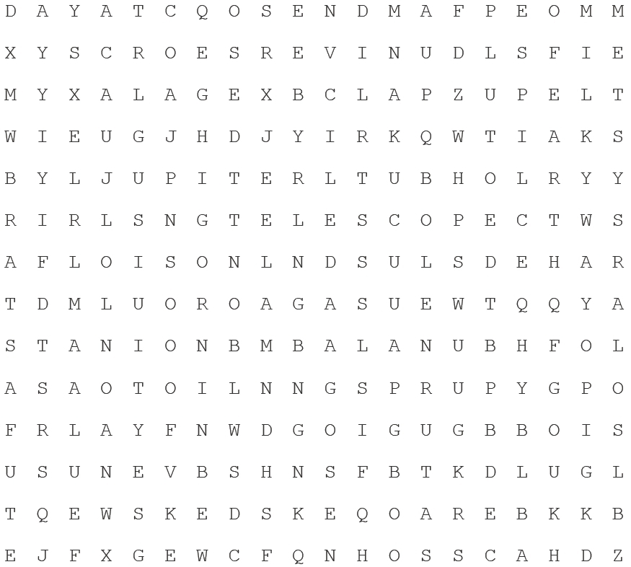

Fill in the missing words for each of these definitions
Circle the words you already knew and did not need to check on the front page
English | Meaning in English
Equator | An imaginary line around the middle of the Earth.
Sun | The star that the Earth orbits around.
Star | A huge ball of gas that gives out heat and light energy.
Jupiter | The largest outer planet made of gas, fifth from the Sun
Day | 24 hours, the time it takes the Earth to spin once on its axis.
Telescope | A device made with lenses that allows distant objects to be seen clearly
Big bang | The expansion of space which we believe started the Universe
Milky way | The galaxy that our Solar System is in.
Atmosphere | The layer of air above Earth's surface
Saturn | A large outer planet made of gas, sixth from the Sun
Billions | A thousand million (1 000 000 000)
Thousand | 1 000
Venus | A rocky inner planet, second from the Sun
Million | A thousand thousand (1 000 000)
Poles, of earth | The north and south points of the Earth connected by its axis of tilt
Galaxy | Billions of stars grouped together.
Eclipse | The Sun or Moon is blocked from view on Earth
Light sources | Objects that emit visible light, also called luminous objects
Uranus | A large outer planet made of gas, seventh from the Sun
Earth | The planet we live on.
Moon | A moon is a large lump of rock orbiting around a planet. The Moon is the moon that orbits the Earth.
Year | The length of time it takes a planet to go around the Sun. One year on Earth is 365.25 days.
Planet | Any very large body that orbits a star in a solar system
Seasons | Changes in the climate during the year as the Earth moves around its orbit
Universe | All the galaxies and the space between them make up the Universe.
Pluto | Used to be regarded as the ninth and last planet from the Sun; now called a dwarf planet together with others of the same size that are beyond its orbit
Orbit | The path that a planet takes around the Sun, or the path that a moon or satellite takes around a planet.
Solar system | A star with planets and other objects orbiting it.
Sec1 Sci P7b WL The Earth and beyond 28word Core Matching Quizlet.pdf - Adobe Acrobat Pro

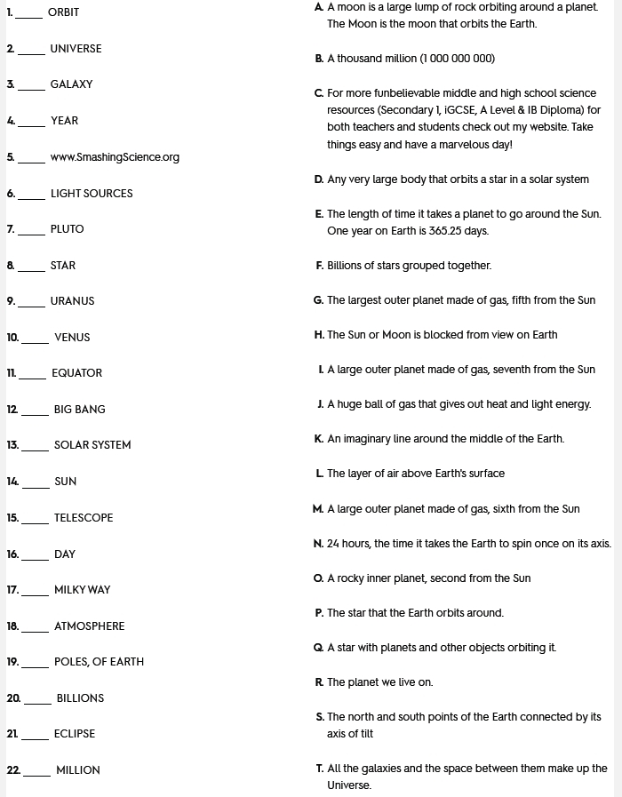
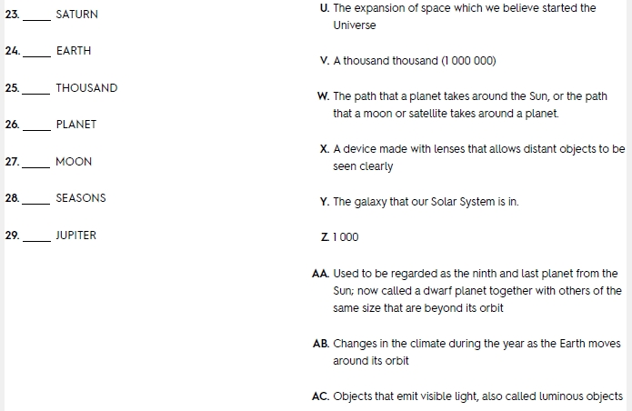
Sec1 Sci P7b WL The Earth and beyond 28word Core MCQ Quizlet.pdf - Adobe Acrobat Pro
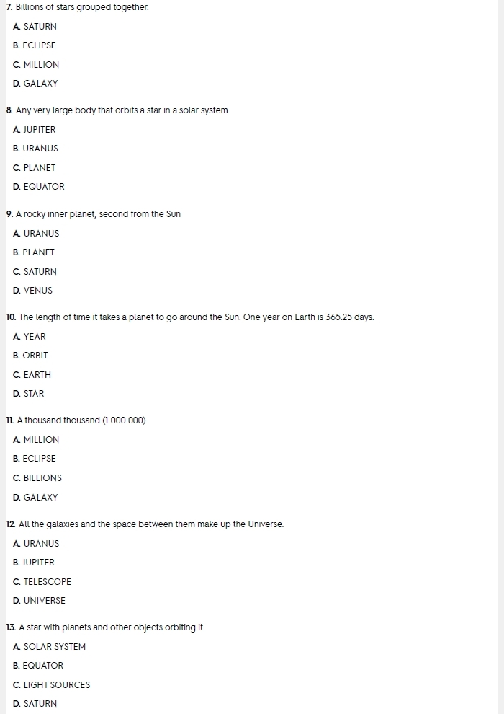
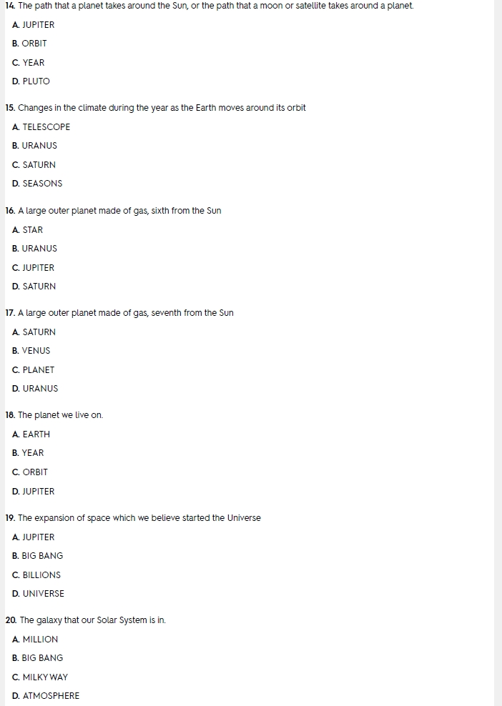
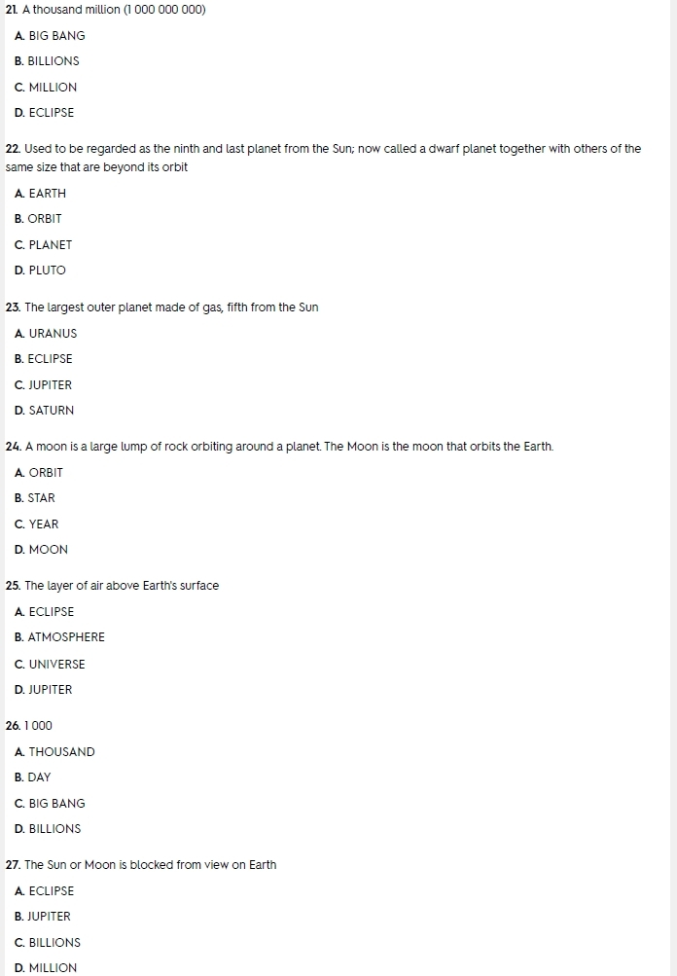
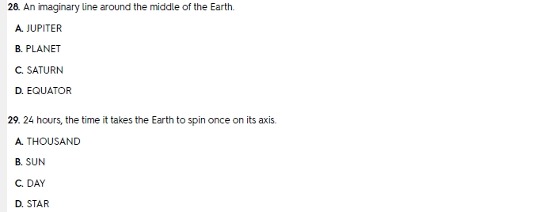
Sec1 Sci P7b WL The Earth and beyond 28word Core True False Quizlet.pdf - Adobe Acrobat Pro
Sec1 Sci P7b WL The Earth and beyond 28word Core Wirtten Quizlet.pdf - Adobe Acrobat Pro
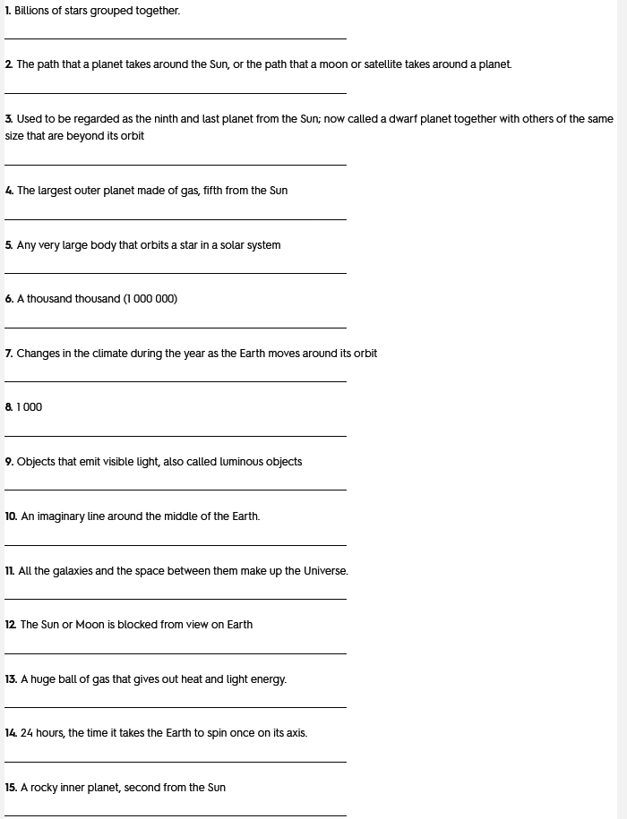
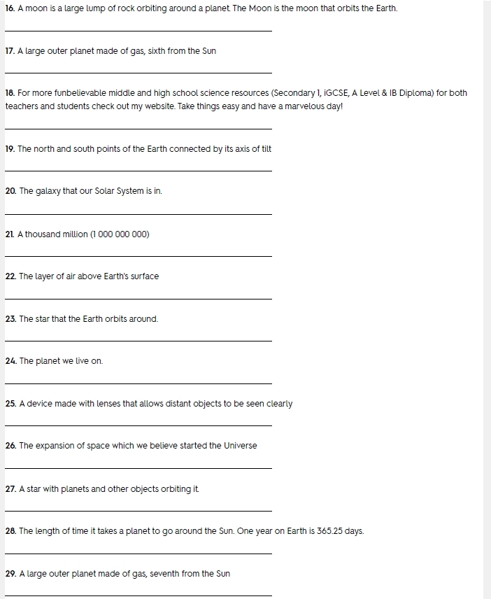

Sec1 Sci P7b WL The Earth and beyond 28word Core WrdCrmbl.pdf - Adobe Acrobat Pro
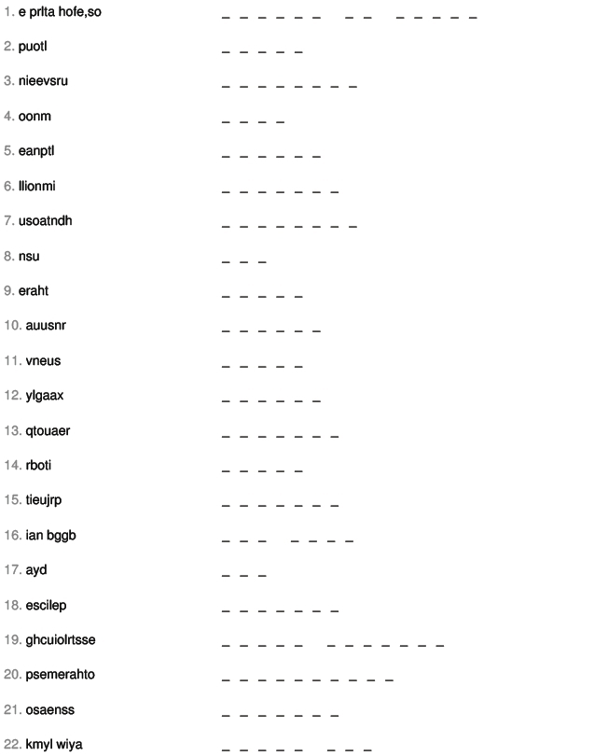

Sec1 Sci P7b WL The Earth and beyond 28word Core Xword.pdf - Adobe Acrobat Pro
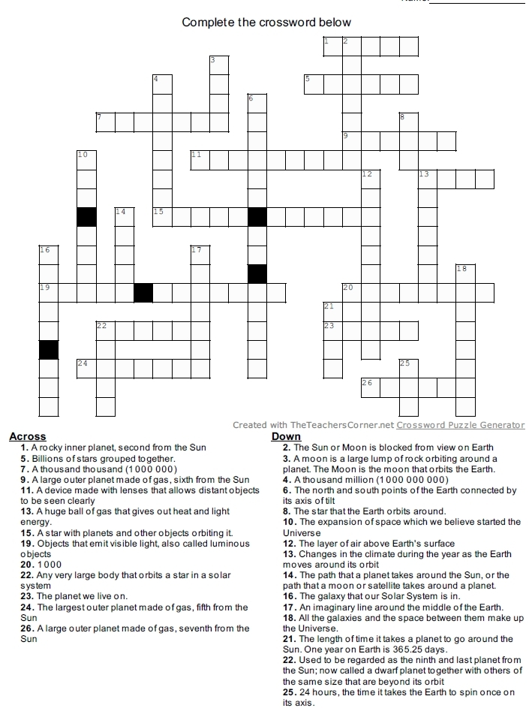

Fill in the missing definition for each of these keywords
Circle the definitions you were able to write without checking the word list on the front page
# | English | Meaning in English
25 | Universe | All the galaxies and the space between them make up the Universe.
4 | Day | 24 hours, the time it takes the Earth to spin once on its axis.
18 | Saturn | A large outer planet made of gas, sixth from the Sun
26 | Uranus | A large outer planet made of gas, seventh from the Sun
19 | Seasons | Changes in the climate during the year as the Earth moves around its orbit
27 | Venus | A rocky inner planet, second from the Sun
24 | Thousand | 1 000
5 | Earth | The planet we live on.
6 | Eclipse | The Sun or Moon is blocked from view on Earth
2 | Big bang | The expansion of space which we believe started the Universe
11 | Milky way | The galaxy that our Solar System is in.
15 | Planet | Any very large body that orbits a star in a solar system
21 | Star | A huge ball of gas that gives out heat and light energy.
8 | Galaxy | Billions of stars grouped together.
14 | Orbit | The path that a planet takes around the Sun, or the path that a moon or satellite takes around a planet.
13 | Moon | A moon is a large lump of rock orbiting around a planet. The Moon is the moon that orbits the Earth.
9 | Jupiter | The largest outer planet made of gas, fifth from the Sun
28 | Year | The length of time it takes a planet to go around the Sun. One year on Earth is 365.25 days.
12 | Million | A thousand thousand (1 000 000)
1 | Atmosphere | The layer of air above Earth's surface
17 | Poles, of earth | The north and south points of the Earth connected by its axis of tilt
20 | Solar system | A star with planets and other objects orbiting it.
16 | Pluto | Used to be regarded as the ninth and last planet from the Sun; now called a dwarf planet together with others of the same size that are beyond its orbit
23 | Telescope | A device made with lenses that allows distant objects to be seen clearly
10 | Light sources | Objects that emit visible light, also called luminous objects
3 | Billions | A thousand million (1 000 000 000)
7 | Equator | An imaginary line around the middle of the Earth.
22 | Sun | The star that the Earth orbits around.

