Sec1 Sci P7f EQ Forces and speed 44marks
Q# 1/ Q1.
The table below shows information about four planets.
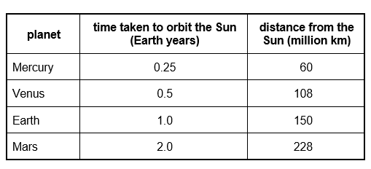
The diagram below shows the orbits of the Earth, Mercury, Venus and Mars, and their position at one particular time.
The arrows show the direction in which the planets move.
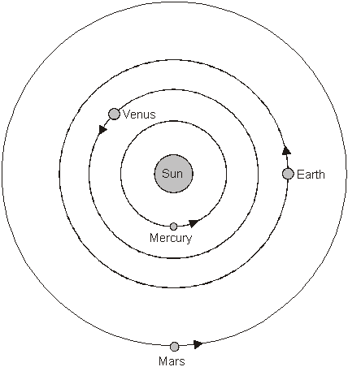
(a) Show the position of each planet six months later by drawing a letter X on the orbit of each planet.
2 marks
(b) Use the information in the table to calculate the largest and smallest distance between the Earth and Venus.
closest ............................................ million km
1 mark
furthest ............................................ million km
1 mark

(c) The speed of light is 300 000 km/second.
Calculate how long light takes to reach the Earth from the Sun.
..................................................................................................................... s
1 mark
(d) The diagram below shows the path of an asteroid around the Sun.
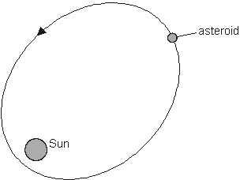
(i) On the path of the asteroid, draw a letter S to show the position where the asteroid is travelling the slowest.
On the path of the asteroid, draw a letter F to show the position where the asteroid is travelling the fastest.
1 mark
(ii) Explain why the speed of the asteroid changes.
...............................................................................................................
1 mark
Q# 2/ Q1. The diagram shows a firework rocket.
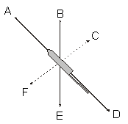
(a) Three forces act as the rocket flies through the air.
Which arrows show the directions of these three forces?
.............................. .............................. ..............................
3 marks
(b) When there is no fuel left, the rocket falls to the ground.
(i) Give the name of the force which pulls it down.
............................................................................................................
1 mark
(ii) Give the name of the force which acts against the motion of the rocket.
.............................................................................................................
1 mark
Q# 3/ Q10 The drawing shows a boy with a bow and arrow. He is holding the arrow and pulling it back.
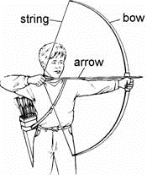
(a) Two horizontal forces act on the arrow. These are the force exerted by the boy’s hand and the force exerted by the string. The arrow is not moving.
The boy pulls the arrow with a force of 150 N. What is the size of the force exerted by the string on the arrow?
...................... N
1 mark
(b) When the boy lets go of the arrow, it starts to move forward.
Explain why it starts to move.
......................................................................................................................
1 mark
(c) The arrow flies across a field and hits a target.
Two forces act on the arrow while it is in the air. Air resistance acts in the opposite direction to the movement, and gravity acts downwards. These two forces cannot balance each other, even when they are the same size. Why is this?
......................................................................................................................
1 mark
Q# 4/ Q10.
The picture shows a man called Aristotle. He lived in Greece over 2000 years ago.
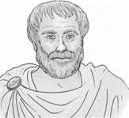
Aristotle said that the heavier an object is, the faster it will fall to the ground.
(a) The drawings below show a bowling ball, a cricket ball and a ping-pong ball.
Lila dropped them all at the same time from the same height.
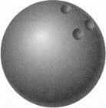
bowling ball cricket ball ping-pong
mass = 5 000 g mass = 160 g mass = 2.5 g
If Aristotle was correct, which of the three balls would you expect to reach the ground first?
Give the reason for your answer.
.....................................................................................................................
1 mark
(b) Joe said that it would be a fairer test if Lila had only used a cricket ball and a hollow plastic ball as shown below.
cricket ball hollow plastic ball
mass = 160 g mass = 56 g
Why was Joe correct?
.....................................................................................................................
1 mark
(c) About 400 years ago in Italy, a man called Galileo had a different idea. He said that all objects dropped from the same height would reach the ground at the same time.
(i) Lila dropped a hammer and a feather at the same time from the same height.
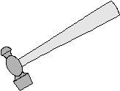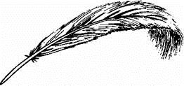
If Galileo was correct, which, if either, would reach the ground first?
.............................................................................................................
1 mark
(ii) Gravity acts on both the hammer and the feather as they fall. Give the name of one other force which acts on them as they fall.
..........................................
1 mark

(iii) An astronaut on the moon dropped a hammer and a feather at the same time from the same height.
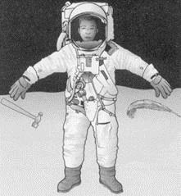
How would the results of the astronaut’s experiment on the Moon be different from Lila’s experiment on the Earth?
.............................................................................................................
Explain your answer.
.............................................................................................................
2 marks
Q# 5/ Q11.
The graph shows how the speed of a 0.1 kg mass changes as it falls.
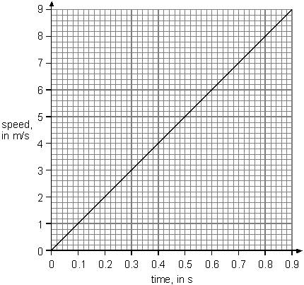
(a) Read from the graph the speed of the mass at 0.4 s and 0.8 s.
Use your results to work out the average speed of the mass between
0 and 0.4 s and then between 0 and 0.8 s. Give the units.
(i) final speed at 0.4 s = ............................
average speed between 0 and 0.4 s = ...................................
1 mark
(ii) final speed at 0.8 s = ............................
average speed between 0 and 0.8 s = ...................................
1 mark
(b) Using the average speeds calculated in (a), work out how far the mass falls in:
(i) 0.4 s
.............................................................................................................
1 mark
(ii) 0.8 s
.............................................................................................................
1 mark
(c) Complete the sentence:
If the mass falls for double the time, it will fall .............................................
times as far
1 mark
Q# 6/ Q11. Ruth is investigating how much a piece of wood can bend. She hangs some masses on the end of the piece of wood and measures how far the wood has bent.
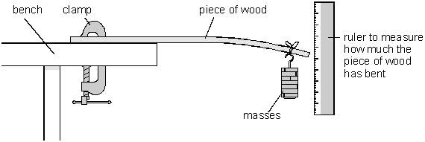
(a) Give the name of the force which pulls the masses downwards.
....................................................................
1 mark
(b) The graph below shows Ruth’s results.
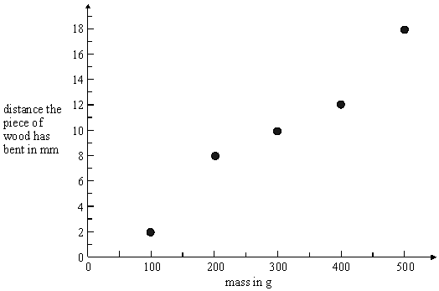
(i) Complete the graph by drawing a straight line of best fit.
1 mark
(ii) A mass of 350 g is hung on the piece of wood. How much does the wood bend?
......................….. mm
1 mark
Q# 7/ Q12.
A video recorder is loaded with a tape which plays for 180 minutes.
The length of the tape is 260 m.
(a) (i) Calculate the speed of the tape, in metres per minute.
……………………………………….……………………………… m/min
1 mark
(ii) What is the speed of the tape in metres per second?
……………………………………….…………………………………. m/s
1 mark
(b) To rewind the tape quickly, a different motor is used, which rewinds the tape at a maximum speed of 1.08 m/s.
(i) At this speed, how long would it take to rewind the tape completely?
Give the units.
……………………………………….……………………………………….
1 mark
(ii) In fact, it takes slightly longer than this to rewind the tape.
Explain why.
……………………………………….……………………………………….
1 mark
Maximum 4 marks
Q# 8/ Q12. The photograph shows two rubber tyres.
One is old and worn and the other is new.
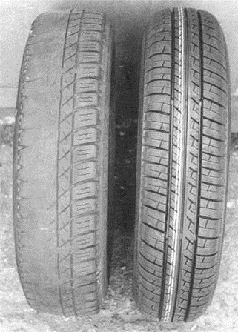
old tyre with new tyre with
worn tread deep tread
(a) A car is moving along a road. What force between the tyres and the road makes the car stop? Tick the correct box.
air resistance friction
gravity weight
1 mark
(b) The diagram and the table show the stopping distance of a car.
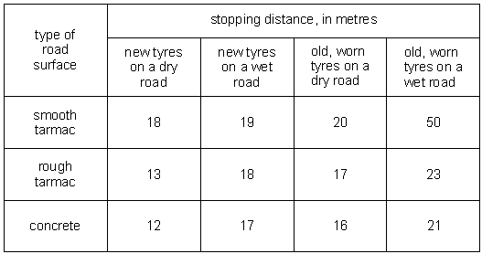
(i) What happens to the stopping distance when a road gets wet?
……………………………………….……………………………………….
1 mark
(ii) Why does the stopping distance change when a road gets wet?
……………………………………….……………………………………….
1 mark
(iii) What happens to the stopping distance as tyres get old and worn?
……………………………………….……………………………………….
1 mark
(iv) What is the safest type of road surface in the table?
……………………………………….……………………………………….
1 mark
Q# 9/ Q13.
A sky-diver jumped out of an aeroplane. After falling for some time she opened her parachute. The graph below shows how the speed of the sky-diver changed from the moment she jumped out of the aeroplane until she landed on the ground.
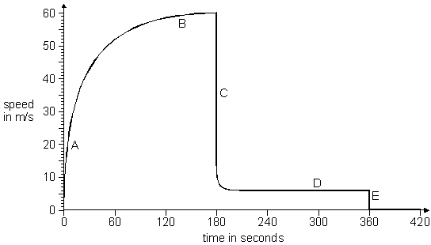
(a) What happened at 180 seconds and at 360 seconds after the sky-diver jumped out of the aeroplane?
180 seconds ………………………………………………………………………..
360 seconds ………………………………………………………..………………
2 marks
(b) There was an increase in air resistance on the sky-diver as her speed increased.
Explain how the graph shows this.
……….………………………………………………………………………………
1 mark
(c) Two sections of the graph show where the air resistance was equal and opposite to the sky-diver’s weight. Which sections are they?
Give the letters.
…………………… and …………………
1 mark
(d) (i) Use the graph to estimate how far the sky-diver fell between 180 s and 360 s.
…………………………………………………………………………………
1 mark
(ii) Why can this only be an approximate figure?
…………………………………………………………………………………
1 mark
Maximum 6 marks

Mark Scheme

Q# 1/ Q1.
(a)
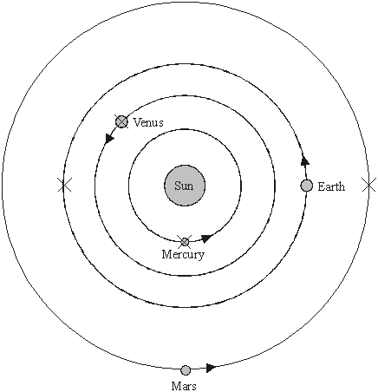
for all four correct, award two marks
for any two or three correct, award one mark
accept a cross drawn that lies within the width
of the Sun for each planet, e.g.
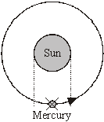
2 (L7)
(b) • 42
accept ‘150-108’
1 (L7)
• 258
accept ‘150+108’
1 (L7)
(c) 500
accept 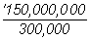 or 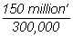
accept ‘8.3 minutes’
accept ‘about 8 minutes’
1 (L7)

(d) (i)
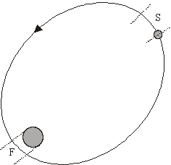
both answers are required for the mark
accept an answer within the dotted lines
at either end of the ellipse
1 (L7)
(ii) attracted by the Sun’s gravity
accept ‘increased gravity near to Sun’
1 (L7)
[7]
Q# 2/ M1. (a) A D E
letters may be written in any order if more than three
letters are given deduct one mark for each incorrect letter;
minimum mark zero
3
(b) (i) gravity or weight
1
(ii) air resistance or drag
accept ‘friction’ or ‘wind resistance’
do not accept ‘wind’ or ‘upthrust’
1
(c) the bright flash of light was seen first
if more than one box is ticked award no mark
1
light travels faster than sound
accept ‘the sound takes longer to reach you
or ‘light travels faster’
do not accept ‘the sound takes time to reach you’
or ‘light travels fast’
1
[7]
Q# 3/ M10. (a) 150
1
(b) there is nothing to balance the force of the string
accept ‘it is pushed by the string’ accept ‘there is a forward
force acting on it’ accept ‘potential energy is converted to kinetic
energy’ or ‘energy from the bow is transferred to the arrow’
1

(c) any one from
• because they are not in opposite directions
accept ‘because they are in different directions’
or ‘because they are at an angle to each other’
or ‘because they are not both horizontal’
do not accept ‘because they are at an angle’
• because they do not act along the same line
accept ‘gravity pulls down and friction pushes across’
1
1
Q# 4/ Q10.
(a) Both the correct ball and the correct reason are required for the mark.
the bowling ball because it has the greatest mass or it is the heaviest
do not accept ‘because it is bigger’
‘the bowling ball because it is bigger’ insufficient
1 (L5)
(b) any one from
• they are the same diameter
accept ‘they are the same size’
• they produce the same air resistance or friction
1 (L5)
(c) (i) they would both reach the ground at the same time
1 (L5)
(ii) air resistance
accept ‘friction’
1 (L5)
(iii) either
• the feather and the hammer landed at the same time
1 (L6)
• there is no atmosphere or air resistance or air on the moon
1 (L6)
or
• they would take longer to fall on the moon
1 (L6)
because there is lower gravity than on the Earth
do not accept ‘there is no gravity on the moon’
1 (L6)
[6]
Q# 5/ Q11.
(a) (i) final speed = 4 m/s average speed = 2 m/s
the unit is required for the mark in (i) and (ii)
1
(ii) final speed = 8 m/s average speed = 4 m/s
the unit is required for the mark in (i) and (ii)
consequential marking applies
1

(b) (i) distance = 2 × 0.4 = 0.8 m
accept numerical answer to (a) (i) × 0.4
1
(ii) distance = 4× 0.8 = 3.2 m
accept numerical answer to (a) (ii) × 0.8
1
(c) 4 times
accept a correct statement based on the
answers to (b) (i) and (b) (ii)
1
[5]
Q# 6/ M11. (a) gravity or weight
1
(b) (i)
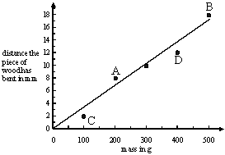
accept any straight line which goes
through or below both points A and B
and through or above both points C and D
the line does not have to extend to an axis
1
(ii) 11.5
accept any answer from 10.0 to 13.0
1
[3]
Q# 7/ Q12.
(a) (i) 1.44
accept ‘1.4’ or ‘1.44444’
1 (L7)
(ii) 0.024
consequential marking applies
accept the answer to (a) (i) ÷ 60
1 (L7)
(b) (i) 240.7 s or 241 s
unit is required
accept ‘4 minutes’
1 (L7)
(ii) any one from
• it takes time to reach the maximum speed
• it slows down before the end
• it is not the average speed
1 (L7)
[4]
Q# 8/ M12. (a) friction
if more than one box is ticked, award no mark
1 (L3)
(b) (i) it gets longer
accept ‘it is more’
1 (L3)

(ii) any one from
• there is less friction or grip
• the road is slippery
accept ‘water is a lubricant’
1 (L4)
(iii) it gets longer
accept ‘it is more’
1 (L3)
(iv) concrete
1 (L4)
[5]
Q# 9/ Q13.
(a) 180 seconds: the parachute opened
1
360 seconds: she landed
answers must be in the correct order
do not accept ‘her speed dropped’
1
(b) any one from
• the slope of the graph decreases or the curve gets less steep
• the graph begins to level out
• the acceleration gets less
accept ‘it curves between A and B’
1
(c) B and D
letters may be in either order
both letters are required for the mark
1
(d) (i) any answer between 1000 m and 1350 m
the unit is required for the mark
1
(ii) because its speed takes time to reach 6 m/s
accept ‘because the speed is not constant’
• because it was slowing down at first
• because the speed is difficult to read
accept ‘because the speed may not be exactly 6 m/s’
accept ‘because the graph curves at the corner’
1
[6]

